IMPACT OF HYDROTHERMIC BIOMASS WASHING ON THE ENZYMATIC HYDROLYSIS
Ariane S. S. Pinto^{1,2}, Marcelo P. A. Ribeiro¹, Roberto C. Giordano¹, Cristiane S. Farinas ^{1,2}

¹ Graduate Program of Chemical Engineering, Federal University of São Carlos, São Carlos, Brazil;
² Embrapa Instrumentação, São Carlos, Brazil
*Corresponding author: arianesbrice@gmail.com
Highlights
- 2G ethanol bioconversion process still needs to overcome process challenges.
- Inhibitors from lignin degradation hinder the biochemical reactions.
- Removal of soluble inhibitors improved the conversion of the hydrolysis.

1. Introduction
The large scale production of 2G ethanol is still under development and needs to overcome obstacles such as high solids loading in the reactors, in addition to inhibitors impairing the biochemical reactions (1). Inhibitors released from both chemical degradation of lignin and cellulose/hemicellulose during the pretreatment process negatively impacts the subsequent steps (2). During enzymatic hydrolysis of biomass, the phenolic inhibitors from lignin degradation deactivate and/or inhibit the biological catalysts (3-4), increasing the amount of enzymes required. In this context, the configuration of the overall processes with a detoxification of soluble inhibitors is a possible strategy for contributing to the feasibility of large-scale process (3). Washing the pretreated biomass with hot water, for instance, has been shown a high removal of inhibitors from steam pretreated hardwood (5). Thus, the purpose of this work was to investigate a feasible protocol for washing pretreated sugarcane bagasse in order to improve the enzymatic hydrolysis process.
2. Methods
Hydrothermal pretreatment of sugarcane bagasse was carried out at 195 ° C, 10 minutes and 15% solids (w:w). The washing protocols were carried out using hot water at 90 °C. The first procedure consisted in homogenization of the mixture water and biomass at 10% solids (t_{MIX} < 1 minute), followed by filtration for 2 and 3 washing steps. The second washing process was conducted using a batch with 3% solids during 10 minutes for 6 washing steps (assuring the stabilization of the pH of the washing water). Subsequently, the enzymatic hydrolysis was performed at 50°C, 15% solids (w:w) and 10 FPU/g of dry bagasse in sodium citrate buffer (50 mM, pH = 5.0). Glucose was determined using a D-glucose enzymatic assay kit (Liquiform®, Brazil).
3. Results and discussion
The enzymatic hydrolysis conversion of washed pretreated biomass from first washing procedure with 2 washing steps removed the soluble inhibitors and improved up to 30.2% the conversion during enzymatic hydrolysis.
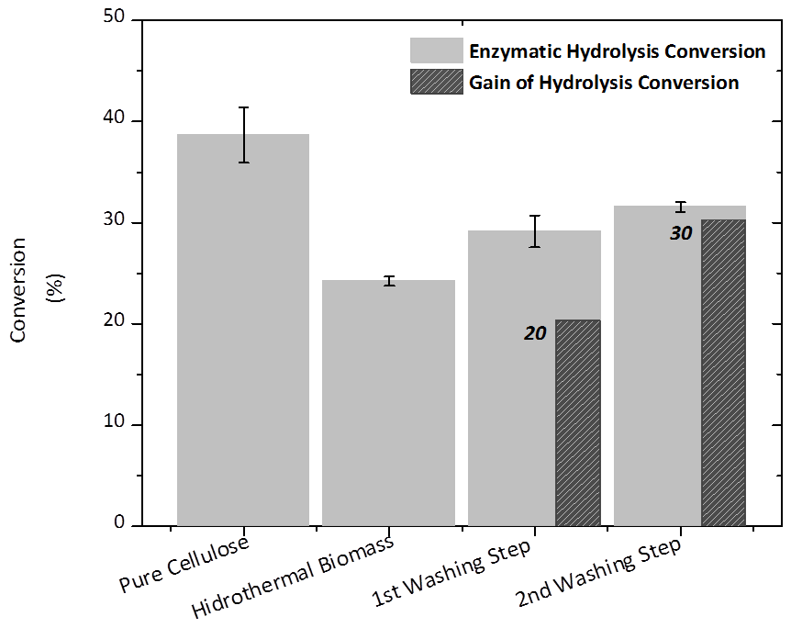
Figure 1. Conversion in the hydrolysis stage for each biomass processing and the conversion gain for the unwashed hydrothermal bagasse (52.41 % of cellulose).
On the other hand, the severe conditions of time and the many stages of washing with a lower solids loading (3% w:w) showed a negative impact on the enzymatic hydrolysis reaction (second protocol). This washing procedure not only removed the soluble inhibitors, but also helped to solubilize and disperse the remaining lignin in the biomass, resulting in the blocking of biomass to the action of the enzymes.
4. Conclusions
The results suggest that for improving the enzymatic conversion, the study of different washing proceedings is crucial to optimize the removal of soluble inhibitors during the production of 2G ethanol.
References
[1] L. H. d. S. Martins, S. C. Rabelo, A. C. d. Costa, Effects of the pretreatment method on high solids enzymatic hydrolysis and ethanol fermentation of the cellulosic fraction of sugarcane bagasse. Bioresource Technology 191, 312-321 (2015).
[2] L. J. Jönsson, C. Martín, Pretreatment of lignocellulose: Formation of inhibitory by-products and strategies for minimizing their effects. Bioresource Technology 199, 103-112 (2016).
[3] L. Qin et al., Inhibition of lignin-derived phenolic compounds to cellulase. Biotechnology for Biofuels 9, 70 (2016).
[4] S. Sun, Y. Huang, R. Sun, M. Tu, The strong association of condensed phenolic moieties in isolated lignins with their inhibition of enzymatic hydrolysis. Green Chemistry 18, 4276-4286 (2016).
[5] Y. Kim, T. Kreke, R. Hendrickson, J. Parenti, M. R. Ladisch, Fractionation of cellulase and fermentation inhibitors from steam pretreated mixed hardwood. Bioresour Technol 135, (2013).

