Selectivity of gas-liquid reactions in straight and coiled capillaries and CFI
Julia Grühn¹, Norbert Kockmann¹
1 TU Dortmund University, Biochemical and Chemical Engineering, Laboratory of Equipment Design,
Emil-Figge-Str. 68, 44227 Dortmund, Germany
*Corresponding author: julia.gruehn@tu-dortmund.de
Highlights
- Deeper understanding of gas-liquid reactions with mass transfer
- Optical measurement technique for mass transfer and selectivity
- Correlations between flow behavior and chemical selectivity

1. Introduction
Two-phase flow and gas-liquid reactions in particular are of great importance in the chemical industry and, therefore, subject of current research since they are often limited by mass transfer or show low selectivity ^{[1]}. Investigations of Krieger et al. based upon the consecutive oxidation of leuco-indigo carmine ^{[2]}. To visualize local gas-liquid mass transfer in capillary plug-flow a colorimetric technique was used there. For studies on selectivity it is essential that the oxidation passes two detectable color changes. Further investigations on flow behavior have shown three relevant flow regimes depending on different operating conditions ^{[2]}. Since the selectivity in bio-catalytic reaction systems is an important field in research as well, investigations of bio-catalytic parallel reactions were performed, too. Beyond that, suitable reaction systems from the DFG-SPP1740 “Reactive Bubbly Flows” ^{[3]} were tested and an optical measuring method was established.
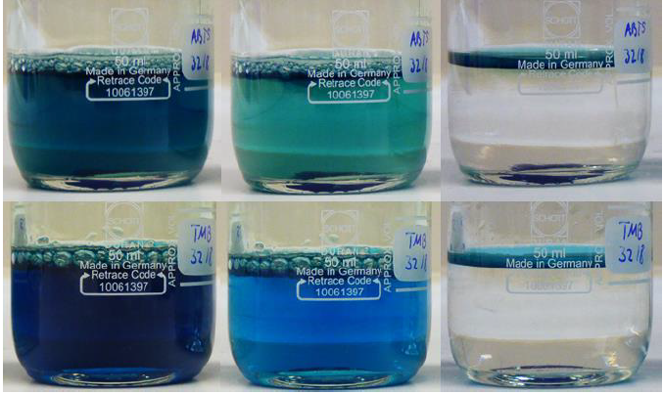
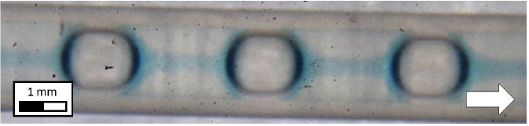
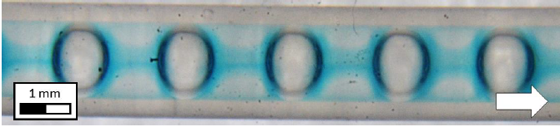

Figure 1. Top left: Enzymatically solution of glucose oxidase and ABTS (2,2´-azino-bis(3-ethylbenzothiazoline-6-sulphonic acid)) as dye. Completely oxidized (l.), 35 s after oxidation (m.), completely reduced (r.). Top right: Gas-liquid capillary flow with the enzymatically solution and ABTS as dye. Bottom left: Enzymatically solution of glucose oxidase and TMB (3,3´,5,5´-Tetramethylbenzidine) as dye. Completely oxidized (l.), 45 s after oxidation (m.), completely reduced (r.). Bottom right: Gas-liquid capillary flow with the enzymatically solution and TMB as dye.

2. Methods
The experiments of the two-phase flow in capillaries were performed according to the approach of Krieger et al., in which the flow regime is dominated by Taylor vortices. The experimental setup consists of a straight capillary build of FEP (fluorinated ethylene propylene) with 1.6 mm inner diameter. Furthermore, the experiments were performed in a PMMA box (Poly(methyl-methacrylate)) filled with deionized water ^{[2]}. Since FEP and water have nearly the same refractive index, it can be assumed that disturbances caused by deviating refractive indices are negligible. Beyond this, the experimental setup is temperature-adjustable. Building on this, investigations on gas-liquid reactions in coiled capillaries and coiled flow inverters (CFI) follow for suitable bio-catalytic systems as well as for chemical systems from the DFG-SPP1740 “Reactive Bubbly Flows” ^{[3]}. For analytical evaluation an optical measurement system is required to avoid flow disturbances. The colorimetric technique used by Krieger et al. was adapted to the respective reaction system ^{[2]}.

3. Results and conclusion
Finally a deeper understanding on selectivity of gas-liquid reactions in general is developed by comparing the experimental results of the consecutive oxidation of leuco-indigo carmine with the bio-catalytic parallel reaction and other reaction systems from the DFG-SPP1740 “Reactive Bubbly Flows”. Furthermore, the studies on the different reactor types (straight capillary, coiled capillary and CFI) provide information about the correlation between flow behavior and selectivity for gas-liquid reactions.

References
- P.V. Danckwerts, Gas-liquid reactions, McGraw-Hill, New York, 1970.
- W. Krieger, J. Lamsfuß, W. Zhang, N. Kockmann, Chem. Eng. Technol. 2017, 40 (11), 2134-2143.
- SPP-1740: Reactive Bubbly Flows http://www.dfg-spp1740.de/
[Online] Accessed: 14.01.2019

