Improvement of a CDI System Concerning the Adsorption of Organic Acids by Investigation of the Potential Free Adsorption.
Robin Wagner¹, Matthias Franzreb²
1 Karlsruhe Institut of Technology, Kaiserstraße 12, 76131 Karlsruhe; 2 Karlsruhe Institut of Technology, Kaiserstraße 12, 76131 Karlsruhe
*Corresponding author: robin.wagner@kit.edu
Highlights
- Adsorption Isotherms of an organic acid for various pH-values.
- Presentation of an easy way to improve adsorption capacities.
- Influence of co-ions on the adsorption process.

1. Introduction
Capacitive Deionization (CDI) is an easy to use method, which is suitable for the separation of ions or charged molecules in solutions. The advantages of this method are that it is already established for desalination and therefore available at low cost. Furthermore, it offers the opportunity to concentrate a charged species in a solution without additives [1]. Therefore, CDI can also be an interesting alternative for the purification and concentration of larger molecules like organic acids, which gained importance e.g. due to their use for the production of biopolymers [2]. Here we present a method to determine an appropriate pH-value and concentration for electrosorption purposes, by investigating the potential free adsorption properties of the carbon material. Furthermore, the influences of co-ions on the adsorption process are described. Afterwards the predicted optimum for the electrosorption of weak organic acids was checked by further experiments.

2. Methods
An organic acid solution with a specific pH-value was pumped through the CDI system without the application of an external electrical potential until an equilibrium between the molecules in the solution and the adsorbed molecules was reached. The moment when the conductivity stopped to change was taken as the state of equilibrium. After a sample was taken an equal amount of a high concentrated stock solution was added to increase the concentration and the process was repeated. Based on the results of the adsorption of the organic acids on the carbon surfaces due to potential free adsorption the best operation conditions for the electrosorption could be derived. For electrosorption experiments a potentiostat was attached to the CDI unit and different experimental series applying constant current or constant voltage mode were conducted.
3. Results and discussion
The adsorption isotherms of an organic acid onto an activated carbon based CDI electrode are plotted in Fig. 1. It shows that the isotherms mainly split into two groups with isotherms representing high capacities at pH-values ≤ 5.5 and isotherms representing small capacities at pH-values ≥ 6.5. The fast variation of the potential free adsorption capacity in-between these pH-values directly correlates with the second dissociation constant of this organic acid. In the presentation the strong effect of this potential free adsorption onto the achievable electrosorption will be theoretically discussed and experimentally validated.
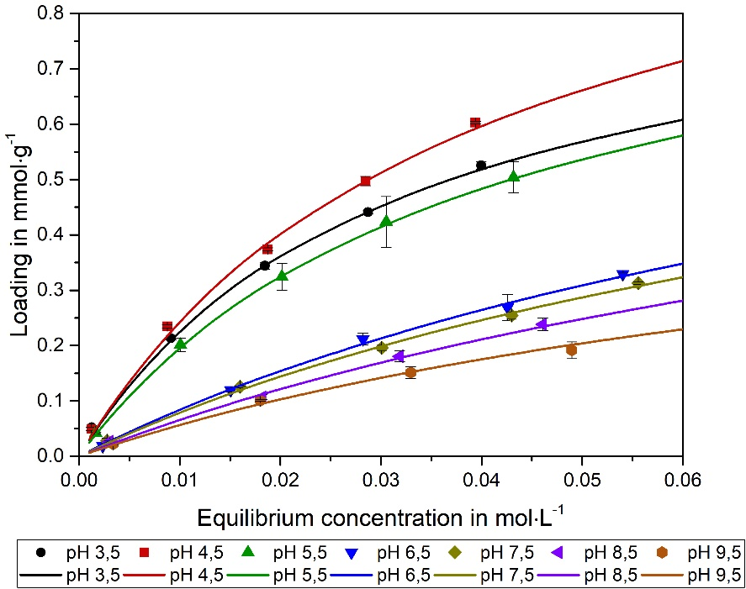
Figure 1. Adsorption isotherms of an organic acid for different pH-values and concentrations, fitted following the approach of Langmuir.
In addition to the pH also the concentration and type of strong electrolytes present, e.g. sodium chloride, show a clear effect onto the potential free and potential driven adsorption of weak organic acids. A generalized, thermodynamics based model will be presented which simulates these effects.
4. Conclusions
The electrosorption of weak electrolytes onto carbon materials shows a strong dependence onto the adjusted pH and the presence of other ions. In order to explain these effects, the dissociation behavior as well as potential free adsorption effects must be taken into account, resulting quickly in a relatively complex network of adsorption and chemical equilibria in combination with electrostatic effects. Detailed investigation of potential free adsorption data and literature based chemical equilibrium constants built the basis to understand this network and predict optimum operation windows for electrosorption processes.
References
- M. E. Suss, S. Porada, X. Sun, P. M. Biesheuvel, J. Yoon and V. Presser, Energy Environ. Sci 2015, 8, 2296
- P. Liu, L. R. Jarboe, Computational and Structural Biotechnology Journal 2012, 3 (4), e201210011

