Modelling of Enzymatic Fat Splitting Kinetics in Liquid – Liquid Multiphase System.
Sherly Rusli¹, Julia Lange¹, Janna Grabowski¹, Matthias Kraume¹
1 Chair of Chemical and Process Engineering, TU Berlin
*Corresponding author: s.rusli@tu-berlin.de
Highlights
- Modification of Michaelis Menten and Ping Pong Bi Bi Kinetics to accommodate surface area limitation.
- Validation of model by experimental data with in-situ drop size measurement.
- Inclusion of product inhibition in model.

1. Introduction
The enzymatic (trans)esterification process using lipase has attracted attention of both academic and industrial researchers due to its promising applications. This particular enzyme are able to react with two substrates in different phases, water or methanol in aqueous phase, and triglycerides in oil phase. Modelling its kinetics is a challenging task, as the reaction depends on the available surface area, and the surface area is dependent on the emulsification process.
2. Methods
To include the surface area, the Michaelis Menten kinetics was modified into two steps mechanism. The first step is the adsorption of enzyme molecules to the surface area, to create an activated enzyme molecule. The adsorption – desorption constants were fitted from experimental data of enzyme adsorption on single drop. To include the influence of side product Glycerol, the Ping Pong Bi Bi Mechanism is needed. The reaction are then divided into 5 steps, including formation of intermediate products Mono- and Di- Glycerides.
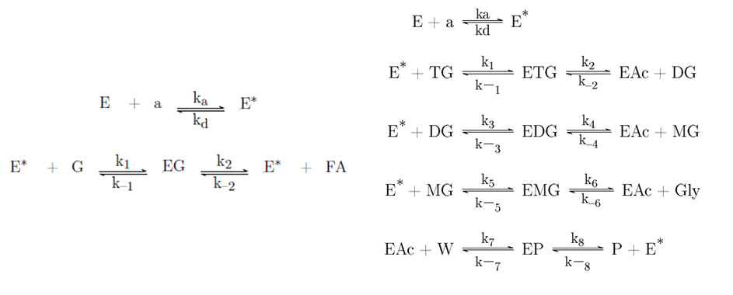
Figure 1. Modified Michaelis Menten (left) and Ping Pong Bi Bi (right) kinetics for inclusion of surface area limitation.
To validate the models, experiments were conducted in a batch stirred tank reactor, equipped with endoscope for measuring the surface area. Increasing the impeller speed decreases the drop sizes. Samples were taken from oil phase and analyzed by HPLC to quantify the amount of substrate and product.
3. Results and discussion
Experimental data shows two different kinetics. The initial reaction rate increases with increasing stirring rate, until all enzyme molecules are adsorbed. Above this point, the kinetics follow conventional enzymatic kinetics without surface area limitation. To make things more complicated, the prediction of drop sizes is dependent on the enzyme concentration, as increasing enzyme concentration decreases the interfacial tension, thus decreasing the drop sizes.
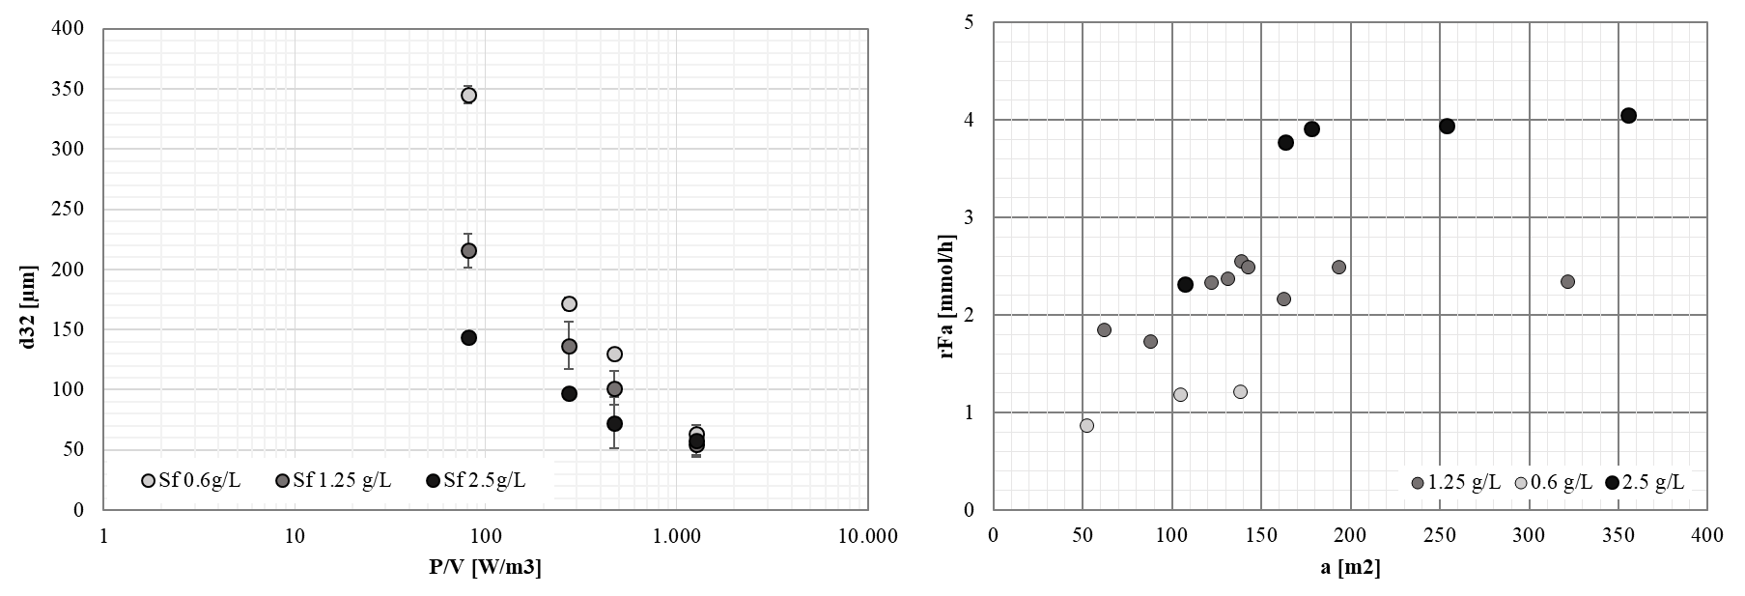Figure 2. Effect of enzyme on drop sizes (left) and effect of surface area on reaction rate (right).
The two conditions can be predicted by a set of parameters from fitting against experimental data. The inclusion of surface area is imperative in the model, as is predicts the surface limiting mechanism. Without Glycerol inhibition, it is sufficient to model the reaction with the Michaelis Menten Kinetics, as there are no influence of the second substrate (water is in excess). However, when Glycerol is present, Ping Pong Bi Bi Kinetics is needed to predict the shift in reaction equilibrium.
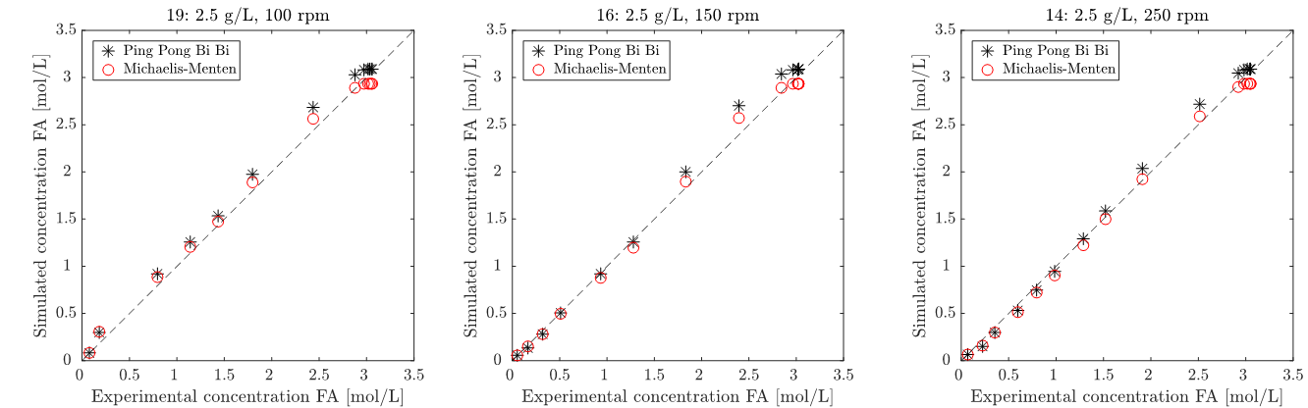
Figure 3. Deviations of experimental data and simulation.
4. Conclusions
To model the enzymatic transesterification, it is imperative to include the surface area and the glycerol concentration in the model.

