Hydrocarbon Mass Transfer in Ionic Liquids.
Noemí Delgado-Mellado¹, Miguel Ayuso¹, Julián García¹, Francisco Rodríguez¹
1 Department of Chemical Engineering, Complutense University of Madrid, 28040 Madrid, Spain
*Corresponding author: noemidelgado@ucm.es
Highlights
- Determination of hydrocarbon diffusion coefficients at infinite dilution in ILs
- Hydrocarbon diffusion is highly influenced by the ionic liquid viscosities
- A modified Wilke-Chang correlation successfully predicts the diffusion coefficients

1. Introduction
The experimental values of diffusion coefficients are of special importance in the theory of transport properties and to predict the rate-limiting factor for chemical processes and engineering design [1]. Herein, the Taylor dispersion method has been used for the first time to measure the diffusion coefficients at infinite dilution of n-heptane and toluene in two ionic liquids (ILs), namely 1-ethyl-3-methylimidazolium dicyanamide ([emim][DCA]) and 1-ethyl-4-methylpyridinium bis(trifluoromethylsulfonyl)imide ([4empy][Tf₂N]). The importance of both ILs lies in their remarkable extraction properties in the aromatic/aliphatic separation process by liquid-liquid extraction [2]. A correlation based on the Wilke-Chang equation has been proposed to estimate the diffusion coefficients that satisfactorily predicts the temperature dependence.
2. Methods
The experimental equipment consists of a KDS Legato 200 metering pump which provides a constant and a laminar flow, a PEEK diffusion tubing (10 m length and 0.375·10⁻³ m inner radius) located in a thermostatic incubator, and a Refractive Index Detector Agilent 1260 Infinity II which records the concentration gradient signal at the end of the diffusion tubing. The experiments were performed at temperatures between (298.2 and 333.2) K and a constant laminar flow of 50 μL·min⁻¹ for 20 μL of samples with a hydrocarbon concentration of (0.02-0.10) mol·dm⁻³ in excess.
3. Results and discussion
Toluene presents higher values of diffusion coefficients than n-heptane in the [emim][DCA] IL because of the lower toluene molecular volume, meanwhile both toluene and n-heptane show similar values in the [4empy][Tf₂N] IL due to high effect of the solvent viscosity on the hydrocarbon diffusion (Figure 1). Meanwhile at a temperature of 298.2 K the [emim][DCA] IL has a viscosity of 15.1 mPa·s, the [4empy][Tf₂N] viscosity presents a much higher value of 34.5 mPa·s [3]. Therefore, the higher [4empy][Tf₂N] viscosity leads to a lower influence of the solute molecular volume on the diffusion coefficients.
It has been observed that the Wilke-Chang correlation [4] does not correctly predict these diffusion coefficients; it tends to underestimate them at low temperatures and overestimate them at high temperatures, with an average deviation of 17.5%. The association parameter seems to be a nonconstant value influenced by the temperature in ILs, therefore a modified Wilke-Chang equation is proposed and expressed as:
being φ_{mod}(T) the association parameter dependent on temperature as φ_{mod}(T)=a₁·T+a₂. The modified Wilke-Chang equation correctly represents the temperature effect on the diffusion coefficients and estimates them with an average deviation of 2.6% (Figure 1).
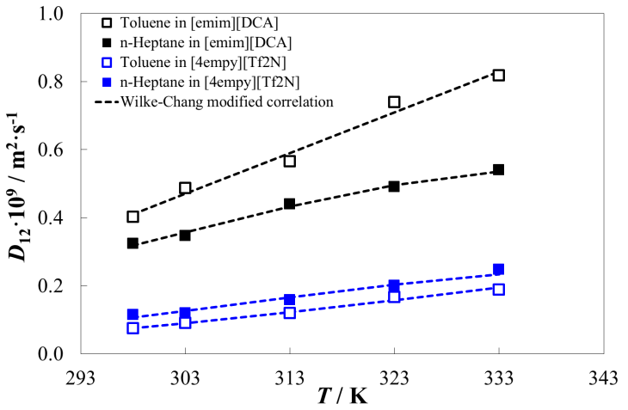
Figure 1. Diffusion coefficient at infinite dilution of n-heptane and toluene in [emim][DCA] and [4empy][Tf2N] ILs and dotted lines for Wilke-Chang modified correlation.
4. Conclusions
The hydrocarbon diffusion is faster in [emim][DCA] because of the much lower values of its viscosity, and the difference between n-heptane and toluene diffusion coefficients are due to their respective molecular volume. On the contrary, the high viscosity of [4empy][Tf₂N] IL leads to lower and similar diffusion coefficients of both hydrocarbons, prevailing the effect of the viscosity over the effect of the hydrocarbon molecular volume. The Wilke-Chang correlation, the most common one used to estimate the diffusion coefficients, unsuccessfully predicts the temperature dependence with an average deviation of 17.5%. A modified Wilke-Chang correlation has been proposed to properly estimate the dependence of the temperature on the association parameter. This correlation has shown a good fit in the studied temperature range with an average deviation of 2.6%.
References
- A. Safi, C. Nicolas, E. Neau. J. L. Chevalier, J. Chem. Eng. Data 53 (2008) 444-448.
- M. Larriba, P. Navarro, J. García, F. Rodríguez, J. Chem. Eng. Data 59 (2014) 1692–1699.
- M. Larriba, P. Navarro, J. García, F. Rodríguez, Sep. Purif. Technol. 120 (2013) 392–401.
- C. R. Wilke, P. Chang, AIChE Journal 1 (1955) 264-270.

