Synthesizing Temperature Control System for Binary Distillation Columns.

Lu Liu¹, Kejin Huang², Yang Yuan³, Xing Qian⁴, Haisheng Chen⁵
College of Information Science and Technology,
Beijing University of Chemical Technology, Beijing 100029, People’s Republic of China
*Corresponding author:2017210320@mail.buct.edu.cn
Highlights
- Sensitivity analysis and minimum deviation methods give inconsistent outcomes.
- The new method balances the static and dynamic behaviors of rectifying section.
- The new method suppresses sensitivities to pressure variations of stripping section.
- The new method renders better static and dynamic behaviors than the former two methods.

1. Introduction
Based on the sensitivity analysis and minimum deviation methods, the synthesis and design of temperature inferential control systems for three ethanol/butanol binary distillation columns with, respectively, low, intermediate, and high product purities are addressed in this work. The temperature inference control systems based on the sensitivity analysis method focusing on dynamic behaviors and the minimum deviation method focusing on static behaviors are difficult to give satisfactory control effects under high product purity conditions. Through in-depth analysis of the static and dynamic behaviors of the controlled stages in the rectifying section and the stripping section, we explain why these two methods fail to give consistent control effects at low, intermediate, and high product purities, followed by verification in closed loop control.
2. Methods
The controlled stages by the sensitivity analysis method usually exhibit quick dynamic responses but only in the case of low product purities can their temperatures display satisfactory corresponding relationships with product compositions. For the controlled stages by the minimum deviation method, their temperatures usually display satisfactory corresponding relationships with product compositions. In the case of high product purities, because the controlled stages are quite near in locations to the ends of the distillation column, degraded process dynamics is introduced in the rectifying section and great sensitivity to pressure variations occurs in the stripping section, both worsening the performance of the temperature inferential control system. Therefore, in order to achieve tight inferential control of product qualities, it is necessary to develop a new method that can compensate for changes in system characteristics. In order to compromise the static and dynamic behaviors in the rectifying section, the controlled stage should be selected between the top stage and the sensitive stage. The temperature difference between the two lowest stages in the stripping section should be used as the controlled variable to achieve the most effective compensation for pressure changes.
3. Results and discussion
Let us take the example of an ethanol/butanol binary distillation column with an intermediate product purity of 99%. The closed loop response processing a ±20% step change of feed composition and a ±20 % step change of feed flow rate is shown in Figures 1 and 2, respectively. The closed loop response based on the sensitivity analysis, minimum deviation and new methods are labeled as CS1, CS2 and CS3, respectively. The positive responses are represented by black curves and negative responses by gray curves. In Figure 1, although the CS2 greatly reduces the steady-state deviations compared to the CS1, its dynamic behaviors of the top and bottom products are deteriorated. In Figure 2, the CS2 not only has larger steady-state deviations than CS1 in the bottom product, but also deteriorated dynamic behaviors. Compared with CS1, CS3 not only reduces the steady-state deviation of the top product concentration, but also reduces the transient and steady-state deviations of the bottom product concentration. Although the CS3 has slightly larger steady-state deviations than CS2 processing ±20% step change in feed composition, its static and dynamic behaviors are balanced.
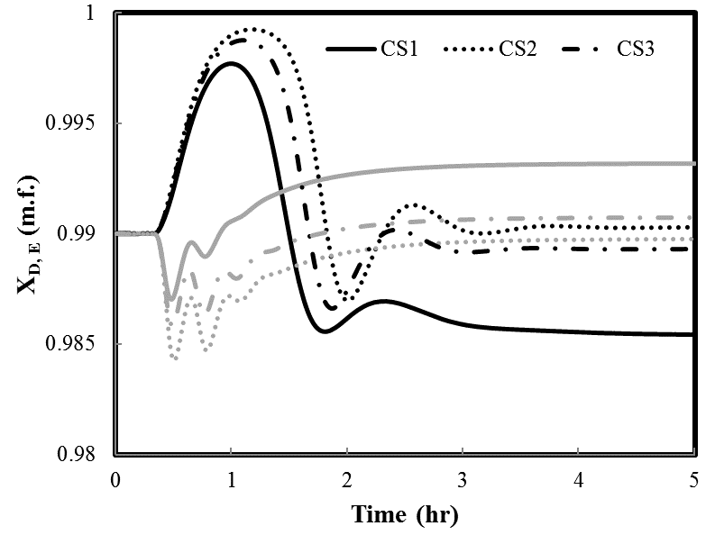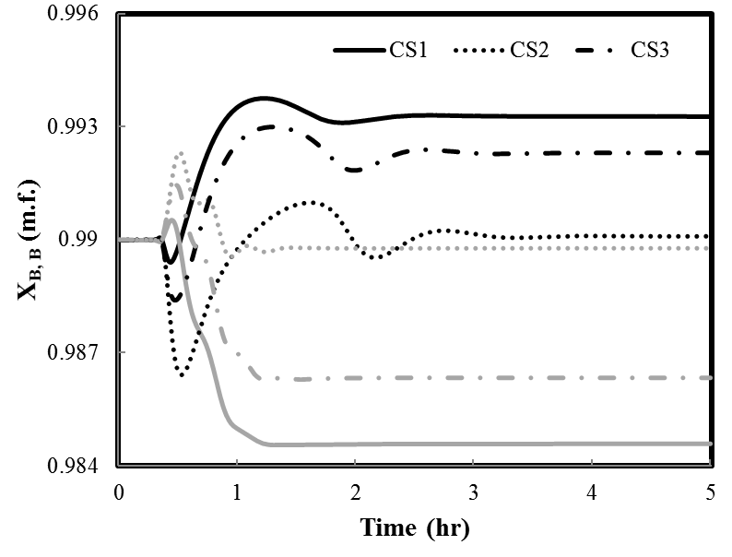
Figure 1. Closed-loop responses in case of a ±20% step change in feed composition.
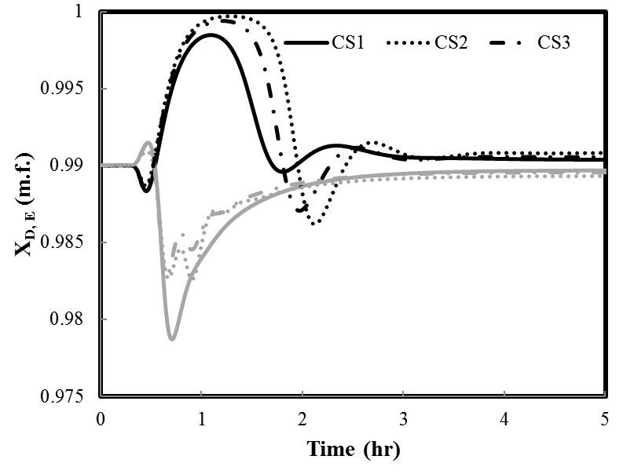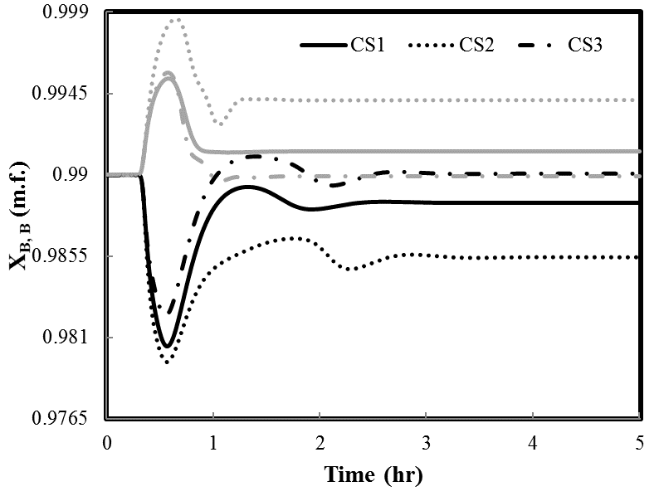
Figure 2. Closed-loop responses in case of a ±20% step change in feed flow rate.
4. Conclusions
Sensitivity analysis and minimum deviation methods give inconsistent outcomes. Therefore, we develop a systematic method that can not only compromise the static and dynamic behaviors of the rectifying section but also suppress the sensitivity to pressure variations in the stripping section. The obtained results have confirmed that the new method can render better static and dynamic behaviors than the sensitivity analysis and minimum deviation methods.
References
- W.L. Luyben, Evaluation of Criteria for Selecting Temperature Control Trays in Distillation Columns, Process Control. J. 2006, 16, 115.
- L.J. Zang, K.J. Huang, T. Guo, Temperature inferential control of a reactive distillation column with double reactive sections, Chinese Journal of Chemical Engineering. J. 2018, 1333-1342.

