Deciphering Alkaloids Bioconversion to High-Added Value Chemicals: the Metabolic Route of Lupanine Degradation in Pseudomonas Putida LPK411.
Stella Parmaki¹, Argyro Tsipa¹, Ioannis Vyrides¹, Ana Mota², Raquel A. M. Teixeira³, Frederico C. Ferreira², Carlos A.M. Afonso³, Michalis Koutinas^{1,}*
1 Department of Environmental Science & Technology, Cyprus University of Technology, 30 Archbishop Kyprianou Str., 3036, Limassol, Cyprus; 2 Institute for Bioengineering and Biosciences, Department of Bioengineering, Instituto Superior Tecnico, Universidade de Lisboa, Av. Rovisco Pais, 1049-001, Lisbon, Portugal; 3 Research Institute for Medicines (iMed. ULisboa), Faculty of Pharmacy, Universidade de Lisboa, Av. Prof. Gama Pinto, 1649-003, Lisbon, Portugal

*Corresponding author: michail.koutinas@cut.ac.cy
Highlights
- Systematic biodegradation kinetics of lupanine enantiomers in P. putida LPK411.
- A different metabolic pathway for each enantiomer exists.
- Systematic transcriptional kinetics of gene expressing lupanine hydroxylase.
- Systematic transcriptional kinetics of global genes in lupanine biodegradation.

1. Introduction
Lupanine constitutes the main quinolizidine alkaloid contained in Lupinus albus seeds. Owing to the useful functionalities of its asymmetric structure, this toxic compound has attracted considerable attention in biotechnological industries and may serve as a starting material for semi-synthesis of a range of novel high added-value compounds [1]. L. albus snack manufacturing generates excess of wastewater containing lupanine, while the most common process for lupanine elimination requires exhaustive boiling and leaching of seeds in water [2]. Biodegradation is a promising, greener alternative for detoxification of the wastewater generated. Thus, the objective of this study was to decipher the metabolism of lupanine biodegradation in Pseudomonas putida LPK411.

2. Methods
Microbial cultures: Lupanine enantiomers’ biodegradation was investigated during fermentation of P. putida LPK411 using initial D-(+)-lupanine and L-(-)-lupanine concentration of 0.75 g L⁻¹ respectively. The cultures were maintained at 31 ºC, pH 7 and 100 rpm.
Analytical techniques: Culture samples were withdrawn at regular intervals and biomass concentration was determined by absorbance at 600 nm on a UV/VIS spectrophotometer. Lupanine concentration was measured using GC analysis [3].
Molecular biology techniques: Total RNA isolation, cDNA synthesis and Quantitative Real-Time Polymerase Chain Reaction (Q-RT-PCR) was conducted as previously described [4].

3. Results and discussion
Lupanine in nature exists in a racemic mixture of two enantiomers (D-(+)-lupanine and L-(-)-lupanine) [5]. Biodegradation kinetics of D-(+)-lupanine and L-(-)-lupanine was investigated during fermentation of P. putida LPK411. Two batch experiments were performed. The results demonstrated that P. putida LPK411 can degrade D-(+)-lupanine, while L-(-)-lupanine concentration was only slightly reduced (Fig. 1). The latter indicates a different metabolic pathway for each enantiomer [6]. Moreover, LPK411 fermentations fed with racemic lupanine clarified that the strain is capable of achieving more than 95% enantiomeric excess of L-(-)-lupanine enabling the fermentative production of enantiopure L-(-)-lupanine, which avoids the application of other costly and laborious chemical methods.
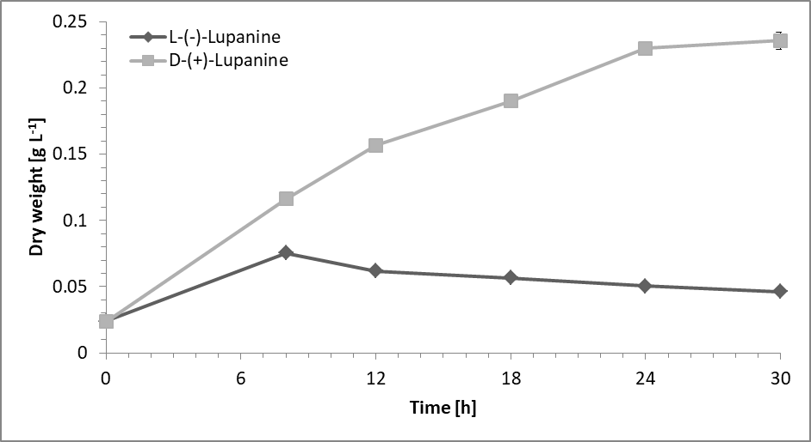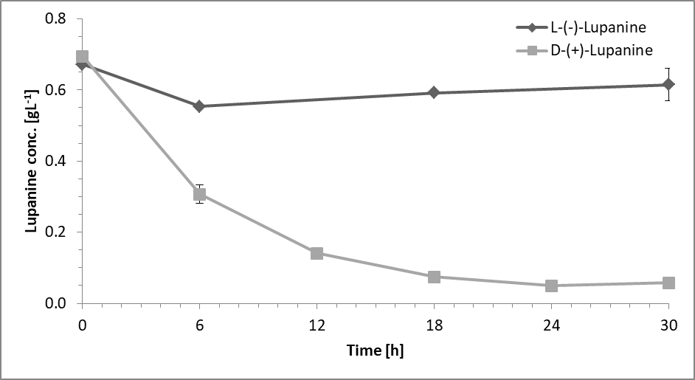
Figure 1. Lupanine enantiomers biodegradation by P. putida LPK411. (A) Microbial growth (expressed as dry cell weight), (B) concentration of D-(+)-lupanine and L-(-)-lupanine during fermentation.
Thus far, only a few studies have focused on metabolic mechanisms of quinolizidine alkaloids, such as lupanine. Lupanine hydroxylase catalyses the first reaction of lupanine biodegradation in P. putida. The specific enzyme is active only upon D-(+)-lupanine [6] biodegradation. Moreover, we have reported that P. putida LPK411 produces three main metabolic products during lupanine fermentation [7]. In this study, we systematically and consistently monitor the transcriptional kinetics of the gene expressing lupanine hydroxylase as well as global genes which may play a critical role during lupanine biodegradation in P. putida. We base our hypotheses on the lupanine derivatives’ structures previously observed as well as on the selective catabolism of each enantiomer, which could potentially activate carbon catabolite repression (CCR) mechanisms.

4. Conclusions
Deciphering the lupanine biodegradation pathway by a Pseudomonas species provides fundamental knowledge of the metabolism during quinolizidine alkaloids biodegradation, which is expected to enhance bioprocess development for the production of high-added value compounds from lupanine wastewater.

5. Acknowledgements
This work was supported by the M-ERA.NET collaborative project Biorg4WasteWaterVal+ co-funded by the Research Promotion Foundation (RPF, Cyprus) and Fundação para a Ciência e a Tecnologia (FCT, Portugal).
References
- F. Villalpando-Vargas, L. Medina-Ceja, Seizure 39 (2016) 49-55.
- M. Erbas, J. Food Qual. 33 (2010) 742-757.
- F.M.C. Santana, A.M. Fialho, I. Sá-Correia, J.M.A. Empis, J. Ind. Microbiol. 17 (1996) 110-115.
- M. Koutinas, M. Lam, A. Kiparissides, R. Silva‐Rocha, M. Godinho, A.G. Livingston, E.N. Pistikopoulos, V. De Lorenzo, V.A.P. Martins Dos Santos, A. Mantalaris , Environ. Microb. 12 (2010) 1705-1718.
- L.A. Nguyen, H. He, C. Pham-Huy, Int. J. Biomed. Sci. 2 (2006) 85-100.
- D.J. Hopper, M.A. Kaderbhai, Biochim. Biophys. Acta (BBA)-Proteins Proteomics 1647 (2003) 110-115.
- S. Parmaki, I. Vyrides, M.I. Vasquez, V. Hartman, I. Zacharia, I. Hadjiadamou, C.B.M. Barbeitos, F.C. Ferreira, C.A.M. Afonso, C. Drouza, M. Koutinas, Chemosphere 193 (2018) 50-59.

