Enzymatic Membrane Reactors: a Critical Analysis of Their Interest Through the Coupling of Experiments and Modelling.
Jose Sanchez-Marcano*, Ricardo Abejon, Marie Pierre Belleville.
Institut Européen des Membranes, IEM, UMR-5635, Université de Montpellier, ENSCM, CNRS, Place Eugène Bataillon, 34095 Montpellier, France.
*Corresponding author: jose.sanchez-marcano@umontpellier.fr
Highlights
- Model of enzymatic membrane reactors (EMRs) analyzing the influence of parameters.
- Reaction kinetics is the most influent parameter on performance of EMRs.
- Model to simulate large-scale EMRs.

1. Introduction
Enzymatic reactors using immobilized enzymes reactors are usually stirred-tank or packed-bed reactors. However in such reactors the yields can be limited by mass transfer phenomena. In enzymatic membrane reactors (EMRs), the biocatalyst can be located on the surface or within the porosity of the membrane; in this last case the reaction takes place during the transfer of substrates through membrane pores using a “flow through membrane reactor concept”. This configuration results in avoiding mass transfer limitations while enhancing the contact between the biocatalyst and the substrates. Indeed, higher yields can be expected [1, 2]. The objective of this work is to carry out a fine analysis of the advantages or drawbacks of EMRs through a multi-scale modelling from the study of local mass transfers coupled with enzymatic kinetics and hydrodynamics up to the optimization of a bundle configuration for two model reactions: the hydrolysis of butyl acetate (HBA) and the degradation of tetracycline (DTC) (as model micro-pollutant) from aqueous solutions with respectively lipase or laccase grafted membranes.
2. Methods
2.1 Experimental. The active membranes (EMs) were prepared according to a method which involves the coating of porous ceramic supports with a gelatin solution, the activation with glutaraldehyde and enzyme grafting [1, 2]. Different ceramic membranes were used (mean pore size from 0.2 µm to 1.4 µm, lengths from 0.13 to 1.1 m and with 1, 7 or 39 channels). The HBA and DTC were used to test respectively EMs prepared with a Lipozyme CALB L from Candida antarctica and a Laccase from Trametes versicolor in batch reactors or in a pilot unit with a continuous recycling of permeate and retentate.
2.2 Modelling. 3D models were built with COMSOL Multiphysics™ by coupling the experimental reaction kinetics described through the Michaelis-Menten equation together with permeability, Navier-Stokes, Brinkman and continuity equations [2, 3]. The models were validated by comparison of the theoretical and experimental EMRs productivities.
3. Results and discussion.
The experimental results of productivity for HBA with lipase grafted membranes were almost identical (1.2 10⁻⁴ mol.s⁻¹.m⁻²) when compared with values obtained by the model (1.1 10⁻⁴ mol.s⁻¹.m⁻²), we can then conclude that the model matches well the experimental results. In order to generalize the model to all types of EMRs simulations considering different kinetics and mass transport properties were carried out. As example, in the Figure 1 is shown the evolution of the conversion in function of the membrane permeability (tangential configuration) expressed as permeate (Xperm), retentate (Xret) and global conversions (Xglobal) for (a): a relatively fast reaction kinetics (vMAX = 3.6 10⁻² mol.s⁻¹ m⁻² and KM = 0.5 mol.m⁻³) and (b): low reaction kinetics (vMAX = 1.6 10⁻⁴ mol.s⁻¹ m⁻² and KM = 20 mol.m⁻³).
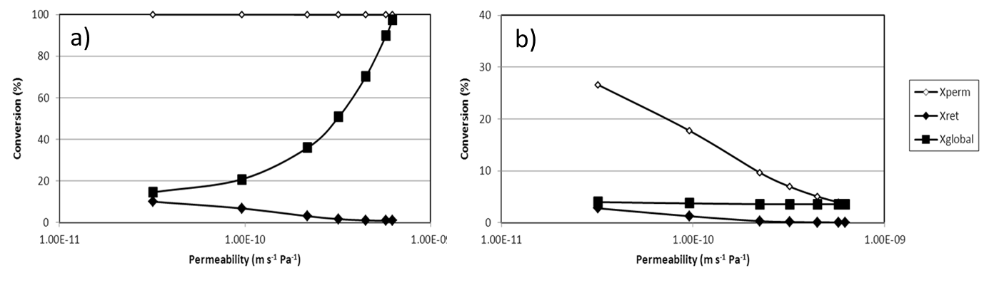Figure 1. Evolution of the conversion in function of the membrane permeability (tangential configuration) expressed as permeate, retentate and global conversions for (a) fast reaction kinetics (b): low reaction kinetics.
In the case (a), the high reaction rate allows a complete conversion of the permeate stream within the full proposed permeability. Differing to the case of a low reaction rate (b), the global performance of this reactor is strongly influenced by the membrane permeability: while very permeable membranes lead to very high total conversion, less permeable membranes improve the retentate conversion at the expense of the moderate global conversion.
4. Conclusions
An experimentally validated model was developed coupling the measured reaction kinetics with mass transfer. The model allowed the determination of the hydrodynamics and 3D concentration profiles in EMRs. It has been demonstrated that reaction kinetics has the greatest influence among all the analyzed variables. Almost total conversion in the permeate stream can be attained for the fastest reactions, while slow reactions suffer from irrelevant conversions. When the model was applied to the scale-up of EMRs for the DTC it has been demonstrated that EMRs are not really efficient for actual systems presenting relatively low reaction kinetics.
References
- M. De Cazes, M. Belleville, M. Mougel, H. Kellner, J. Sanchez-Marcano. J. Membrane Sci. 476 (2015) 476, 384-393.
- R. Abejón, C. Gîjiu, M. Belleville, D. Paolucci, J. Sanchez-Marcano. J. Membrane Sci. 473 (2014) 189-200.
- S. Ben Ameur, C. Gîjiu, M. Belleville, J. Sanchez, D. Paolucci. J. Membrane Sci. 455 (2014) 330-340.

