H₂-CCS Chain Tool and Evaluation Methodologies for Integrated Chains.

D. Iruretagoyena^{1,*}, N. Sunny¹, C. Antonini², R. de Kler³, N. Mac Dowell¹, N. Shah^{1,*}
¹ Department of Chemical Engineering, Imperial College London, South Kensington, London, SW7 2AZ, UK
² ETH Zurich, Institute of Process Engineering, Sonneggstrasse 3, CH-8092 Zurich, Switzerland
³ TNO Science and Industry, Leeghwaterstraat 46, 2628 CA Delft, The Netherlands

*Corresponding authors: n.shah@imperial.ac.uk, d.iruretagoyena09@imperial.ac.uk

Highlights
- An open-source design tool for a fully integrated H₂-CCS chain is developed
- Combining SMR, CCS and salt caverns enables to meet heating and CO₂ emissions regulations in the UK
- Dynamic behavior of a CCS plant shows smooth responses to SMR load ﬂuctuations
- Large flow fluctuations are not desirable for the compressor train operation

1. Introduction
Carbon Capture and Storage (CCS) is currently considered as the “most important technology” to decarbonize the industrial sector by the International Energy Agency (IEA). This technology can in principle be integrated with industrial process plants, separate out the carbon dioxide and transport it to a suitable location for long term underground storage. Similarly, hydrogen (H₂) will play an important role to decrease the carbon emissions from fossil fuel combustion, primarily due to its use as an ultraclean fuel in the heating and transportation sectors, as well as a process feedstock.^{[1]} Contrary to natural gas that produces about 180 gm/kWh CO₂, hydrogen emits no GHGs (at the point of use). However, steam reforming of methane (SMR) and coal gasification, which are currently considered to be the most feasible and economic routes to large-scale H₂ production, also produce significant quantities of CO₂.^{[2]} Therefore, it is crucial to develop strategic H₂-CCS infrastructure to meet the targets in the Paris 2016 Climate Agreement, which have resolved to reduce carbon emissions by over 80% by 2050.^{[3]} The ELEGANCY project enables the evaluation of integrated H₂-CCS chains with respect to technological and economic efficiency, operability and environmental impact. To this end, this contribution is focused on the development of an open-source systems modelling framework with a steady-state design mode and a dynamic operational mode. The methodology developed is applied to five national case studies: Netherlands, Switzerland, United Kingdom, Germany and Norway.
2. Methods
The modelling toolkit developed involves two modes: (1) Design mode: Steady state model where the user can explore the time evolution of system design (e.g. choice, scale and location of key technologies and network structure for H₂ and CO₂). For this purpose, we use the Resource-technology network (RTN) methodology, which integrates key elements such as space, time, resources, technologies, infrastructure/Networks to obtain optimal H₂-CCS configurations in terms of costs (CAPEX and OPEX). The Mixed Integer Linear Programming (MILP) models are developed using Python software. QGIS is used for geographical visualization. (2) Operational mode: This enables the user to simulate dynamic behavior of the designed system including intermittent operation. The ranges of key systems variables such as flowrate, temperature, pressure and impurity profiles are quantified. Different technologies for H₂ production are assessed including steam methane reforming and autothermal reforming. The models are developed using OpenModelica software and are compared to relevant ASPEN, gPROMS and Matlab codes.
3. Results and discussion
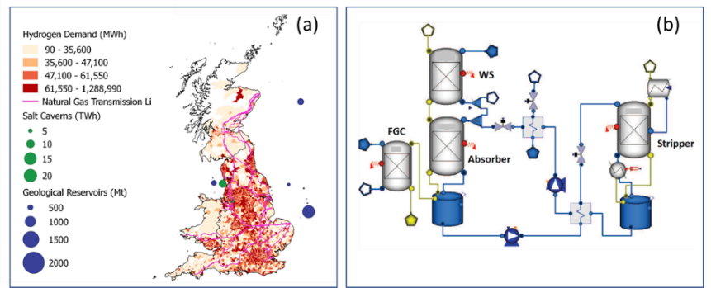
An open source H₂-CCS steady-state model based on the RTN framework has been successfully developed. The toolkit provides the location, type, number and capacities of process and storage technologies, the distribution infrastructure linking one region to another and the retrieval rates of all resources in the system in every location in the time horizon. Figure 1a shows an example of the implementation of the model to the UK as a case study. It is found that combining SMR with salt cavern technologies enables the production of sufficient amounts of H₂ to meet the heating demands in the UK. The integration of SMRs with CCS technologies is able to reduce the carbon emissions content from 180 gCO₂/kwh in natural gas to approximately 50 gCO₂/kwh from H₂, resulting in a 73% reduction in overall emissions.^{[4]} Regarding the operational mode, a dynamic model for integrated SMR-CCS processes is successfully developed. A scheme of the dynamic model of a CCS plant in OpenModelica is shown in Figure 1b. Some key results indicate that the CCS section has a smooth response to load ﬂuctuations of the SMR plant, and the required stabilization time of the CCS plant is closely related to its liquid residence time. Large flow fluctuations are not desirable for the compressor train operation. Simulations showed that a single compressor train with recycle valve surge control is able to meet the desired performance.^{[5]}

Figure 1. (a) Design mode, H₂-CCS, UK Case study. (b) Operational mode, Dynamic model of CCS plant.

4. Conclusions
In this study, we describe an open-source system modelling framework with a steady-state design and a dynamic operational modes that has been developed in the Elegancy project. The modelling toolkit is applied to five national case studies providing particular strategies to implement efficient H₂-CCS networks. The results obtained for the UK case study are relevant to accelerate implementation of the low-carbon gas network for Leeds.

References
- R. Anantharaman, et al., Hydrogen production with CCS, Int. J. Hydrog. Energy, 41 (2016) 4969-4992.
- N. Shah, et al., Optimal transition towards a large-scale hydrogen infrastructure for the transport sector: The case for the Netherlands, 36 (2011) 4619-4635.
- Committee on Climate Change, Next steps for UK heat policy, (2016).
- H21 North of England, H21 NoE Report/2018
- R. de Kler et al., Dynamic behaviour CO₂ capture and compression: an assessment, Energy Procedia, 63 (2014) 2727-2737.

