Particle generation process by crystallization : a multiscale approach.
Béatrice Biscans
Laboratoire de Génie Chimique CNRS/INP/UPS
Toulouse FRANCE
*Corresponding author: beatrice.biscans@ensiacet.fr
Crystallization science and engineering workshop organized by EFCE Working Party on Crystallization

Crystallization is a separation and purification process used in the production of a wide range of materials. Many aspects of industrial crystallization have been developed in the past years and have a good scientific basis. Recent developments are in progress such as isolation of polymorphs and resolution of enantiomeric systems, molecular modelling, effect of added impurities on the crystal growth process, use of computed aided fluid dynamic modelling or new methods for crystal characterization. However, new challenges arise from new industrial needs. These developments create research on complicated substances such as drugs or proteins in complicated or new solvents or multi-phase systems and lead to consider what is called “complex media”.
This presentation gives some examples of crystallization in complex media. Different reactor scales are used as generic tools studying crystal nucleation and growth.
Scale 1: an original microfluidic device was developed for investigating nucleation rate, growth kinetics, and phase transition of organic crystals in organic solvents (1,2) . This set-up allows to store up to 2000 small crystallization containers (20 to 100nL) and to control precisely their temperature and supersaturation. The case of eflucimibe showing two polymorphs and ibuprofen,in different organic solvents are studied. We believe that this microfluidic system gives new opportunies to study nucleation and phase transition of complex materials.

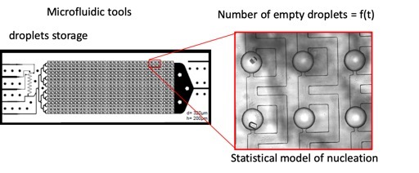

Scale 2: in a batch reactor the effect of additives on crystal growth is difficult to study because of the supersaturation evolution. We propose to adapt the constant composition (constant supersaturation) method in a semi-batch reactor, to compare the effect of several additives (3). This study provides insights on the mechanisms governing the inhibition CaCO₃ crystallization at local scale, and enable to benchmark several additives.
Scale 3: transposition of the kinetics laws obtained are made at industrial scale with respect to changes in operating conditions. Observations at lab-scale allows to propose laws for governing mechanisms and explains the trends observed at pilot-plant scale.
References
- VITRY Y., TEYCHENE S, CHARTRON S., LAMADIE F., BISCANS B.
Investigation of a microfluidic approach to study very high nucleation rates involved in precipitation processes. Chem. Eng. Science, 2015, vol.133, pp. 54-61.
- BOURGEOIS F., TEYCHENE S., BISCANS B.
Applicability of probabilistic nucleation modelling for analysis of microfluidics data
KONA Powder and Particle Journal, 2018, n°35, pp. 258-272
- CHHIM N., KHARBACHI C., NEVEUX T., BOUTELEUX C., TEYCHENE S., BISCANS B.;
Inhibition of calcium carbonate crystal growth by organic additives using the constant composition method.
Journal of Crystal Growth, 2017, Vol. 472, pp. 35-45

