Enhancing the Thermal Efficiency of Hydrogen Compressor
by the use of LOHC Falling film.
Arian Shoshi¹*, S. Ehsan Emamjomeh¹, Eberhard Schlücker¹
1 Institute of Process Machinery and Systems Engineering, Friedrich-Alexander-Universität Erlangen-Nürnberg (FAU)
*Corresponding author: arian.shoshi@fau.de
Highlights
- Transient CFD Simulations for compressing hydrogen gas.
- LOHC falling film investigation inside compressor chamber.
- Optimizing LOHC layer for the increase of volumetric efficiency.

1. Introduction
Liquid Organic Hydrogen Carriers (LOHCs) are chemical compounds, which they store hydrogen by bonding it chemically during the hydrogenation process in chemical reactors. The hydrogenation process to take place, heat, is required relatively to high temperatures at elevated pressures. The release of hydrogen during the dehydrogenation process requires more energy in terms of heat at even higher temperatures. By compressing hydrogen gas to very high pressures up to 1000 bar in hydrogen compressors, very high discharge temperatures are reached since the compression process undergoes close to the adiabatic process. The generated heat during the compression in the most cases is wasted to the surrounding. The current research represent an approach for using this heat. LOHCs are stable in liquid state up to 300 °C and there is no risk in vapor formation. Therefore, they offers an excellent use as a cooling liquid in hydrogen compressors, in this way improving the thermal efficiency and the volumetric efficiency of the compressor. The new prototype of this compressor designed at Institute of Process Machinery and Systems Engineering is currently carrying out the first tests with very promising results.
2. Methods
The described compressor is a plunger type operating always upward and use a LOHC falling film as coolant liquid formed along at the inner walls of compressor chamber for absorbing the compression heat. The flow of falling film from the top to bottom dead center of the compressor form a LOHC layer above the front end of the plunger. This LOHC layer has a crucial role in preventing hydrogen to leak outside the compressor chamber. Falling film ensures cooling of the walls in order to avoid also the heating of hydrogen gas brought during the suction phase. Beside this, LOHC liquid level above the plunger in a significant way decrease the detrimental space, by filling this clearance between the compressor head and the piston, which is left in order to prevent the mechanical collusion. The detrimental space therefore is nearly “zero”. A thin layer of the hot LOHC together with the compressed hydrogen by the end of the stroke is discharged in the separator, for separating hydrogen form LOHC. Hot LOHC afterwards follows the dehydrogenation process in reactor. The high-pressure hydrogen can be used wherever is required but the best example of use is in mobility since the LOHCs plays an important role in hydrogen logistic as well. This compressor is an important component of a new hydrogen storage system or hydrogen transport system for making the hydrogen available with high pressures and without wasting energy in terms of heat. For better understating and validating the results, in parallel simulations and experimental tests are investigated. For observing the behavior of LOHC falling film and optimizing the LOHC layer, a Plexiglas cylinder same as the real compressor chamber were used. The figure 1 shows formation of the LOHC layer above the plunger
3. Results and discussion
Ongoing research represent results only for the transient state operation. Due to the safety issues, for the early phase, nitrogen gas and loaded LOHC is used during the all experiments. Until now, pressures up to 630 bar are reached with one stroke starting from 2 bar absolute pressure. The presented compressor is driven with a hydraulic unit at relative low velocities starting from 10-40mm/s. The results depicted in Figure 2 shows a temperature rise of nitrogen gas above 110 °C by 630 bar. Compressing a diatomic gas such as nitrogen, hydrogen, undergoing an adiabatic process from 1 bar (abs) to 1000 bar, results in temperature rise of gas above 2000 K.
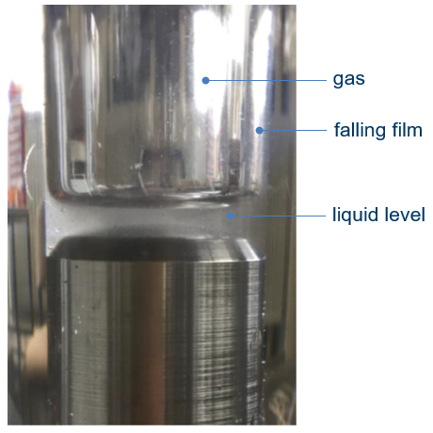
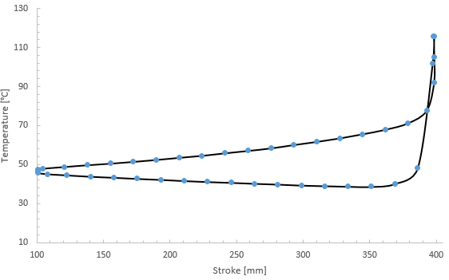
Figure 1. LOHC Falling film. Figure 2. Temperature rise of nitrogen gas during compression up to 630bar.
4. Conclusions
This conceptual research describes a way of internal cooling of a hydrogen compressor for enhancing the thermal efficiency. Currently are running tests still with nitrogen for the higher pressures and as long it is reached a safe and a stable state hydrogen will be used. Thereafter, the validation of the data take place to justify the thermal efficiency.
References
- O. Singh, Applied Thermodynamics, third ed., 2009.
- I.L. Spain, J. Paauwe, High Pressure Technology, Vol. 1, New York and Basel, 1977.
- R. N. Brown, Compressors: Selection and Sizing, third ed., Elsevier, 2005
- Th. Bergman, A. Lavine, F. Incropera, D. Dewitt, Fundamentals of Heat and Mass Transfer, John Wiley & Sons, 2011

