CFD-DEM Simulation of The Breakup of Carbon Black Agglomerates in an Internal Mixer.
Graziano Frungieri¹, Gianluca Boccardo¹, Antonio Buffo¹, Daniele Marchisio¹, Marco Vanni¹
¹ Dept of Applied Science and Technology, Politecnico di Torino, Corso Duca degli Abruzzi 24, Torino
*Corresponding author: graziano.frungieri@polito.it
Highlights
- Novel approach for modelling the compounding of rubber materials.
- CFD simulation of an internal mixer for rubber compounding.
- Stokesian Dynamics of carbon black agglomerates.

1. Introduction
The compounding of rubber materials frequently requires the incorporation of solid filler particles, in order to enhance the mechanical properties of the final product. Carbon black particles are among the most commonly used; they generally exist in the form of large agglomerates (up to hundreds of micrometers) which, during the mixing process, are broken down into smaller fragments and uniformly distributed into the rubber matrix.
Previous studies have generally focused on the investigation of the flow field in the mixing equipment and only few attempts have been made in the analysis of the breakup behavior of the agglomerates, with most of them adopting severe simplifications on the aggregate morphology and the breakup mechanism [1].
In this work we adopt a numerical approach which couples a computational fluid dynamics (CFD) simulation of the flow field in a typical mixing equipment with detailed Discrete Element Method (DEM) simulations, able to fully count for the agglomerate morphology and to predict accurately the occurrence of breakup.

2. Methods
A 2D section of an actual rubber internal mixer has been used for the current investigation. The flow field inside the mixing equipment is computed using the open-source CFD code Code_Saturne. The rheology of the rubber medium is modelled according to the Bird-Carreau model. At this stage, agglomerates are treated as point particles, whose trajectories are recorded together with the viscous stress experienced during the motion.
This piece of information is used by a DEM code built in the framework of the FTS (force-torque-stresslet) formulation of Stokesian Dynamics [2]. At this stage the disordered structure of the agglomerates is modeled in detail; the DEM is thus able to evaluate the hydrodynamic forces acting on each constituent monomer and to evaluate the internal stress acting on each single intermonomer contact, in terms of normal force, transverse force and bending moment. The occurrence of breakup can be then readily determined by comparing the internal stresses with the single bond resistance.
3. Results and discussion
Figure 1 shows an overview of the simulation results. In the top figure a snapshot of the instantaneous velocity contour plot is reported. As expected, the regions of highest shear are located in the narrow gap between the rotor tip and the chamber wall. The bottom left figure reports the intensity of the hydrodynamic force acting on each single monomer. It is apparent that larger forces act on the most external monomers. On the contrary, inner monomers experience lower hydrodynamic forces because of the screening effect induced by the surrounding ones. However, the most stressed bonds are generally located in the inner parts of the agglomerate (bottom right figure); this is in line with the expectation that the stress induced by the flow field propagates from the peripherical to the internal region of the agglomerate and accumulates in some critical locations. [3]
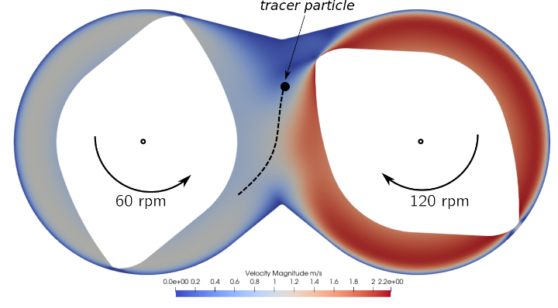
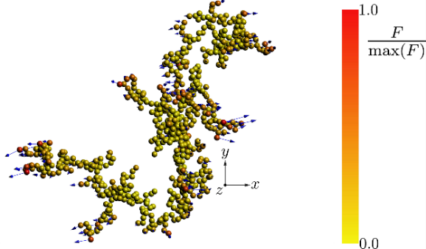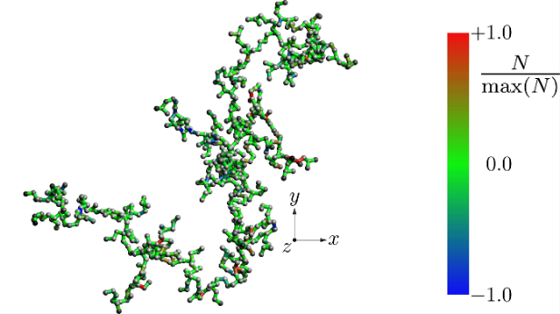
Figure 1. (top) Instantaneous velocity contour plot in a 2D section of an internal mixer. The gap between the rotor tip and the chamber wall is 1 cm wide. (bottom left) Instantaneous hydrodynamic forces acting on a model carbon black agglomerate. The agglomerate has fractal dimension equal to 1.7 and gyration radius equal to 30 micrometers. (bottom right) Instantaneous normal stress acting on the monomer-monomer bonds. Positive values indicate tensile stress.
4. Conclusions
In this work a combined CFD-DEM approach is adopted to investigate the compounding process of rubber composites. Results provide new insights into the breakup mechanism and may be useful for the design and the choice of operative conditions of internal mixers.
The project leading to this application has received funding from the European Union’s Horizon 2020 research and innovation programme under grant agreement No 760907.
References
- I. Manas-Zloczower, Mixing and compounding of polymers: theory and practice, second ed., Hanser Publishers, Munich, 2009.
- G. Frungieri, M. Vanni, Can. J. Chem. Eng. J. 95 (2017) 1768-1780.
- M. Vanni, A. Gastaldi, Langmuir 27 (2011) 12822-12833.

