Synthesis and Gas Adsorption Properties of Hypercrosslinked Styrene-based Polymer for CO₂ capture
Kateřina Setničková¹*, Karel Jeřábek¹, Tomáš Strašák¹, Petr Uchytil¹
1 Institute of Chemical Process Fundamentals of the CAS, v. v. i., Department of Bioorganic Compounds and Nanocomposites, Rozvojová 2/135, CZ-165 02 Prague 6 – Suchdol, Czech Republic
*Corresponding author: setnickova@icpf.cas.cz
Highlights
- Hypercrosslinked styrene-divinylbenzene porous material have been prepared.
- The resulting porous network exhibited the high surface area around 800 m²/g.
- The CO₂/H₂, CO₂/N₂ selectivity of the polymer were 22 and 5 at 298 K, respectively.
- Promising material for mixed matrix membranes preparation usable to gas separation.

1. Introduction
The continuous and increasing release of carbon dioxide to the atmosphere due to human activities, being damaging to the environment and the earth, has initiated considerable interest in the development of new materials and technologies for CO₂ capture. To date, a cheap alternative solution to effective CO₂ capture has been developed by design and synthesis of microporous organic polymers (MOPs) categorized into four classes according to the types of organic reactions and the chemical structures [1]: polymers of intrinsic microporosity (PIMs), hypercrosslinked polymers (HCPs), conjugated microporous polymers (CMPs), and covalent organic frameworks (COFs). These organic porous materials generally possess low skeletal density, in which the precise control over the material’s chemical composition and textural properties can lead to a signiﬁcant enhancement in gas storage. In this study, we report on the synthesis of hypercrosslinked styrene-divinylbenzene microporous material and its application for CO₂ capture, gas separation.
2. Methods
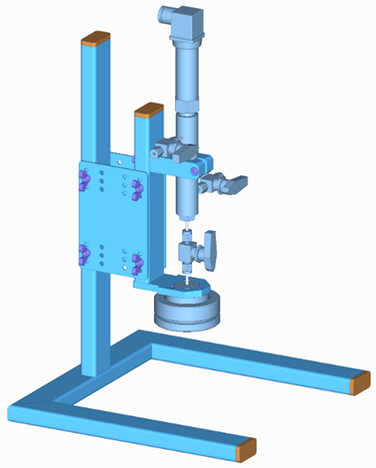
The gas adsorption ability in new materials was determined using an apparatus based on the volumetric method. Simplified, the weighted amount of sample was placed in the adsorption chamber and evacuated. Then the chamber is filled with a gas at a certain pressure, the pressure value inside apparatus was monitored by computer. The pressure decrease corresponded to the adsorption of gas in the studied material.

Figure 1. Design of the experimental apparatus for gas adsorption capacity measurement in materials.

After reaching the equilibrium the pressure is subtracted and used to determination of absorbed amount of gas in material. The constant temperature of the whole system during the absorption experiment was provided by a heated box.
3. Results and discussion
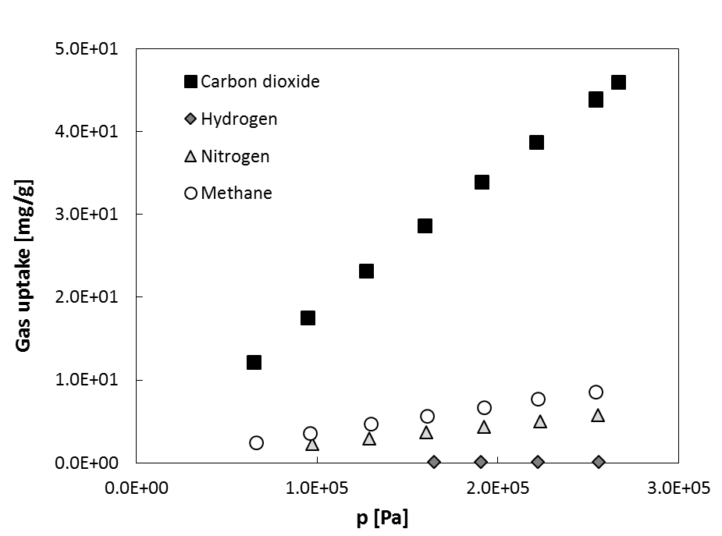
The results of adsorption capacities measurement of synthetized hypercrosslinked styrene-divinylbenzene microporous polymer for four tested gases is depicted in Fig.2.
Figure 2. Gas adsorption isotherms in tested material.

4. Conclusions
The synthesis, characterization, and the CO₂ adsorption performance of new hypercrosslinked styrene-divinylbenzene based polymer exhibiting a high apparent surface area and very good sorption properties is reported in this study.
References [Calibri 10]
- YL. Luo, BE. Tan, Porous Materials for Carbon Dioxide Capture Book Series: Green Chemistry and Sustainable Technology (2014) 143-180.
- P. Veverka, K. Jeřábek, React. Funct. Polym. 41 (1999) 21–25.

