Hydrophilic and hollow nanocubes functionalized thin film nanocomposite membrane with enhanced nanofiltration performance
Zhipeng Liao, Jiansheng Li
Affiliation and address: Nanjing University of Science and Technology, Nanjing 210094, P.R .China
*Corresponding author: lijsh@njust.edu.cn
Highlights
- Hydrophilic hollow nanocubes (HHNs) nanofillers were obtained by etching ZIF-8 with tannic acid.
- HHNs were incorporated into the polyamide layer to form thin film nanocomposite (TFN) membranes.
- The prepared TFN membranes exhibit improved permeability and antifouling performance.
- The enhanced performance stems from the structural and compositional characteristics of the incorporated nanofillers
1. Introduction
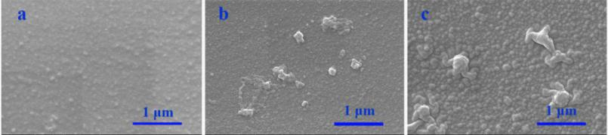
Nanofiltration has prevailed in water desalination, and is mainly applied to the removal of divalent salts. However, the application of nanofiltration membrane is limited by the intrinsic defects, such as low permeability and poor antifouling property. Incorporation of nanoparticles into the selective layer of composite membrane is an ideal strategy to resolve the dilemma. The structure and composition of nanoparticles are detrimental to the performance of the fabricated composite membrane. Herein, hydrophilic and hollow nanocubes (HHNs) were prepared and incorporated into the selective layer of the composite membrane. The fabricated composite membrane presents excellent permeability, selectivity as well as antifouling property.
ZIF-8
HHNs
Zn(NO₃)₂
CTAB
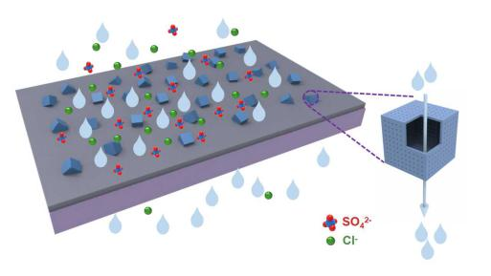
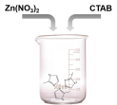
TA
etching

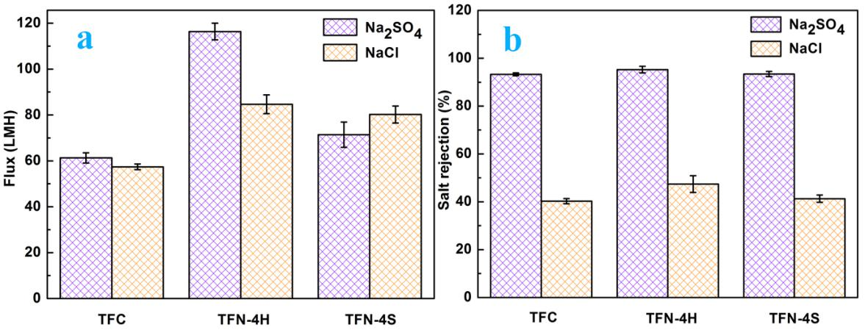
Figure. 2 SEM images of various membranes: TFC (a), TFN-4H (b) and TFN-4S (c) .

Figure. 3 Performances of various membranes: water flux (a) and salt rejection (b) tested with 1 g/L Na₂SO₄ and NaCl solution at ambient temperature and 6 bar.
Figure. 1 Schematic diagram of the TFN-4H membrane.

2. Methods
Hydrophilic and hollow nanocubes were prepared by etching hydrophobic zeolitic-imidazolate-framework-8 (ZIF-8) using tannic acid. 0.04 wt% HHNs was added to the organic phase and introduced into the selective layer of the nanofitration membrane via interfacial polymerization, the prepared nanocomposite membrane was denoted as TFN-4H (Figure. 1). To highlight the influence of the structure and composition of nanofillers to the performance of composite membrane, equal dose of solid and hydrophobic ZIF-8 was incorporated into the selective layer, the final membrane was denoted as TFN-4S. The filtration performances of the fabricated composite membranes were investigated by Na₂SO₄ and NaCl solution. Meanwhile, the antifouling properties of the composite membranes were studied using humic acid and bovine albumin as the simulated pollutants.
3. Results and discussion
As shown in Figure 2, more and larger nodular structures present on the surface of the composite membranes after the introduction of nanofillers into the selective layer. Besides, there are some incorporate nanofillers exist on the membrane surface. The observed nanofillers are embedded in the selective layer of the composite membranes. It can be concluded from Figure 3, the permeabilities and selectivities of composite membranes modified by nanofillers are better than that of the control membrane. Moreover, the performance of the TFN-4H membrane is much better than that of the TFN-4S membrane. With the introduction of HHNs, the flux and Na₂SO₄ rejection of the TFN-4H membrane increased up to 116.4 L/(m²·h) (LMH) and 95.24 %, respectively. However, the flux and Na₂SO₄ rejection of the TFN-4S membrane only increased to 71.6 LMH and 93.4 %, respectively. In addition, the TFN-4H membrane presents excellent antifouling property. Oppositely, the antifouling property of TFN-4S membrane is undesirable and even poorer than the control membrane.

Figure. 4 Time-dependent relative water flux of various membranes tested with 1 g/L Na2SO4 and 1 g/L Na2SO4 + 1 g/L HA solution (a) and 1 g/L Na2SO4 and 1 g/L BSA solution (b) at ambient temperature and 6 bar.

4. Conclusions
The incorporation of HHNs significantly enhanced the permeability and selectivity of the nanocomposite membrane. Compared with the solid and hydrophobic ZIF-8, the prepared hollow and hydrophilic HHNs are more favorable for the improvement of the membrane performance. More importantly, the introduction of HHNs elevated the antifouling property of the composite membrane.
References
- J. Zhu, L. Qin, A. A. Uliana, et al, ACS Appl Mater Interfaces, 9 (2017) 1975-1986.
- R. R. Choudhury, J. M. Gohil, S. Mohanty et al, J. Mater. Chem. A, 6 (2018) 313-333.
- Z. Liao, X. Fang, J. Li, et al, Sep. Purif. Technol, 207 (2018) 222-230.

