A wind tunnel method to develop products for controlled delivery of volatiles: experimental apparatus and mathematical model.
Fernando Bernardo*, Rita Chim, Mara Braga
CIEPQPF, Department of Chemical Engineering, University of Coimbra
Rua Sílvio Lima, Pólo II, Pinhal de Marrocos, 3030-790 Coimbra-Portugal
*Corresponding author: bernardo@eq.uc.pt
Highlights
- Method to test/develop products that release volatile active ingredients
- Application to a product releasing an insect attractant compound
- Method semi-validated with first set of assays; further validation is needed
- Useful to assess different product concepts and optimize formulation
1. Introduction
The release of a volatile active ingredient (AI) is a key functionality in a wide range of products, including personal care products, home fragrance products and insecticides. The method here presented was motivated by the development of a product releasing an AI that strongly attracts a particular insect (the beetle Monochamus galloprovincialis), known to be the main vector of the pinewood nematode, which in turn is responsible for the pine wilt disease [1]. The product should be active for several days (or even weeks) and up to a certain distance from the source. Product testing will be done in three stages: lab tests without insects, lab tests with insects and finally field tests (in the pine forest).
The method here described applies to the first stage tests where the goal is to evaluate AI concentration in the surrounding air resulting from a given product formulation, as a function of time and distance from the product. For that purpose, the product is tested in a wind tunnel and AI concentration measured downstream of the product. Complementarily, a mathematical model of AI transport is setup and solved, aiming at producing useful estimates to plan further tests and thus accelerate product optimization. The results from this stage, together with the known threshold concentration (above which attraction effect is significant), will be used to design the second stage tests, where the insect response will be monitored in a larger wind tunnel system.
2. Methods
Figure 1 shows a sketch of the cylindrical wind tunnel. The product is placed on the tunnel axis, 1 meter away from the entrance, where the air fan is located. In the base case here considered, the product is a small porous cylinder composed of an inert polymer (polycaprolactone) loaded with AI (α-pinene). The concentration of AI is measured through adsorption fibres that are first exposed to the flowing air until saturation (which is fast), and then analysed by SPME-GC-MS (details of the procedure and its calibration are not here described). The duration of this analysis only allows the use of four fibres at a time. The four selected positions P, in cylindrical coordinates (z,r), are: P1(0.25,0.085), P1’(0.25,0.035), P2(0.50,0.085) and P3(0.75,0.085) (values in meters; the product is at the origin (0,0)). The concentration in these four points is measured at different times after the beginning of the assay.
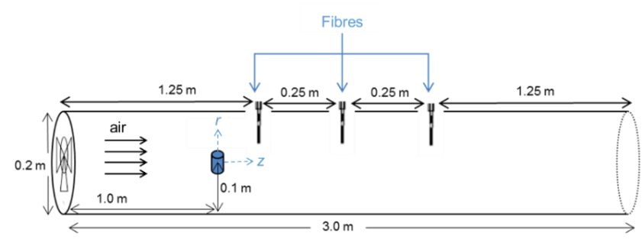
The AI transport model comprises two components: A) release from the cylindrical product (internal diffusion with effective coefficient Di, partitioning at the air/product interface with coef. K, convective transfer to the surrounding air); B) axial and radial dispersion along the tunnel (coefs. Dz and Dr), and axial advection with the cross-section mean velocity (u). Model A has a well-known analytical solution, available in classical textbooks. Model B (with the source at z=0 approximated to a disk) also has analytical solution [2], but we have derived an equivalent one, using simpler methods. The dynamics of transport B is much faster than that of transport A (a few tens of seconds compared with several days). A pseudo-steady-state is then assumed for transport B, resulting in an overall model A+B for which we have derived an analytical solution (and this is a new contribution). The main model parameters are the ones above mentioned (Di, K, Dz, Dr and u). Di was previously determined based on AI release tests under quiescent air, and for the base case here considered is (0.72±0.21)×10⁻⁹ m²/s. Initial estimates for the other parameters are: K₀=330 (from AI vapour pressure and Flory-Huggins model), u₀=0.38 m/s (from the fan specifications), Dz₀=0.026 and Dr₀= 0.00017 m2/s (for fully developed turbulent flow in a pipe).
Figure 1. Wind tunnel.
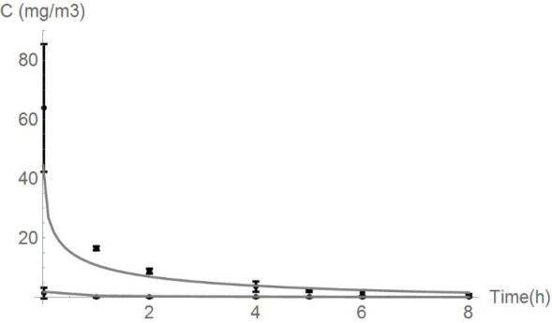
3. Results and conclusions
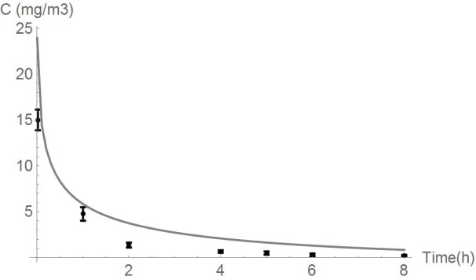
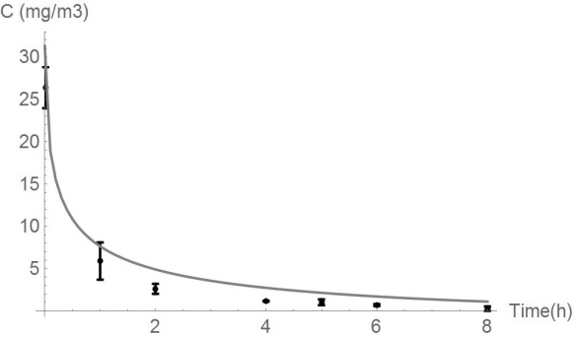
Figure 2 shows experimental results and the best fit of the model, obtained with K=23K₀, u=1.9u₀, Dz=0.12Dz₀ and Dr=8.0Dr₀. The fit is good for points P1 and P1’, and not so good for further away points P2 and P3. The model still needs to be improved in order to produce reliable estimates of low concentrations far from the source (e.g., the air flowrate should be directly measured, thus revealing the true value of u). After these improvements, we believe the model may provide valuable guidance in product development (e.g., making predictions for other AIs and for alternative product formulations).
Figure 2. Measured AI concentrations (discrete points) and model predictions (continuous curves).
P1
P1’
P3
P2
References
- P. N. Calvão et al., Forest Ecology and Management 389 (2017) 105-115.
- J-S Chen et al., Journal of Hidrology 405 (2011) 522-531.

