Solketal purification by Supercritical Fluid Simulated Moving Bed technology
Pedro M. Walgode, Rui P. V. Faria, Alírio E. Rodrigues
LA LSRE-LCM, Department of Chemical Engineering - FEUP – University of Porto
Rua Dr. Roberto Frias, s.n., 4200-465 Porto, Portugal *Corresponding author: pwalgode@fe.up.pt
Highlights
- Adsorption experiments using HBEA-25 as adsorbent and ScCO₂ as eluent.
- $k_{ads}$, $Q_{sat}$, $k_{L}$ estimated using acetone, solketal and water pulse perturbations data.
- Water and solketal separation using a four zones SF-TMB.
- Solketal productivity of 8 kg/L·day at 150 bar, 353 K and 99% purity outlet streams.
1. Introduction
Increasing world’s biodiesel production is leading to the accumulation of crude glycerol, a reaction byproduct with almost no economic value. A glycerol valorization route is reacting it with acetone over an acid catalyst, yielding water and 2,2-dimethyl-1,3-dioxolane-4-methanol (solketal) with almost full selectivity. Solketal is a high added value product and is considered a green fuel additive¹. Solketal industrial production is not yet economic viable, and despite the scientific community efforts, almost no work was found concerning solketal separation process. In this work, supercritical CO₂ (ScCO₂) is proposed as an efficient and environmental friendly separation eluent for solketal separation process from water and unreacted acetone, to overcome equilibrium and mass transfer problems. ScCO₂ is cheap, safe, nontoxic, nonflammable, its critical point is readily attainable, has well-established industrial use and it is easily separated and recycled by depressurizing the system below CO₂ critical point²⁻⁴. The aim of this work is to design a supercritical fluid simulated moving bed (SF-SMB) to separate solketal from water, using a high water affinity HBEA-25 zeolite as adsorbent. For that, a supercritical fluid true moving bed supercritical (SF-TMB) was simulated using data obtained by single solute pulse experiments with ScCO₂ as eluent in a supercritical chromatographic fixed bed column (SF-FBC), under different operating conditions.
2. Methods
Mono component pulse perturbations at the inlet concentration were performed using ScCO₂ as eluent and zeolite HBEA-25 (from Süd-chemie, SiO₂/Al₂O₃ molar ratio of 25:75, particle diameters between 600 and 1180 nm) as adsorbent in a SF-FBC with dimensions 4 x 125 mm, bulk porosity of 0.438, particle porosity of 0.326 and total volumetric flow of 2 mL min⁻¹. A SF-FBC model was developed in gPROMS software assuming: plug flow model with axial dispersion and isothermal process and the adsorption is described by Langmuir competitive equilibrium isotherm model. The model was used to adjust the experimental pulse data, allowing the estimation of the Langmuir adsorption isotherm parameters, $k_{ads}$ and $Q_{sat}$, and overall mass transfer coefficients, $k_{L}$. SF-TMB process was designed and optimized through numerical simulations using the data obtained and estimated for SF-FBC.
3. Results and discussion
Water solketal and acetone mass transfer coefficients and the adsorption isotherm parameters were estimated three different conditions: 150 bar and 313 K; 150 bar and 353 K; and 200 bar and 313 K (Figure 1 a) to c)). As expected, water presented the highest retention times, independently of the conditions tested. The SF-FBC model was able to accurately describe the experimental results obtained for the water, solketal and acetone pulse experiments.
A four zone SF-TMB was optimized through a simulation study for the three operating conditions, using columns similar to SF-FBC (except for the length, which was set to 37.5 cm) and considering the following parameters: safety factor of 0.4, solid flow velocity of 3.75 cm min⁻¹, raffinate and extract purity above 99 %. The best separation performance was achieved operating at 150 bar and 353 K (Figure 1 d)). A solketal productivity of 8.4 kg/L_{Ads}·d and an eluent consumption of 99.9 L_{Des}/kg_{solk} were estimated.
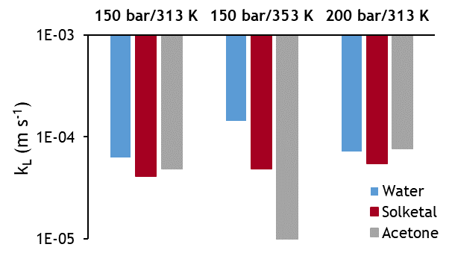 | 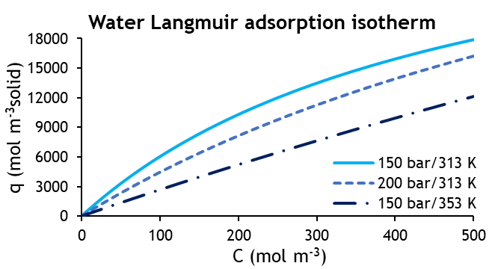
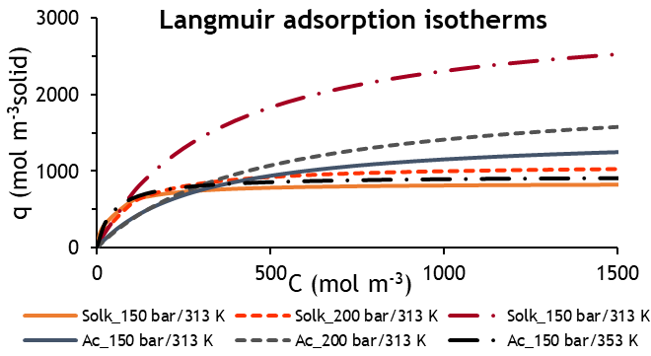 | 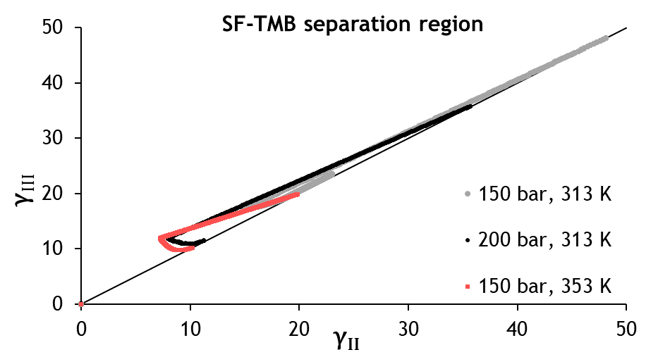
Figure 1 – a) Water, solketal and acetone estimated $k_{L}$. b) Water, c) solketal and acetone Langmuir equilibrium adsorption isotherms using the estimated $K_{ads}$, $Q_{sat}$ at the three operating conditions, d) SF-TMB separation regions.
4. Conclusions
Through the present work it was possible to estimate $k_{L}$, $K_{ads}$ and $Q_{sat}$ for water solketal and acetone using SF-FBC pulse experiments. A four-zone SF-TMB unit was simulated, and the optimum operating conditions were found at 150 bar and 353 K. The zeolite HBEA-25 is also a strong acid catalyst for glycerol ketalization into solketal and its dehydration properties may overcome reaction equilibrium limitations by adsorbing water from the reaction media, allowing a possible future process intensification with reaction and separation in the same unit, such as a reactive SF-SMB.
References
[1] Nanda, M. R.; Zhang, Y.; Yuan, Z.; Qin, W.; Ghaziaskar, H. S.; Xu, C. C., Renewable and Sustainable Energy Reviews 2016, 56, 1022-1031.
[2] Majewski, W.; Valery, E.; Ludemann‐Hombourger, O., Journal of liquid chromatography & related technologies 2005, 28 (7-8), 1233-1252.
[3] dos Santos, B. A. V. Process Intensification in the Synthesis of the Green Chemical Dimethyl Carbonate. Department of Chemical Engineering, Faculty of Engineering, University of Porto, Portugal, 2014.
[4] Puiggené, J.; Larrayoz, M.; Recasens, F., Chemical Engineering Science 1997, 52 (2), 195-212.

