Experimental and numerical study of a radial multi-zone vortex chamber spray dryer
Thomas Tourneur¹, Axel de Broqueville¹, Anton Sweere², Albert Poortinga², Anton Wemmers³, Umair Jamil Ur Rahman⁴, Artur Pozarlik⁴, Juray De Wilde^{1,5*}
1. Université Catholique de Louvain, Material & Process Engineering, Louvain-la-Neuve, Belgium
2. FrieslandCampina Research, Wageningen, The Netherlands
3. Energieonderzoek Centrum Nederland, Petten, The Netherlands
4. University of Twente, Laboratory of Thermal Engineering, Enschede, The Netherlands
5. Institute for Sustainable Process Technology, Amersfoort, The Netherlands
*Corresponding author : juray.dewilde@uclouvain.be
Highlights
- High-G spray drying intensification
- New radial multi-zone vortex chamber design
- Experimental and numerical study of the flow pattern and drying behavior
- Distinct temperature separation and short particle residence time in the hot zone allows efficient 2-step drying using hot (350°C) air without burning produced milk powder

1. Introduction
Vortex chambers introduce process gas via tangential inlet slots over the entire length of the cylindrical vortex chamber and evacuate the gas via a chimney in one of the end plates of the vortex chamber. A strong rotational flow is generated, allowing high-G operation. The latter intensifies interfacial mass, heat and momentum transfer by easily one order of magnitude and also facilitates the use of fine particles [1]. In previous studies, application to particle drying [2,3] and fine particle coating [4] was demonstrated. Applications taking advantage of the very short gas-solids contact time and combining high-G intensified gas-solids contact, gas-solids separation and solids segregation were also studied [5].
In the present work, a specific design called the radial multi-zone dryer (RMD) [6] is experimentally and numerically studied. Application to spray drying is focused on, characterized by dilute operation and very strong rotational flows. Two distinct temperature zones are created without physical barrier, a radially central zone where hot air with a temperature up to 350°C is injected and a peripheral zone where air at a temperature of around 100°C is injected through the vortex chambers (Figure 1). The proposed multi-zone operation allows significant process intensification while preventing degradation of the product. Liquid droplets are injected in the hot central zone, co- or counter-current with the hot air. Fast initial drying is achieved in this zone while burning the product is prevented by rapid evacuation of the produced particles to the colder periphery under the action of the centrifugal force generated by the vortex chamber(s). Typical residence time of the particles in the hot zone can be limited to a few milliseconds. Drying is continued in the colder periphery where high-G operation intensifies interfacial mass, heat and momentum transfer and ensures efficient gas-solids separation.
2. Methods
The experimental set-up that was used is flexible and allows studying various multi-zone concepts, varying the dimension/design of the different zones and the type of spray nozzle. Extension chambers allowing to minimize air consumption and to optimize gas-solids separation can be added. Tests were carried out with total air flow rates of maximum 1000 Nm³/h, liquid flow rates of up to 6 g/s and hot air temperatures of maximum 350°C. Both hollow-cone and full-cone nozzles were tested. Three types of experiments were carried out: (i) in the absence of liquid injection, (ii) injecting water, and (iii) injecting milk. The axial and radial temperature profiles in the device were measured by means of 16 thermocouples. Comparison of the profiles in the three types of experiments and visual observations allowed gaining understanding in the complex flow pattern of the gas and droplets and the extent of evaporation in specific regions. Deposition of powder on the walls and in the gas and solids outlets was also carefully analyzed. Protection of the nozzle from fouling required a new protective sleeve design. To gain further insight in the flow pattern, CFD simulations were carried out, adopting the RANS-approach and a coarse-grained discrete particle model to track the motion of the droplets. Evaporation was accounted for and the behavior of droplets of different size studied.

3. Results and discussion
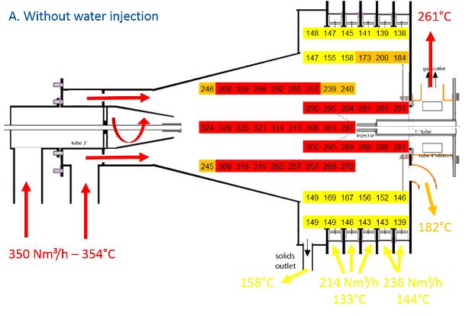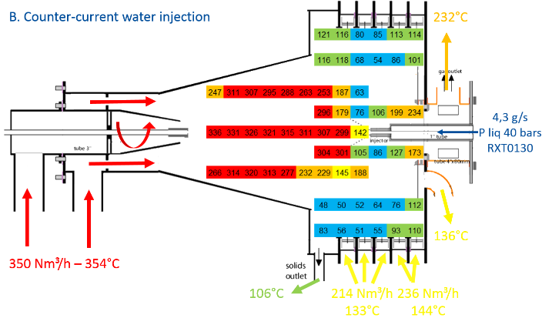Figure 1. Measured temperature profiles in a radial multi-zone vortex chamber spray dryer with and without water injection.
The droplet/particle trajectories could be tracked by comparing detailed temperature measurements in the absence and presence of water injection (Figure 1) and by means of the CFD simulations. With a counter-current configuration (Figure 1), an S-shaped particle trajectory was observed. Radial multi-zone operation and mastering the axial motion of the gas and droplets/particles and the related residence times in the different zones remains challenging. Fouling also needs to be addressed. Promising results were obtained with an optimized radial multi-zone dryer design with a full cone nozzle and high-quality powder could be produced. Distinct separation of the two temperature zones was confirmed and could be maintained in the presence of droplets/particles (Figure 1), allowing efficient 2-step drying of the powder. A counter-current configuration (Figure 1) was found to be more efficient than a co-current configuration. Protection of the nozzle tip from fouling required a new protective sleeve design.

4. Conclusions
Experimental studies and CFD simulations of spray drying in a radial multi-zone spray dryer show that the technology is feasible and promising for intensified two-step drying. Efficient separation of a hot central zone and cold periphery and an extremely short residence time of the droplets/particles in the central hot zone can be achieved. As a result, using 350°C hot air, high-quality milk powder could be produced. A full cone nozzle was shown to be more efficient and stable than a hollow cone nozzle, especially with counter-current injection of hot air.
References
- Axel de Broqueville, Juray De Wilde, Numerical investigation of gas-solid heat transfer in rotating fluidized beds in a static geometry, In Chemical Engineering Science, Volume 64, Issue 6, 2009, Pages 1232-1248, ISSN 0009-2509.
- Eliaers, Philippe ; De Wilde, Juray. Drying of Biomass Particles: Experimental Study and Comparison of the Performance of a Conventional Fluidized Bed and a Rotating Fluidized Bed in a Static Geometry. In: Drying Technology, Vol. 31, no.2, p. 236-245 (2013)
- Philippe Eliaers, Jnyana Ranjan Pati, Subhajit Dutta, Juray De Wilde, Modeling and simulation of biomass drying in vortex chambers, In Chemical Engineering Science, Volume 123, 2015, Pages 648-664, ISSN 0009-2509,
- Philippe Eliaers, Axel de Broqueville, Albert Poortinga, Tom van Hengstum, Juray De Wilde, High-G, low-temperature coating of cohesive particles in a vortex chamber, In Powder Technology, Volume 258, 2014, Pages 242-251, ISSN 0032-5910
- Juray De Wilde, George Richards, Sofiane Benyahia, Qualitative numerical study of simultaneous high-G-intensified gas–solids contact, separation and segregation in a bi-disperse rotating fluidized bed in a vortex chamber, Advanced Powder Technology, Volume 27, Issue 4, July 2016, Pages 1453-1463, ISSN 0921-8831
- Axel de Broqueville, Juray De Wilde, Thomas Tourneur, Device for treating particles in a rotating fluidized bed, WO/2018/203745, November 2018

