The Differential Gibbs and Helmholtz Reactors for Ideal and Non-Ideal Gases and Selected Applications
Sindre Bakke Øyen¹, Tore Haug-Warberg¹, Hugo Atle Jakobsen¹, Jannike Solsvik¹
1 Norwegian University of Science and Technology, Sem Sælands vei 4
*Corresponding author: sindre.b.oyen@ntnu.no
Highlights
- Fluid mechanics combined with thermodynamics in continuity equations
- Rate expressions in classical reactors substituted out for minimizing Gibbs free energy
- A theoretical upper limit at all points throughout the reactor

1. Introduction
In chemical process design, equilibrium calculations are frequently carried out to explore whether the construction of a production plant is profitable or not. Simulation tools, such as Aspen HYSYS, provide the tools for this kind of calculation: the equilibrium reactor or the Gibbs reactor. Both obtain chemical reaction equilibrium by minimizing Gibbs free energy at the specified temperature and pressure, displaying the theoretical maximum production. However, this does not account for the real conditions in a reactor such as temperature, pressure and velocity gradients. This work is a continuation of the differential Gibbs and Helmholtz reactors presented by Solsvik et al. [1], where the idealized plug flow reactor, e.g. Fogler [2], with ideal gas conditions were used to illustrate a chemical reactor combined with the thermodynamic equilibrium condition, i.e. minimum Gibbs energy [3]. The reactor displays a maximized production at each point throughout the reactor, giving insight on both the deviation from optimality as well as how high/low the temperature can get at its extremes.
2. Methods
The idealized plug flow reactor model with Ergun’s equation used by Solsvik et al. [1] is still used. The ideal gas model is used initially, and after successfully converging this problem, the model is extended to also consider equations of state for non-ideal gas behavior. This affects both the reactor models as well as the thermodynamic equilibrium calculation. The simulations are repeated for several chemical systems, numerical schemes and for both the differential Gibbs and Helmholtz reactors. The results are then compared to classical reactor models with rate expressions to see how the compositions differ throughout the reactor. The numerical scheme chosen will impact the complexity of the algorithm for solving the reactor model and, hence, the choice of energy surface to minimize, e.g. Gibbs or Helmholtz energy.

3. Results and discussion
Results presented here include the production of methanol from synthesis gas, a mixture of H₂, CO and CO₂. Results obtained with the differential Gibbs reactor are presented below. As seen, the immediate equilibrium next to the inlet yields a steep rise in temperature. The exothermic reaction also makes the density drop, which by continuity makes the velocity rise. The methanol production is however inhibited by the high temperature, and hence, the mole fraction of methanol is not at its maximum value. As the reactor is cooled, the mole fraction slowly rises, and at approximately 4 meters, the value stabilizes. The density rises to this point as well, causing the velocity to drop. After 4 meters, only the pressure drop from Ergun’s equation affects the velocity and density to some degree. However, this has no significant impact on the equilibrium composition, since the pressure drop is relatively small.
The apparent bump in carbon dioxide mole fraction is caused by the following reaction reversing:
$$CO_{2}+3H_{2}=CH_{3}OH+H_{2}O$$
while the following reaction is shifted towards right:
$$CO+H_{2}=CH_{3}OH$$
Therefore, only the mole fraction of H₂O and CO₂ is visually apparent.
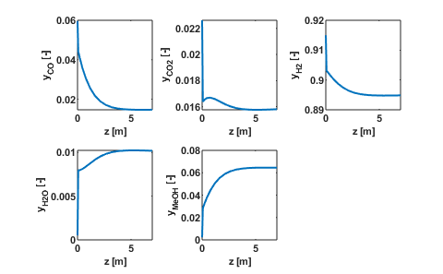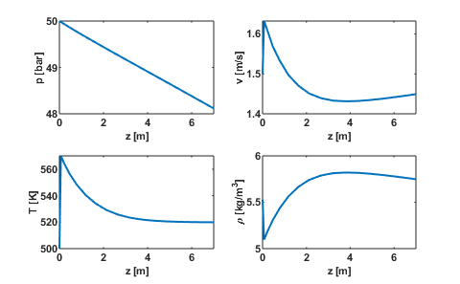
4. Conclusions
The model considered suggests an approach for combining fluid flow with thermodynamic equilibrium. The thermodynamic part is a useful tool in the lack of reaction rate kinetics and in a process design feasibility study, while the fluid dynamic part retains the effects of fluid flow. The profiles from the fluid dynamic part can also be used to characterize worst-case scenarios, such as steep temperature rise, and therefore in risk assessment and online operation, making the model a proactive choice.
References
- Solsvik, J., Haug-Warberg, T., & Jakobsen, H. A. (2016). Implementation of chemical reaction equilibrium by Gibbs and Helmholtz energies in tubular reactor models: Application to the steam-methane reforming process. Chemical Engineering Science, 140, 261–278. https://doi.org/10.1016/j.ces.2015.10.011
- Fogler, H. S. (2016). Elements of chemical reaction engineering. Boston: Prentice Hall.
- Haug-Warberg, T. (2006). Den termodynamiske arbeidsboken (1st ed.). Fornebu: Kolofon Forlag AS.

