Comparison between carbonic anhydrase biocatalysts for CO₂ capture by enzymatic reactive absorption
Maria Elena Russo^{1*}, Sara Peirce², Sonia Del Prete³, Clemente Capasso³, Antonio Marzocchella², Piero Salatino²
1 Istituto di Ricerche sulla Combustione – Consiglio Nazionale delle Ricerche, P.le V. Tecchio 80, 80125 Napoli, Italy; 2 Dipartimento di Ingegneria Chimica dei Materiali e della Produzione Industriale – Università degli Studi di Napoli Federico II, P.le V. Tecchio 80, 80125 Napoli, Italy, 3 Istituto di Bioscienze e Biorisorse – Consiglio Nazionale delle Ricerche, Via P. Castellino 111, 80131 Napoli, Italy
*Corresponding author: m.russo@irc.cnr.it
Highlights
- Different immobilization techniques have been applied to carbonic anhydrase.
- Whole cell catalyst bearing carbonic anhydrase has been developed.

1. Introduction
Post-combustion CO₂ capture strategy asks for novel processes avoiding the use of polluting solvents and aimed at CO₂ utilization. CO₂ absorption processes based on the enhancement of capture rate by the enzyme carbonic anhydrase (CA) (EC - 4.2.1.1) have been deeply investigated [1]. CA is able to catalyze the CO₂ hydration reaction and its thermophilic and halophilic forms are active into aqueous alkaline solvents [2]. In addition, the use of carbonate aq solvents and CA allows the exploitation of the bicarbonate enriched solvent for CO₂ utilization processes based on the cultivation of high value microalgae biomass [3, 4]. This contribution reports on recent efforts for the development of three techniques for the production of CA biocatalysts: two different CA immobilization techniques were developed and compared with a whole cell biocatalyst where CA is present on the outer membrane of engineered Eschierichia coli cells [5].
2. Methods
Thermostable CA was (Novozymes) and immobilized in the form of Cross Liked Enzyme Aggregates (CLEA) [6] and covalently attached on magnetic nanoparticles (MNP) [7]. Whole cell biocatalyst bearing CA on outer surface of cell membrane were prepared according to Del Prete et al. [5]. Kinetic characterization of CA based biocatalyst was performed through CO₂ absorption tests in a stirred cell lab scale bioreactor [6, 7].
3. Results and discussion
Figure 1 shows the immobilization yields (mass of immobilized enzyme/initial mass of enzyme) and the enzyme loadings (mass of enzyme/mass of biocatalyst) after preparation of CA CLEA and MNP with attached CA. CLEA shows remarkable improvement of these characteristics with respect to CA covalently attached on MNP. On the other hand, large CLEA size (low biocatalyst effectiveness) did not allow kinetic characterization [6]. MNP and free CA apparent kinetics were fully characterized under industrially relevant conditions [7]. Whole cell biocatalyst showed active CA on its membrane [5] and its kinetic characterization is ongoing through CO₂ absorption tests used for CLEA and MNP characterization [6, 7].
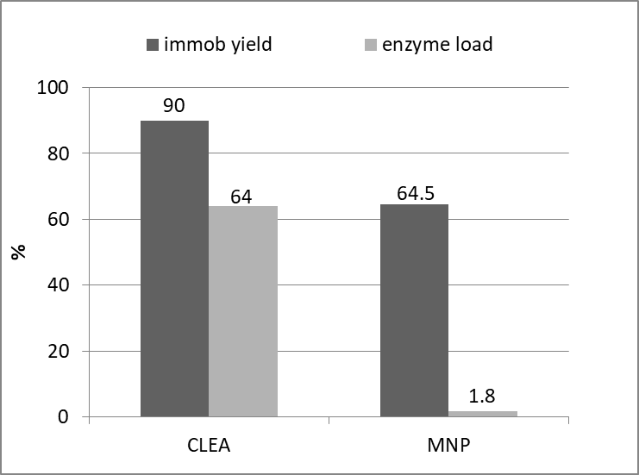
Figure 1. Comparison between CA immobilized on magnetic nanoparticles (MNP)and cross linked enzyme aggregates (CLEA).
4. Conclusions
Three technologies have been developed to produce CA-biocatalysts for the development of CO₂ capture processes oriented through aq phase CO₂ utilization [3, 4]. Table 1 reports pros and cons about each investigated biocatalyst. Among these, MNP biocatalyst is ready to further scale-up tests since assessed kinetic parameters have been used for an absorption column design study [8].
 | Free CA/aggregates | CA on MNP | CLEA | Whole cell biocatalyst
Enzyme purification | + | + | + | -
Stability | - | + | + | Ongoing
Biocatalyst effectiveness | +/- | + | - | +
Kinetic parameters | + | + | - | Ongoing
Table 1 Comparison between possible strategies for CA use as promoter of enzymatic reactive absorption for CO₂ capture.
References
- M. E. Russo, G. Olivieri, A. Marzocchella, P. Salatino, P. Caramuscio, C. Cavaleiro, Sep Pur Technol, 107 (2013) 331–339.
- M. Leimbrink, S. Tlatlik, S. Salmon, A. K. Kunze, T. Limberg, R. Spitzer, A. Gottschalk, A. Górak, M. Skiborowski, Int J Greenhouse Gas Control, 62 (2017) 100–112.
- Z. Chi, J. V O’Fallon, S. Chen, Trends Biotechnol. 29 (2011) 537–41.
- B. Gris, E. Sforza, L. Vecchiato, A. Bertucco, Ind. Eng. Chem. Res. 53 (2014) 16678–16688.
- S. Del Prete, R. Perfetto, M. Rossi, F. A. S. Alasmary, S. M. Osman, Z. AlOthman, C. T. Supuran, C. Capasso, J. Enz Inihib Medicinal Chem, 32 (2017) 1120–1128
- S. Peirce, M.E. Russo, R. Isticato, R.F. Lafuente, P. Salatino, A. Marzocchella, Biochem. Eng. J. 127 (2017) 188–195.
- S. Peirce, M.E. Russo, R. Perfetto, C. Capasso, M. Rossi, R. Fernandez-Lafuente, P. Salatino, A. Marzocchella, Biochem. Eng. J. 138 (2018) 1–11.
- M. E. Russo, P. Bareschino, F. Pepe, A. Marzocchella, P. Salatino, Chem. Eng. Transact. 69 (2018)

