Real-time planar temperature measurement of fluidized particle aggregates heated by high radiation flux
Wanxia Zhao^{1,2}, Kimberley Kueh^{2,3}, Graham Nathan^{2,3}, Zeyad Alwahabi^{1,2,}*
1 School of Chemical Engineering, University of Adelaide, Adelaide, South Australia 5005, Australia;
2 Centre of Energy Technology, University of Adelaide, Adelaide, South Australia 5005, Australia;
3 School of Mechanical Engineering, University of Adelaide, Adelaide, South Australia 5005, Australia
* Corresponding author: zeyad.alwahabi@adelaide.edu.au
Highlights
- The fast-moving aggregates were heated by well-characterized multi-diode laser.
- The in situ planar aggregate temperature was determine by PLIP technique.
- Averaged particle aggregates temperatures were compared at several fluxes.

1. Introduction
Heat transfer within particle-laden flow strongly influence the process heat flow, energy conversation and the system’s reliability of chemical engineering processes [1]. Thus, the understanding of heat transfer in two phase flow and precise temperature measurement of particles are important in improving such process efficiencies. Nowadays, the heat transfer of two-phase flow is still not fully understood because the temperature measurements of suspended particles in the gas flow are extremely difficult. Therefore, planar laser-induced phosphorescence (PLIP) technique has been developed to offer the non-invasive temperature measurement for both static and moving surfaces with higher accuracy [2]. In this work, the temperature measurement of particle aggregates, heated by high radiation flux, has been investigated. PLIP technique has been applied to yield accurate non-intrusive surface temperature of fluidized aggregates. The radiation was supplied by the well-characterized high radiation multi-diode laser system that recently developed at the University of Adelaide [3].
2. Methods
The experiment setup was divided into three parts, which are the high radiation multi-diode laser system to generate high radiation flux, the fluidized bed to provide particle-laden flow, and imaging system for signal collection. BaMg₂Al₁₀O₁₇:Eu (BAM) was selected as thermographic phosphor due to its large temperature sensitivity up to 1300 K. The Nd:YAG laser excited phosphorescence emission signals from particles were directed to the imaging system. An imaging splitter transferred two images, which captured at two different wavelengths, into a single ICCD camera. Both images were collected simultaneously with the advantages of minimizing the error during the image processing. The real-time particle aggregates temperature is determined by the emission intensity ratio at two different wavelengths, namely 400 nm and 460 nm.
3. Results and discussion
Single-shot particle aggregates temperature measurement was performed at 7 different heating fluxes. For each flux, 300 images were recorded by the ICCD camera during the heating period. Figure 1 presents the typical example of particle aggregates temperature derivation. Column A and column B are the individual particle aggregates images taken with the 400 ± 20 nm filter and 460 ± 7 nm filter respectively, while column C shows the inferred particle temperature. The final temperature distribution of particle aggregates is obtained by dividing the intensity on two sub-images pixel-by-pixel using MATLAB code.
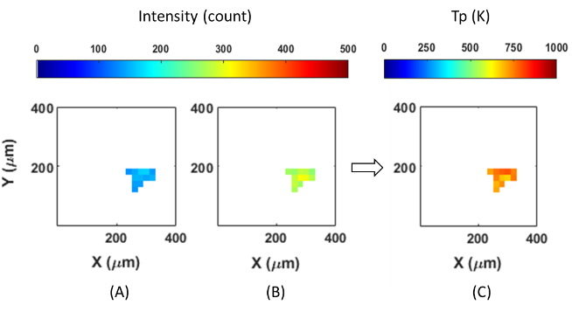
Figure 1: Example of single shot aggregates temperature distribution images deriving from two raw sub-images
Figure 2(a) presents the example of aggregates temperature distribution over 300 images, while Figure 2(b) shows the average aggregates temperature at 7 different fluxes. The average aggregates temperature has the linear increasing trend. As heat flux increasing, the maximum BAM average temperature is achieved more than 700 K when the heat flux at 27.28 MW/m².
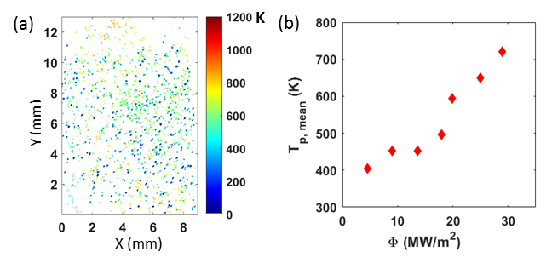
Figure 2: (a) Real particle aggregates temperature distribution in measurement area by overlap particles over 300 images at heating flux of 24.97 MW/m². (b) Mean BAM particle aggregates temperature at various heat fluxes
4. Conclusions
Real-time planar temperature measurement of fluidized BAM aggregates was performed by planar laser induced phosphorescence (PLIP) technique with using a single ICCD camera and imaging split system. Averaged particle aggregates temperatures were compared at several fluxes. At the highest heating flux, the average aggregates temperature was increased to more than 700 K.
References
[1] W. Lipiński, J.H. Davidson, S. Haussener, J.F. Klausner, A.M. Mehdizadeh, J. Petrasch, A. Steinfeld, L. Venstrom, Journal of Thermal Science and Engineering Applications 5 (2013) 021005-021014.
[2] M. Aldén, A. Omrane, M. Richter, G. Särner, Progress in Energy and Combustion Science 37 (2011) 422-461.
[3] Z. T. Alwahabi, K. C. Kueh, G. J. Nathan, and S. Cannon, Opt Express 24 (2016) A1444-A1453.

