Pervaporation characteristics of PVA-alumina hollow fiber composite membrane for the recovery of by-product in the epoxy resin manufacturing process

Seung-Eun Nam*, Yong Sung Kwon, Ahrumi Park, Young Mi Kim
HoSik Park, You-In Park,

Membrane Research Center, Korea Research Institute of Chemical Technology,
141 Gajeongro, Yuseong, Daejeon 34114, Korea
* Corresponding author: senam@krict.re.kr

1. Introduction
Pervaporation is a membrane separation technology with high efficiency and energy saving benefits for liquid mixture separation, in particular, for the separation of close boiling or azeotropic mixtures [1]. One of the most frequent industrial application areas of pervaporation is dehydration of solvents that form an azeotrope with water e.g. ethanol, isopropanol, tetrahydrofurane. The membrane contacts with the liquid mixture on the feed side, while permeate is removed as a vapor. The mass transport is driven by the vapor pressure difference between the feed solution and the permeate vapor. The chemical potential gradient across the membrane is the driving force for the mass transport. The driving force and be created by applying either a vacuum or an inert sweep gas on the permeate side to maintain the permeate vapor pressure lower than the partial pressure of the feed liquid. Mass transport in the pervaporation membrane can be explained by the solution-diffusion model [2]. Pervaporation is a well-known alternative method to classical distillation due to its high selectivity and low operational cost. Since the pervaporation is normally applied to remove a minor component of a liquid mixture, high permselectivity is essential for competing with convential means such as distillation and extraction.
Epichlorohydrin (ECH) containing epoxide and organochlorine moieties is a highly reactive electrophilic compound used in the production of glycerol, plastics, and epoxy resins [3]. Epoxy resin is prepared by polymerization of ECH with phenol, Bisphenol-A (BPA) is used as a phenol resin and isopropanol (IPA) is used as solvent. Excess ECH is included in the raw material to control the molecular weight of the produced epoxy resin. After reaction, ECH, IPA, a series of chlorine impurities, and water is remained and distillation process has been widely applied for the recovery of these by-products. However, the impurity content gradually increases after repeated reuse. During the recovery of ECH and IPA by distillation, ECH and IPA form a ternary azeotropic mixture with water impurities, and the recovery of high purity ECH and IPA is difficult only by distillation process. Therefore, in terms of energy efficiency and reuse of unreacted materials, improvements to this process are required. Furthermore, ECH can cause environmental hazards because it is carcinogenic in nature and can have serve adverse effects on ecological systems if its effluent comes into contact with the environment. A hybrid process involving moisture removal by pervaporation and recovery and purification of ECH and IPA via distillation can improve the ecofriendly energy efficiency and the product competitiveness by reducing the cost associated with the epoxy resin manufacturing process.
In this study, pervaporation performance and stability of the prepared PVA-alumina hollow fiber composite membrane was evaluated at various operational condition in a highly reactive ECH-containing ternary mixture feed system of ECH/IPA/Water(50/30/20 wt%).

2. Methods
Selection of stable polymeric membrane material for pervaporation in the ECH/IPA/water feed system is a challenging task because ECH is a highly reactive chemical. Poly(vinylalcohol) (PVA, M.W. 85000-124000 g/mol) as active layer material for dehydration aqueous organic solution has excellent membrane forming properties, a high tensile strength, and stability in organic solvents. The crosslinking reaction of PVA was carried out at 50ºC for 2hr and the composition of the crosslinking agent was GA/IPA/Water/HCl = 5/89.5/5/0.5 vol%. Pervaporation performance and chemical stability of the prepared composite membrane was evaluated at various operational condition in a highly reactive ECH-containing ternary mixture feed system of ECH/IPA/Water (50/30/20 wt%).

3. Results and Discussion
Figure 1 shows the SEM pictures of (a) the surface and fractured cross-section of the alumina hollow fiber support and (b) the fractured cross-section of PVA-alumina hollow fiber composite membranes. PVA active layer was observed to be a have uniform thickness of less than 2 µm.
The prepared PVA-alumina hollow fiber composite membranes, in this study, showed excellent pervaporation dehydration performance with the feed comprising an ECH/IPA/Water (50/30/20 wt%) azeotropic mixture in long-term stability test: the permeate flux of above 0.135 kg/m² hr and separation factor was above 3500 at 30 ºC. As shown in Figure 2, the composite membrane was operated for 500 hours with no observed decrease in performance.

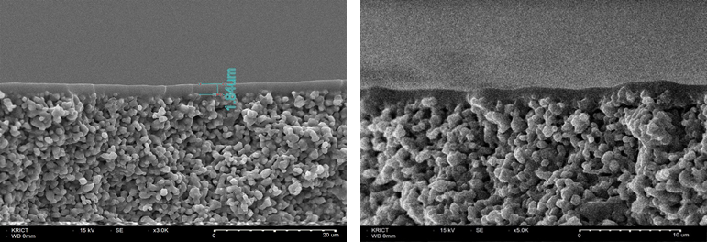

- (b)
Figure 1. SEM pictures of (a) alumina hollow fiber support (b) PVA-alumina composite membrane.
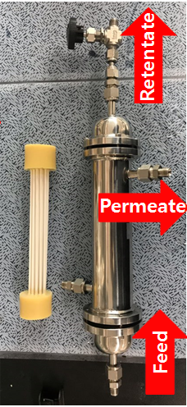

Figure 2. Pervaporation performance of the PVA/alumina composite membrane.

4. Conclusions
The stability and pervaporation performance of PVA-based composite membranes in a highly reactive ECH-containing ternary mixture feed system showed remarkable pervaporation dehydration efficiency. To reduce energy cost, make possible a difficult separation, and improve the degree of separation, pervaporation-based hybrid process are very promising especially in cases where high product purities are required.

References
[1] P.D.Chapman, T.Oliveira, A.G.Livingston, K.Li, J. Membrane. Sci., 318 (2008) 5.
[2] J.G.Wiljmans and R.W.Baker, J. Membrane. Sci., 107 (1995) 1.
[3] C.Chang and W.Lee, J. Appl. Poly. Sci., 116 (2010) 2065.

