DESIGN OF A CONTINUOUS SEMI-PARTITION BIOREACTOR FOR IN-SITU (EXTRACTIVE FERMENTATION) PRODUCT REMOVAL
George .M. Teke ¹, Robert .W. Pott¹
Department of Process Engineering, University of Stellenbosch, South Africa
*Corresponding author: rpott@sun.ac.za
Highlights
- A novel adapted bioreactor for in-situ product recovery (ISPR) was design and demonstrated.
- Separation profile, mixing and settling studies were conducted and evaluated.
- Mathematical model was demonstrated for mass transfer and flowrate characterization.
1. Introduction
Fermentation technology involves the use microorganism to convert simple substrates to valuable products, which find use in a variety of industries, from pharmaceuticals to fine chemicals. While fermentation technologies are commonly used, and represent a mature technology, there are nonetheless still challenges, particularly with regards low product yield and productivity caused by product inhibition, high energy consumption, mass transfer and selective metabolic issues [1], [2].
Extractive fermentation was introduced in the 1960’s, as a mechanism to combat several of these issues. The technique is based on product removal while it is been formed (in-situ). This technology has developed over years, with usage of different separation techniques such as gas stripping, pervaporation, adsorption and liquid-liquid extraction. For the most part, many of these systems have been developed to run on batch mode operation. While development of fed-batch or continuous production systems has not received as much attention. Continuous systems, in particular, can be attractive, since yield, productivity and economies of scale can be improved over batch operation (although other operational challenges remain) [3], [4].
To give biotechnologists another operational mode from which to select from, more research needs to be focused on a robust in-situ design on the continuous systems of production, to be implemented for industrial use. This project presents the design and evaluation of adapted bioreactors for usage during in situ liquid-liquid extractive fermentation.

2. Methods
Reactor operation
The designed bioreactor is shown in Figure 1 below, this design permitted the continuous mixing and settling of two immiscible liquids. The mixing region used a Continuous stirred tank bioreactor (CSTR) while the settling region was an insert. As an exemplary two-phase system, 10 wt% of polyethylene glycol (PEG-8000) and 10wt% potassium phosphate solutions where added to the system of deionized water and stirred continuously. The addition of New Coccine dye to the mixture permits the recording of the separation profile of the liquids which was based on settling heights of the top and the bottom phases with respect to time.
Tracer solutions of 0.1M NaCl salt was used that permitted the validation and parameter fitting of a mathematical model derived to obtain the mass transfer and inter-compartmental flux values. Also, a mixing time studies was done using this tracer solution to understand the homogeneity of the systems. All experiments were done in triplicates for errors minimization.
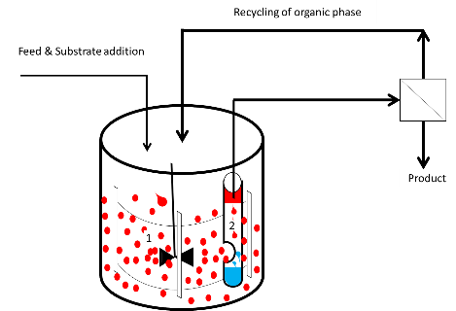
Figure 1: A Semi-Partitioning Bioreactor Diagram, 1- CSTR (Mixer) and 2- Inserted tube (settler)
3. Results and discussion
In Figure 2 below, 2(A) demonstrate a mixing and settling capacity of the designed bioreactor which is in line with other works on phase separation [5]–[7]. These previous studies demonstrate a phase boundary after settling which is not our case because the driving force of the impellers into the settler still permits some mixing as demonstrated by S (figure 2A). This indicates the possibility of a continual mixing, settling, potential substrate addition, cell or organic phase recycling, and a possibility of product/ by-product removal from the top organic phase there by reducing production cost. 2(B) demonstrated a perfectly fitted model that generates a 0.005 $l{(sec⁡)}^{-1}$ and $1.53 lm^{-2}{(sec⁡)}^{-1}$of flowrate and mass transfer ${(K}_{L})$values respectively of the system (Semi-partitioning bioreactor) after triplicate runs. This high rate of exchange of materials is evident as there is a rapid homogeneity of the system as shown in the mixing time ($t_{m}$) curves in 2(C) with $t_{m}$ being 112 seconds and 9 seconds of the settler and mixer sections respectively.
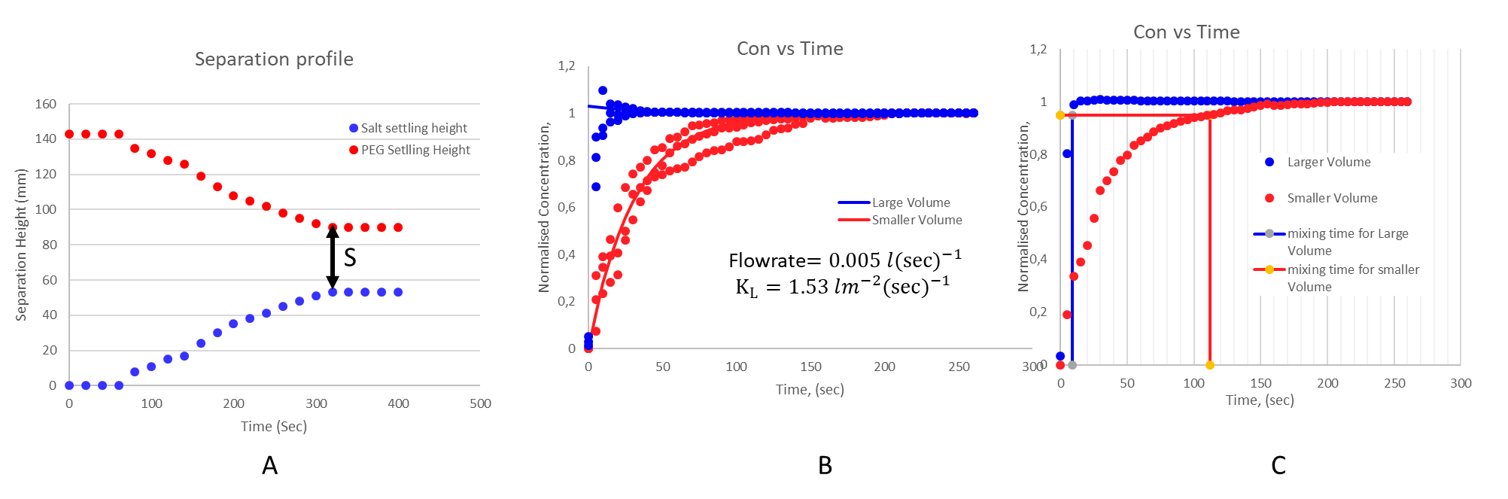
Figure 3:A Brief result summary (A)-Separation Profile, (B)- Mathematical model for Flowrate and Mass Transfer obtained (C)- Extent of mixing (Mixing time). Large volumes - mixer section while smaller volume - settler section.
4. Conclusions
The results above have demonstrated the possibility of designing a mixer-settler bioreactor which would be applicable for in-situ product removal. This implies there would be a continuous addition of substrate in the mixer section with a spontaneous removal of the product through settling section of the bioreactor. A mathematical model was generated for the system which made us better understand the extent of mixing or the fast rate of homogeneity in the system.
References
[1] A. Kuila and V. Sharma, Principles and Applications of Fermentation Technology, First. Martin Scrivener and Phillip Carmical, 2018.
[2] P. F. Stanbury, A. Whitaker, and S. J. Hall, Principles of fermentation technology, Third. Joe Hayton, 2017.
[3] D. Stark and U. von Stockar, “In Situ Product Removal (ISPR) in Whole Cell Biotechnology During the Last Twenty Years,” in Process Integration in Biochemical Engineering, vol. 80, 2003, pp. 149–175.
[4] W. Van Hecke, G. Kaur, and H. De Wever, “Advances in in-situ product recovery (ISPR) in whole cell biotechnology during the last decade,” Biotechnol. Adv., vol. 32, no. 7, pp. 1245–1255, 2014.
[5] E. Barnea and J. Mizrahi, “Separation mechanism of Liquid-Liquid Dispersions in a deep-Layer Gravity Settler: Part IV - Continuous Settler Characteristics.,” Trans. Inst. Chem. Eng., vol. 53, pp. 83–92, 1975.
[6] J. A. Asenjo, S. L. Mistry, B. A. Andrews, and J. C. Merchuk, “Phase Separation Rates of Aqueous Two-Phase Systems : Correlation with System Properties,” 2002.
[7] J. Golob and R. Modic, “Coalescence of liquid/liquid in dispersions in Gravity Settler,” Trans. Inst. Chem. Eng., vol. 55, pp. 207–211, 1977.

