Quality by Design for Fused Deposition Modeling 3D Printing:
Extrudate Mass Flow Control.
Tim Feuerbach, Markus Thommes
TU Dortmund University, Laboratory of Solids Process Engineering,
Emil-Figge-Str. 68, 44227 Dortmund, Germany
*Corresponding author: tim.feuerbach@tu-dortmund.de
Highlights
- Filament diameter variations affect the obtained extrudate mass flow
- Feedback control of filament feeding velocity based on filament diameter
- Implemented control strategy results in more uniform extrudate mass flow

1. Introduction
Fused Deposition Modeling (FDM) is a promising manufacturing method for customized pharmaceutical products, such as patient-specific implants [1]. In FDM, thermoplastics in form of a filament are used as a feedstock material. In addition to the imposed mechanical requirements on the filaments, there are also geometrical requirements [2]. The main reason is the utilization of the nominal diameter to determine the required filament feed velocity to achieve the desired extrudate mass flow. Since there is no feedback control in FDM printers, variations of the filament diameter directly translate into inconsistent flowrates [3], as indicated in Figure 1 (left). These inconsistencies can lead to excess material or to voids and cavities that can influence the object porosity, geometry and mechanical strength. The aim of this study was to evaluate if extrudate mass flow variations can be compensated by adjusting the filament feed velocity based on measured filament diameters to obtain consistent extrudate mass flow.
2. Methods
Commercial grade acrylonitrile butadiene styrene (ABS) filament (White ABS 1.75mm 1 KG, RepRap Austria, Neuhofen/Krems, Austria) was used as received. The filament diameter was measured with a laser gauge (Laser 2025T, Sikora GmbH, Bremen, Germany). The filament was discretized into 1 mm compartments and each compartment was assigned with a representative diameter. A custom-built FDM printer [4] was used to extrude the material. The extruded material was analyzed gravimetrically with an analytical scale (Cubis® MCM66, Sartorius, Göttingen, Germany).
3. Results and Discussion
The printing process was conducted with a constant filament feed velocity, assuming a filament diameter of 1.75 mm. The diameter variations were similarly introduced into the extrudate mass flow. Assuming a worst-case scenario of a 0.05 mm systematic error, a mass deviation of 6 % would be introduced into the product, as shown in Figure 1 (right). For most pharmaceutical products containing at least one drug, this would lead to an intolerable deviation from the nominal drug dosage.
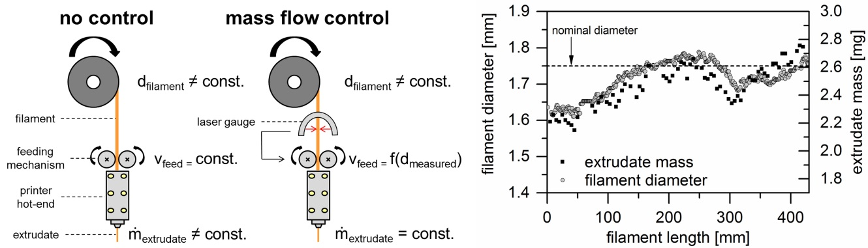
Figure 1. Schematic of the printing process with and without mass flow control (left) and measured filament diameter and corresponding extrudate mass without mass flow control (right).

In a next step, the measured filament diameter was used to adjust the filament feed velocity to obtain the desired extrudate mass flow. A constant diameter of 1.75 mm would have led to sample weights of m_{set} = 48.1 mg, as indicated in Table 1. However, the utilized filament piece for this experiment had a diameter of 1.699 ± 0.021 mm (arithmetic mean ± standard deviation, n = 7). Based on this deviation from the nominal diameter, a theoretical mean sample weight of m_{no control} = 45.33 mg was expected for each compartment, which is similar to a mass deviation of approximately -5.8%. The applied control strategy led to an improved mean sample weight of m_{controlled} = 47.31 mg, which is similar to a mass deviation of only -1.6%.
Table 1. Expected extrudate mass and measured extrudate mass with mass flow control.
m_{set} [mg] | m_{no control} [mg] | m_{controlled} [mg]
48.1 | 45.33 ± 1.11 (n = 7) | 47.31 ± 0.90 (n = 7)
4. Conclusions
Systematic and random deviations from the nominal filament diameter were successfully compensated by the presented control strategy, which resulted in a more uniform extrudate mass flow. This is particularly important for 3D printing of pharmaceutical products to control the drug dosage. The control strategy can be integrated as a Quality by Design tool into the printing process and allows the application of a wider range of filaments.
References
- Espalin, D.; Arcaute, K.; Rodriguez, D.; Medina, F.; Posner, M. and Wicker, R. Fused deposition modeling of patient-specific polymethylmethacrylate implants. Rapid Prototyping Journal, 16, 164-173 (2010).
- Feuerbach, T.; Callau-Mendoza, S. and Thommes, M. Development of Filaments for Fused Deposition Modeling 3D Printing with Medical Grade Poly(Lactic-Co-Glycolic Acid) Copolymers. Pharmaceutical Development and Technology, DOI: 10.1080/10837450.2018.1514522 (2018).
- Rane, K.; Cataldo, S.; Parenti, P.; Sbaglia, L.; Mussi, V.; Annonio, M.; Giberti, H. and Strano, M. Rapid Production of Hollow SS316 Profiles by Extrusion based Additive Manufacturing. AIP Conference Proceedings, 1960, DOI: 10.1063/1.5035006 (2018).
- Feuerbach, T.; Kock, S. and Thommes, M. Characterisation of fused deposition modeling 3D printers for pharmaceutical and medical applications. Pharmaceutical Development and Technology, DOI: 10.1080/10837450.2018.1492618 (2018).

