A Power-to-Liquid Process – An alternative Process for the Production of (Poly-)Oxymethylene Dimethyl Ether (OME) based on Methanol.
Lara Theiss^{1, 2}, Mohamed Ouda¹, Franz K. Mantei¹, Achim Schaadt¹, Robert Güttel²
1 Fraunhofer Institute for Solar Energy Systems ISE, Heidenhofstraße 2, 79110 Freiburg, Germany 2 Institute of Chemical Engineering, Ulm University, Albert-Einstein-Allee 11, 89081 Ulm, Germany
*Corresponding author: lara.theiss@ise.fraunhofer.de
Highlights
- Methanol (MeOH) oxy-dehydrogenation to dimethoxymethane (OME₁) and formaldehyde (FA) shows high potential for efficient OME synthesis
- Reasonable MeOH conversions with high OME₁ and FA selectivities
- Successful water separation via membranes, as one of the crucial steps in all OME synthesis processes

1. Introduction
Due to their interesting thermo-physical and intrinsic combustion properties, (poly)oxymethylene dimethyl ethers (OMEs) have a high potential as diesel fuel alternative, “green” solvents or as CO₂ absorbent [1, 2]. The greatest challenge for introducing OME into the market is the lack of an energy-efficient, economically feasible and scalable industrial process for the synthesis of OME with a certain chain length. A promising synthesis route includes the formation of formaldehyde (FA) and dimethoxymethane (OME₁) by oxidative dehydrogenation of methanol (MeOH) in a single reactor first, using a porous solid catalyst providing both acidic and redox sites. Subsequently, FA and OME₁ are converted into higher OMEs, e.g. OME₃₋₅. The crucial issue in the first step is the stoichiometric by-product water, which limits the equilibrium yield and has to be removed prior to the second higher OME synthesis step. Thus, the water management plays a major role in the overall process. However, due to several azeotropes in mixtures containing FA, MeOH, water and OME₁, separation by distillation is cumbersome. Therefore, alternative processes like the application of membranes gain a lot of interest [3], which is aimed at in the present contribution.
2. Methods
In order to investigate the oxidative dehydrogenation of MeOH and the water removal by membrane technology systematically, a Design of Experiment (DoE) is applied. This allows quantitively evaluation of the correlation between input parameters, such as temperature, pressure and membrane material, and the most important target parameters, e.g. yield or water separation efficiency. The experiments are performed in two stages: A continuously operated plug flow reactor using a self-made bifunctional catalyst was used for MeOH dehydrogenation at 200-300°C and 1 bar. The obtained product mixture was continuously subjected to two membrane units. Moreover, a short cut model for the reaction and the separation step is applied, in order to simulate the whole process for addressing scale up issues.
3. Results and discussion
First results of the oxidative dehydrogenation of MeOH and the subsequent separation of water by selected hydrophilic membranes show promising results. Figure 1 shows the molar fractions of the oxidative dehydrogenation reaction product (denoted with “Reaction”), which is subsequently directly introduced into the membrane unit during the test run. The molar fractions of the retentate (denoted with “Retentate”) shows that almost a complete separation of water could be achieved at different ratios of sweepgas to reaction product stream (denoted with “R”). Moreover it is found that the amount of the other components does not change significantly in the retentate, which indicates a rather selective water separation. During reaction, MeOH conversion of about 40% and OME₁ and FA selectivities of 20% and 50% could be determined. Molar ratios of OME₁ to FA of 0.4 - 0.8 were obtained, which is a crucial target parameter for the subsequent synthesis for higher OMEs.
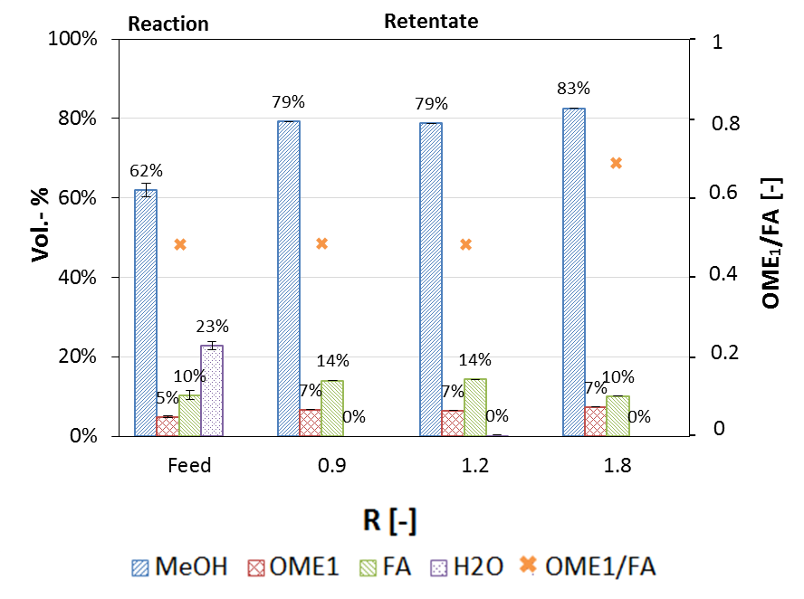
Figure 1. Exemplary combined reaction and separation test run, performed in a plug flow reactor and using a hydrophilic membrane. The initial molar fraction of methanol is 40%. R is the ratio of sweepgas to the membrane feedgas.
4. Conclusions
The oxidative dehydrogenation of MeOH directly into OME₁ and FA shows promising results. By producing OME₁ and FA in one synthesis step, a simple, efficient and scalable synthesis pathway for the production of higher OME can be provided. The separation of water, as one of the biggest challenges in OME synthesis, could be achieved successfully by applying hydrophilic membranes. Maximizing the MeOH conversion, without changing selectivities, as well as the long-term stability of the membrane performance will be investigated successively.

References
[1] M. Schappals, T. Breug-Nissen, K. Langenbach, J. Burger, H. Hasse, J. Chem. Eng. Data 2017. DOI: 10.1021/acs.jced.7b00718.
[2] K. Gaukel, D. Pélerin, M. Härtl, G. Wachtmeister, Internationales Wiener Motorensymposium 2016, 37, 193 – 223.
[3] N. Schmitz, C. F. Breitkreuz, E. Ströfer, J. Burger, H. Hasse, Journal of Membrane Science 2018, 564, 806 – 812. DOI: 10.1016/j.memsci.2018.07.053.

