Effect of metabolite build-up on biofilms of succinic acid producing Actinobacillus succinogenes.
Sekgetho Charles Mokwatlo^{1*}, Hendrik Gideon Brink¹, Willie Nicol¹
1 University of Pretoria; Department of Chemical Engineering, University of Pretoria, Private Bag
X20, Hatfield, 0028, South Africa
*Corresponding author: u11119072@tuks.co.za
Highlights
- Rapid biofilm formation was observed at low succinic acid concntrations.
- Biofilms were patchy at high succinic acid concentrations and struggled to grow.
- Biofilms developed at high SA concentrations were much less viable in comparison.

1. Introduction
The wild type bacterium Actinobacillus succinogenes requires no introduction as a promising biocatalyst for industrial biotechnological production of succinic acid—a reputable platform chemical [1]. Continuous fermentation of A. succinogenes unavoidably results in biofilm formation, leading to high cell densities responsible for high succinic acid titers and volumetric productivities reported in literature [2]. This study looked at the impact that acid metabolite build-up in the fermenter has on the overall biofilm development and its viability.
2. Methods
Actinobacillus succinogenes 130Z (DSM No. 22257; ATCC No. 55618) was grown on a glucose substrate in a novel continuous fermenter suitable for sterile and multiple biofilm sampling. Biofilm was cultivated on plastic coupons at both high (16 g L⁻¹ succinic acid) and low metabolite (8.6 g L⁻¹ succinic acid) build-up conditions by adjusting the fermenter dilution rate. Sampled coupons were stained with Baclight LIVE/DEAD bacterial viability (Thermo Fisher Scientific, USA) stains before acquiring multiple image z-stacks using a Zeiss LSM 880 laser scanning confocal microscope (Zeiss, Germany) at random locations on the coupons. Acquired image z-stacks were analysed using Comstat2 to calculate descriptive biofilm parameters for objective characterisation of the biofilm.
3. Results and discussion
Biofilm formation was rapid when cultivated under low succinic acid (SA) titres, contrary to high SA titre conditions where the biofilm struggled to grow. As such, complete surface coverage was achieved at low SA cultivation whereas a patchy biofilm structure resulted from growth at high SA titre conditions, Figure 1. Furthermore, quantitative analysis showed an average biomass thickness increase from 10 µm on the first day to 30 µm by the third day of sampling for low SA biofilm cultivation in comparison to a 12 µm - 15 µm increase for biofilms cultivated at high SA titres Figure 2b. In addition, elongated bacilli cells were observed at high SA titre biofilm cultivation which may possibly have been a response to stressful conditions, Figure 1b.
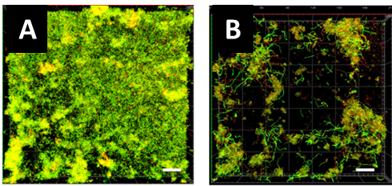
Figure 1. Biofilm images on day 1 of sampling for cultivation at low SA titers (A) and at high succinic acid titers (B). Scale bars indicates 20 µm.

A ratio (viability factor) of the mean intensity of the green fluorescence (for “live” cells) to the mean intensity of the red fluorescence (for “dead” cells) for all the z-stacks collected on a specific day of sampling was computed, which allowed an observation how the overall biofilm viability varied as the biofilm developed, Figure 2a. At low SA titres, the developed biofilm consisted of increasing “live” cells as shown by the increasing viability factor, whereas high SA titre biofilms became increasingly less viable, Figure 2a. The results thus showed that high SA acid titre conditions do not only slow down biofilm development but causes significant loss of biofilm viability.
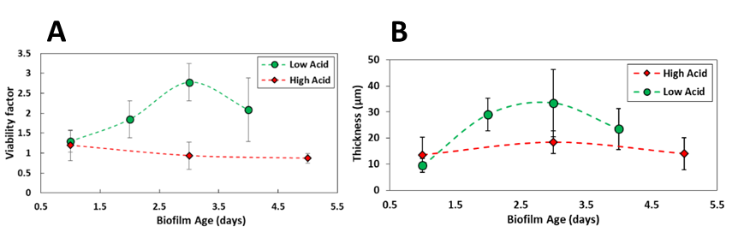
Figure 2. The viability profiles (A) and thickness profiles (B) of biofilms cultivated at both low and high SA acid concentrations.
4. Conclusions
Biofilms developed at both low and high SA titres were compared. High SA acid conditions slowed biofilm growth and resulted in a loss of biofilm viability whereas rapid biofilm growth was experienced at low SA titre conditions with increased biofilm viability.
References
- Pateraki C, Patsalou M, Vlysidis A, Kopsahelis N, Webb C, Koutinas AA and Koutinas M (2016) Actinobacillus succinogenes : Advances on succinic acid production and prospects for development of integrated biorefineries, Biochem. Eng. J. Elsevier B.V., 112, pp. 285–303. doi: 10.1016/j.bej.2016.04.005.
- Maharaj K, Bradfield MFA and Nicol W (2014) Succinic acid-producing biofilms of Actinobacillus succinogenes: Reproducibility, stability and productivity, Appl. Microbiol. Biotechnol., 98(17), pp. 7379–7386. doi: 10.1007/s00253-014-5779-3.

