Study of interfacial adhesion between a nanoparticle coated natural fiber and a thermoset matrix

German Díaz-Ramírez^{1(*)}, Enrique Mejía-Ospino², Rafael Cabanzo³, Brayan Arenas⁴, Ricardo Cruz⁵
1-5 School of Civil engineering, Universidad Industrial de Santander, Bucaramanga, Colombia; 1-2-4 Laboratory of atomic and molecular spectroscopy (LEAM), Universidad Industrial de Santander, Bucaramanga, Colombia; 3 Grupo de Investigación en Tomografía y Tecnologías Emergentes, Universidad Industrial de Santander, Bucaramanga, Colombia

*Corresponding author: german.diaz1@correo.uis.edu.co
Highlights
- The study focuses on the Interfacial shear strength (IFSS) in polymer composites reinforced with natural fiber yarns
- This study proposes a quantitively method for the evaluation of the IFSS
- The results indicated that there is a relationship between the IFSS and the type of chemical treatment performed on the natural fibers
- The NaOH treatment and coating with reduced oxygen graphene (rGO) increase the IFSS to a thermoset matrix in 80 % approximately

1. Introduction
Recently, natural fibers (NF) used as reinforcement for polymeric and cementitious composites have gained interest among researchers in materials engineering, mainly due to their specific tensile properties, such as their elasticity modulus, low costs, sustainability, high socio-economic impact on farming communities and reduction of the environmental impact mostly generated by the use of inorganic fibers such as glass, asbestos or carbon [1], [2]. Fique "furcraea macrophylla" fibers are obtained from the leaves of an agave plant with the same name, they are similar to Brazilian sisal and Mexican henequen fibers. In Colombia, they are cultivated mainly in the Andean areas such as Santander, Antioquia and Nariño. [3]
One of the most important properties used to analyse the mechanical performance of polymer composites is the adherence between the phases (matrix and reinforcement), that property is also known as interfacial shear strength (IFSS). The performance of a polymer composite reinforced with NFs like fique, can be compromised in the medium to long term because of the hydrophilic behaviour of fibers; to evaluate the IFSS, both qualitative and quantitative methods are used, which lately seek to establish the efficiency of different treatments on NFs such the previously mentioned among others, one of the most accepted methods is the uniaxial pull-out test, which has been researched mainly on inorganic singular fibers because the for the ease and precision in carrying out the calculations. The main advantage of this method is that it is a quantitative method of direct measurement, which allows to evaluate in a more accurate way the mechanical composite performance. However, due to the irregularity in the geometry of NFs, both longitudinally and transversally directions, such as fique fibers, this type of experiment can yield results with high degrees of dispersion.

2. Methods
In this work, uniaxial pull-out tests using fique fibers yarns (multifilament fibers) [4] instead of singular fibers, is proposed. The influence of three different treatments: NaOH cationization, nanoTiO₂ and rGO fibers coating on the IFSS in a thermoset composite was evaluated. 5 specimens of each type of modification were tested. The initial length was 100 mm (±0.5 mm). The tensile tests were performed using 2 mm/min displacement speed and at room temperature (≈25º C). For the critical immersion length determination, fique yarns with 20, 15, 10, 5, 2 and 1 mm of immersion were tested. The IFSS were calculated for the different types of modified yarns and the influence of the treatments on the IFSS was analysed.
3. Results and discussion
The main purpose of the multifilament probes instead of singular fibers or filaments was to reduce the dispersion on the obtained data and adjust the results to the commercial products that are marketed in Colombia for the company “Coohilados del fonce”. The tensile tests showed a maximum resistance between 374,5 and 433,8 MPa for the fique yarns, similar to other natural fibers as sisal or henequen [5,6]. Table 1 shows the results of maximum resistance, elasticity modulus and deformation percentage at break for fique fibers yarns.
Table 1. Tensile test results for fique yarns
Treatment | σ _{max} | E | ε _{break}
 | MPa | GPa | %
Untreated | 433,8 ± 81,2 | 13,0 ± 4,5 | 0,0272 ± 0,005
NaOH | 400,8 ± 122,2 | 12,4 ± 2,3 | 0,0301 ± 0,007
NaOH + TiO2 | 374,5 ± 62,1 | 11,4 ± 2,8 | 0,0321 ± 0,003

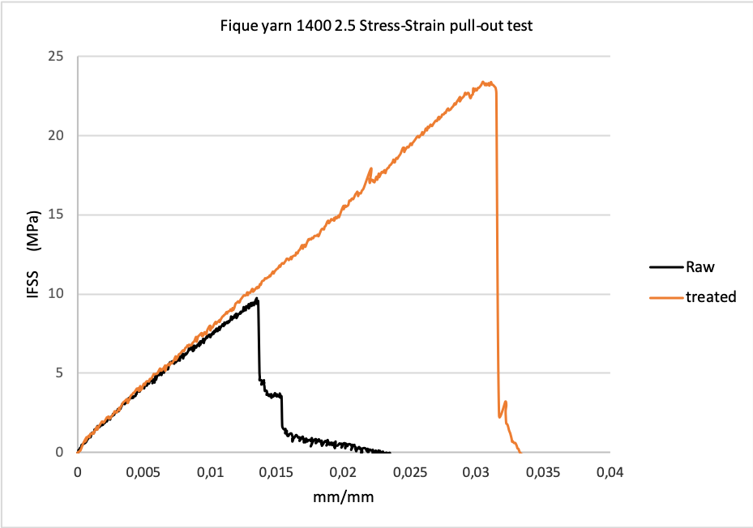
Figure 1. Interfacial shear strength vs strain tensile curve on raw and rGO coated fique natural yarns
The results from the uniaxial tensile test of IFSS are shown in Fig.1. The figure shows a typical IFSS stress strain curve, in this case obtained for the fique yarns tests, the curve indicates that the maximum IFSS stress for fique yarns increase from 9,75 MPa on raw fibers to 23,2 MPa on chemical treated fibers [7].
4. Conclusions
The results indicated that there is a relation between the IFSS and the type of treatment performed on the fique fibers, that is how fique fibers IFSS values increases with the treatments performed from 9,78 MPa for raw fique fibers to more that 20 MPa for the NaOH+rGO coated fibers average for the single fibers, assuming a circular cross section of 82 μm; for fique yarns the same values increase from 25, 5 MPa to 27,4 MPa, by calculating the cross section al area of 0,2278 mm² for raw yarns.
This study proposes the application of a direct measurement method of IFSS to achieve a more accurate evaluation of the interfacial adhesion properties for fique fibers and their derivate products.
References
[1] D. N. Saheb, J. P. Jog, D. Nabi Saheb, and J. P. Jog, “Natural Fiber Polymer Composites : A Review,” Adv. Polym. Technol., vol. 18, no. 4, pp. 351–363, 1999.
[2] K. H. Y. Cheung, “Natural fiber-reinforced polymer-based composites,” Nat. Fiber-Reinforced Biodegrad. Bioresorbable Polym. Compos., pp. 1–18, Jan. 2017.
[3] P. Gañán and I. Mondragon, “Surface modification of fique fibers. Effect on their physico-mechanical properties,” Polym. Compos., vol. 23, no. 3, pp. 383–394, 2002.
[4] A. Orue, A. Jauregi, J. Labidi, A. Eceiza, and A. Arbelaiz, “Composites : Part B The effect of surface modifications on sisal fiber properties and sisal / poly ( lactic acid ) interface adhesion,” Compos. Part B, vol. 73, pp. 132–138, 2015.
[5] S. Rocha, F. De Andrade, P. Roberto, L. Lima, R. Dias, and T. Filho, “Effect of fiber treatments on the sisal fiber properties and fiber – matrix bond in cement based systems,” Constr. Build. Mater., vol. 101, pp. 730–740, 2015.
[6] M. N. Cazaurang-Martinez, P. J. Herrera-Franco, P. I. Gonzalez-Chi, and M. Aguilar-Vega, “Physical and mechanical properties of henequen fibers,” J. Appl. Polym. Sci., vol. 43, no. 4, pp. 749–756, Aug. 1991.
[7] S. Zhandarov and E. Mäder, “Characterization of fiber/matrix interface strength: Applicability of different tests, approaches and parameters,” Compos. Sci. Technol., vol. 65, no. 1, pp. 149–160, 2005.

