**Synthesis and characterization of thermoplastic polyamide elastomers**

**based on PA 1212**

Jie Jiang1, Zhenhao Xi*2, Ling Zhao3

*1 State Key Laboratory of Chemical Engineering, East China University of Science and Technology, Shanghai, China;*

*2 State Key Laboratory of Chemical Engineering, East China University of Science and Technology, Shanghai, China;*

*3 State Key Laboratory of Chemical Engineering, East China University of Science and Technology, Shanghai, China;*

*\*Corresponding author: zhhxi@ecust.edu.cn*

**Highlights**

* Long chain polyamide as hard segment and amino-terminated polyether as soft segment.
* The thermoplastic elastomer is lightweight.
* Microphase separation of the copolymer is observed.
* The thermoplastic elastomer can be used as permanent antistatic agent.

**1. Introduction**

Thermoplastic polyamide elastomers (TPAEs) are block copolymers with hard blocks consisting of polyamide segments, and the soft blocks consisting of polyether segments usually including poly(ethylene glycol) (PEG), poly(propylene glycol) (PPG) or poly(tetramethylene glycol) (PTMG)[1,2,3]. The hard and soft segment are linked with ester group where thermodynamic incompatibility between the two segments results in a microphase separated morphology[4].

**2. Methods**

Thermoplastic polyamide elastomer was synthesized using PA1212 oligomer (Average molecular weight is from 1000 to 5000) and Jeffamine@ED2003 (or Jeffamine@D2000) via a "two-step" melt polycondensation. The TPAEs were characterized by FT-IR, 1H-NMR, WAXD, DSC, DMA, TGA. Meanwhile, the inherent viscosity, density, rheology and dielectric properties of the TPAEs were determined.

**3. Results and discussion**

The hard and soft segment are linked with amide group (Figure 1a). The Jeffamine@ED2003 crystal melting peaks are observed within 0-40 oC which are lower than the reported Tm (43 oC ) (Figure 1c). Two distinct glass transitions of TPAEs have been observed (Figure 1d). This result is attributed to the Jeffamine crystallization being confined by the PA1212 hard domains during cooling, a typical characteristic of microphase separation in elastomeric copolymers. The volume resistivity of the TPAEs decreases as increasing frequency and the values are between 105 and 1012 Ohms·cm (Figure 1e). The density of the synthesized TPAEs is 1.01-1.06 g·cm3.

 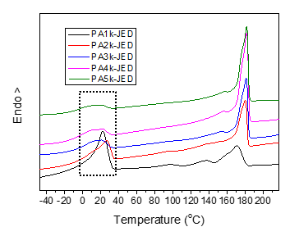

(a) (b) (c)

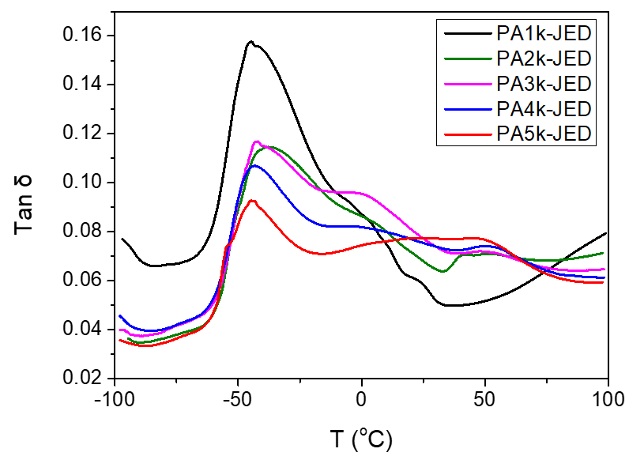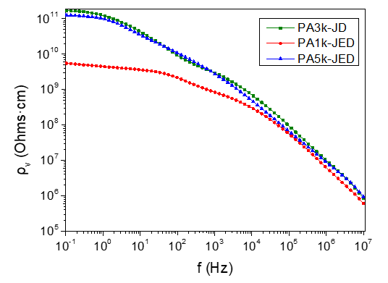

(d) (e)

**Figure 1.** (a) FT-IR spectra of PA1212-co-Jeffamine@ED2003; (b) DSC thermographs of PA1212-co-Jeffamine@D2000; (c) DSC thermographs of PA1212-co-Jeffamine@ED2003; (d) DMA results of PA1212-co-Jeffamine@ED2003; (e)Dielectric properties of TPAEs

**4. Conclusions**

The hard and soft segment are linked with amide group rather than ester group, resulting in good resistance to hydrolysis and organic solvent. The typical characteristic of microphase separation is observed. The density of the synthesized TPAEs is 1.01-1.06 g·cm3. The TPAEs can be used as permanent antistatic agent.

**References**

1. Malet F L G.. Wiley-VCH Verlag GmbH & Co. KGaA, 2006.
2. Boulares A, Tessier M, Marechal E. Polymer, 2000, 41(10): 3561-3580.
3. Huo L, Dong C X. Advanced Materials Research, 2012, 512: 2127-2130.
4. Yuan R, Fan S, Wu D, et al. Polymer Chemistry, 2018, 9(11): 1327-1336.