Novel Solvents and Processes for the Bio-Safe Biorefinery.
Vittoria Sapone¹, Agnese Cicci², Giorgia Sed¹, Marco Bravi^{1*}
1 Dipartimento di Ingegneria Chimica, Materiali e Ambiente, via Eudossiana 00184, Roma; 2 Bio-P s.r.l., via di Vannina, 00156, Roma
*Corresponding author: marco.bravi@uniroma1.it

1. Introduction
Novel modifiable solvents can play a key role in obtaining the maximum value from biomass, increasing sustainability of current biorefinery processes, and avoiding regulatory issues. Switchable solvents ability to reversibly change their nature (hydrophobic-hydrophilic, and/or polar-non polar) can be used to improve existing liquid-solid extraction unit operations thanks to pretreatments simplification and reduction of their energy requirement. Natural Deep Eutectic Solvents (NaDESs) feature an assignable (by proper choice of their components) and in some cases tunable hydrophilicity. Most commonly, NaDES are hydrophilic, but hydrophobic NaDES have been discovered and a NaDES-based SHS has been introduced. Novel SHS- and NaDES-based biorefining concepts and techniques have been developed targeting two major current and forthcoming biomass resources: lignocellulosic materials (LCM) and microalgal biomass. Here we give account of two promising green approaches exploring paradigmatic shifts in biorefinery.
2. Methods
So far, SHS have only been used in their hydrophobic form to extract hydrophobic solutes. During the hydrophobic-to-hydrophilic switch, dissolved hydrophobic solutes separate as a second (hydrophobic) phase which is easily collected. However, the treated biomass might also contain hydrophilic solutes that can be easily removed by treating the residue of the hydrophobic extraction with the hydrophilic form of the very same SHS. Subsequent back-switch to the hydrophobic form leaves a hydrophilic phase constituted by water and water-loving solutes behind, whereby the cyclic extraction can restart. The biomass extraction can begin with either the hydrophobic or the hydrophilic form of the solvent and may continue with the other form. The operation sequence starting with a hydrophobic extraction was denoted by the inventors as Forward-Mode extraction (FME) and the opposite sequence (hydrophilic extraction first, then hydrophobic) was called Backward-Mode Extraction (BME) [1] (Figure 1A). This dual use of SHS, denoted as “Circular Extraction”, has been touted to increase the utility of the extraction process and of the solvent itself. Recently, the first NaDES-based switchable system was developed (“NaDES-Y”) [2] to address the toxicity issues of other SHS (such as DMCHA) in the food and other regulated domains. The present paper compares its performance in microalgae extraction to that of DMCHA (DimethylCycloHexylAmine) under said “Circular Extraction” approach. Choline chloride-based NaDES are of hydrophilic nature and exhibit polarity higher than water that can be tuned by adjusting water content in the NaDES formulation. Choline chloride-based NaDES are able to solubilise lignocellulose. However, a recent quantum leap forward in NaDES-based processing has demonstrated [3] revolutionary closed-cycle fractionation of LCM into cellulose, hemicellulose and lignin.

3. Results and discussion
As far as microalgal biomass biorefining is concerned, Sed at al. (2018) used the “Circular Extraction” protocol to assess NaDES-Y potential in extracting useful biological fractions compared to DMCHA, a well-known SHS. Results are shown in Table 1.
FME  Extraction  stage | Metabolite extraction in FME |  |  | BME  Extraction  stage | Metabolite extraction in BME
 | Proteins | Carbo-  hydrates | Lipids |  | Proteins | Carbo-  hydrates | Lipids
I - Hydrophobic | 4 (7) | 8 (42) | 88(96) | I - Hydrophilic | 4 (7) | 8 (42) | 88(96)
II - Hydrophilic | 32 (34) | 25 (9) | 0 (0) | II - Hydrophobic | 32 (34) | 25 (9) | 0 (0)
Total | 36 (41) | 33 (51) | 88 (96) | Total | 36 (41) | 33 (51) | 88 (96)
Table 1. Extraction efficiency in FME with NaDES-Y compared to (DMCHA)
LCM biorefining by NaDES can be carried out in closed-cycle [3] based on a first extraction, which dissolves lignin and hemicellulose, followed by two selective precipitations, the former obtained by tuning NaDES polarity by adding water (lignin precipitates), and the latter obtained by adding acetonitrile as an antisolvent (xylan precipitates) (Figure 1B). Although acetonitrile still taints the “intrinsically bio-safe” concept, researchers will hopefully find a bio-safe antisolvent alternative.
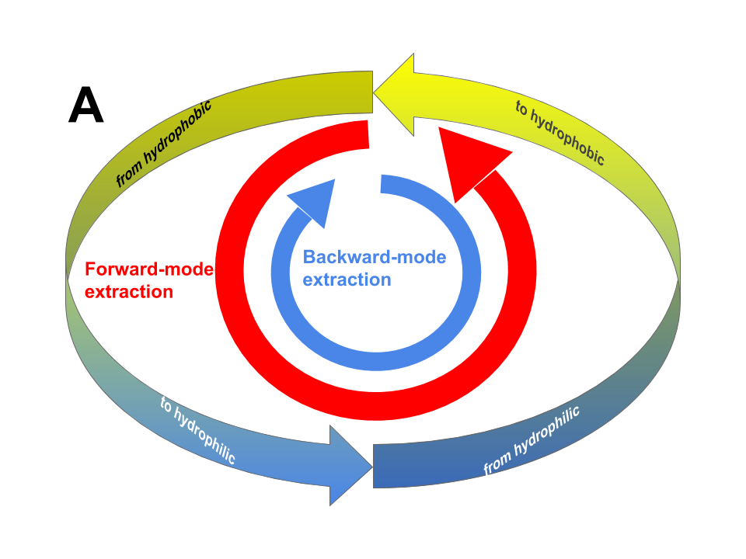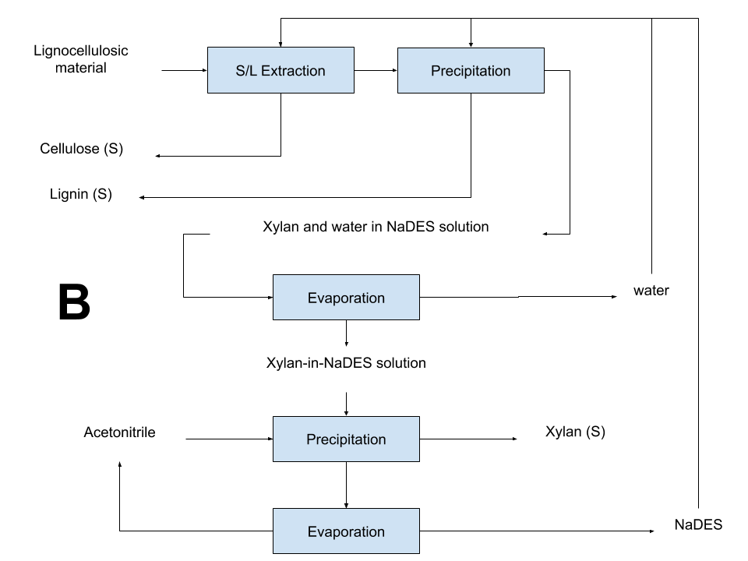
Figure 1. FME and BME approaches (A) and NaDES-based LCM biorefining (B).
4. Conclusions
Solvent extraction of a complex biomass containing an array of compounds should be treated with an array of solvents. With the aid of novel solvents which may change intrinsic features at the user’s will the “one-solvents-fits-all” target might come into the biorefinery range.
References
- Cicci, A., Sed, G., Jessop, P. G., Bravi, M. (2018). Circular extraction: an innovative use of switchable solvents for the biomass biorefinery. Green Chemistry, 20(17), 3908-3911.
- Sed, G., Cicci, A., Jessop, P. G., Bravi, M. (2018). A novel switchable-hydrophilicity, natural deep eutectic
solvent (NaDES)-based system for bio-safe biorefinery. RSC Advances, 8(65), 37092-37097.
[3] Kumar, A.K., Sharma, S., Shah, E. and Patel, A., 2018. Technical assessment of natural deep eutectic solvent (NADES) mediated biorefinery process: A case study. Journal of Molecular Liquids, 260, pp.313-322.

