Phase Equilibrium and Density of Highly Asymmetric Gas-Oil Mixtures at High Temperatures and High Pressures
Yiqun. Liu, Teresa Regueira, Erling H. Stenby, Wei Yan*
CERE, Department of Chemistry, Technical University of Denmark, DK-2800 Kgs. Lyngby, Denmark
*Corresponding author: weya@kemi.dtu.dk
Highlights
- Density and phase equilibrium of CH₄, N₂ and CO₂-oil mixtures systematically measured up to 190 ℃ and 1400 bar.
- Measured data most valuable for modeling highly asymmetric reservoir fluids.
- The more theoretical PC-SAFT model evaluated using the data against the classical cubic models with and without volume translation.

1. Introduction
The global demand for oil is still increasing and expected to stay at a high level for the near future. This has driven many production activities to deep reservoirs at high pressures and high temperatures (HPHT). Accurate description of phase equilibrium and thermophysical properties is of paramount importance to reduce the technical and economic risks in developing HPHT reservoirs. This study is a continuation of our previous work on measuring and modeling asymmetric hydrocarbon systems relevant to reservoir fluids^{[1][2]}. Although we measured binary, ternary and multiple component systems, it is found that the well-defined mixtures are not sufficiently representative for reservoir fluids. Hence, we here conducted a systematic measurement using the mixtures of a stock tank oil with various gases (CH₄, N₂ and CO₂). The measurement includes phase equilibrium and density data up to 190 ℃ and 1400 bar. Since the systems mimic reservoir fluids better, the obtained data provide a more relevant evaluation of various thermodynamic models in describing highly asymmetric reservoir fluids. We evaluated classical cubic models SRK and PR, and the more theoretical PC-SAFT EoS with a heptanes plus characterization method specially developed for it^{[3]}.
2. Methods
The density measurement was conducted in an Anton Paar DMA-512P high pressure oscillating tube densimeter following a modified Lagourette et al. method^{[4][5]}. Densities of CH₄-oil, N₂-oil, and CO₂-oil mixtures with different compositions were measured at six temperatures from 25 to 190 ℃ and at six pressures from 400 to 1400 bar. A full visibility cell ST PVT 240/1500 was used to measure the saturation pressure and liquid fractions in the two-phase region for the same gas-oil mixtures. The cell has a motor-driven piston to vary the system pressure and a sapphire window at its bottom to allow full visual observation of phenomena inside the cell and determination of phase fractions. At six temperatures from 25 to 190 ℃, gas (CH₄, N₂, or CO₂) was added to the oil stage by stage to prepare mixtures with increasing gas mole fraction. The classical cubic models SRK and PR were compared with the more theoretical PC-SAFT EoS in modeling the measured data. For SRK and PR, calculation results with and without volume translation were presented.
3. Results and discussion
Our measurement has produced over 270 density points and over 70 saturation pressure points. Figure 1 shows the phase envelopes for three selected mixtures with a gas mole fraction of 0.2. All models predict the correct trend but SRK and PR show large deviations for N₂-oil. Overall, three models show comparable deviations for the C₁-oil and CO₂-oil but PC-SAFT is better for N₂-oil. Some typical density modelling results are shown in Figure 2 for mixtures with a gas mole fraction of 0.2. PC-SAFT is clearly more accurate than SRK and PR without volume translation, but the volume translated SRK and PR show comparable and sometimes even better results than PC-SAFT.
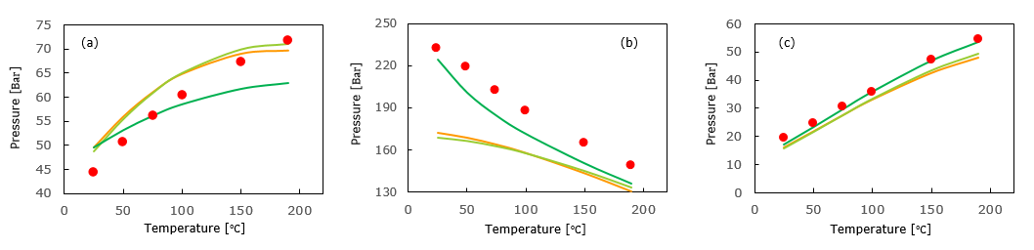
Figure 1. Phase envelope of C₁-oil (a), N₂-oil (b), CO₂-oil (c): data (); prediction by SRK (—), PR (—) and PC-SAFT (—).
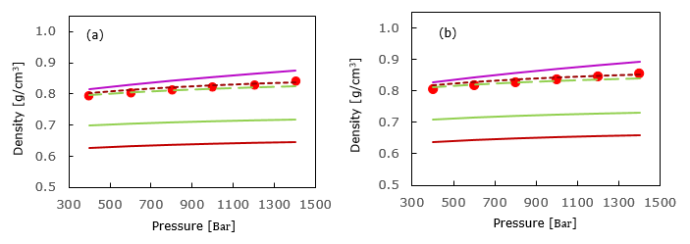
Figure 2. Density for C₁-oil (a) and N₂-oil (b) at 25 ºC: data (); prediction by SRK (—), PR (—), PC-SAFT (—), SRK-VT (– –), and PR-VT (– –).
4. Conclusions
This study has produced valuable HPHT density and phase equilibrium data of highly asymmetric C₁-oil, N₂-oil and CO₂-oil mixtures in a wide composition range. The data are particularly valuable for evaluating and further improving thermodynamic models for HPHT reservoir fluids since well-define mixtures turned out useful but not sufficiently representative in our previous study. The model comparison of PC-SAFT with classical models show that the more theoretical PC-SAFT has some advantages but may not be superior to PR (VT) and SRK (VT) in density modelling. For a more comprehensive evaluation, it is worthwhile to compare these models using other derived properties like excess volume and compressibility data.
References
- T. Regueira, G. Pantelide, W. Yan, E.H. Stenby, Fluid Phase Equilibria 428 (2016) 48-61.
- T. Regueira, M.L. Glykioti, E.H. Stenby, W. Yan, J. of Chem. & Eng. Data 63 (2018) 1072-1080.
- F. Varzandeh, E.H. Stenby, W. Yan, Fluid Phase Equilibria 433 (2017) 97-111.
- M.J.P. Comuñas, J.P. Bazile, A. Baylaucq, C. Boned, J. of Chem. & Eng. Data 53 (2008) 986-994.
- B. Lagourette, C. Boned, H. Saint-Guirons, P. Xans, H. Zhou, Measurement Sci. and Tech. 1992, 3, 699.

