ROMEO – A major step toward INDUSTRIAL membrane reactor application for hydroformylation
jennifer hasselberg¹, peter kreis¹, frank stenger¹, corinna hecht¹, robert franke², marco haumann³, markus schörner³, anders riisager⁴, jakob maximilian marinkovic⁴, morten logemann⁵, nanette zahrtmann³
¹Evonik Technology & Infrastructure GmbH, Process Technology & Engineering, Marl, Germany,
²Evonik Performance Materials GmbH, Marl, Germany
³Friedrich-Alexander-Universität Erlangen-Nürnberg (FAU), Germany,
⁴Technical University of Denmark, Lyngby, Denmark,
⁵ RWTH Aachen University, Aachen, Germany,
⁶LiqTech Intl., Ballerup, Denmark

Introduction

The hydroformylation is one of the most prominent industrially applied reactions. More than 10 million tons of chemical products rely on this homogeneously catalyzed reaction step every year; thus, a permanent improvement of the hydroformylation process is of utmost interest for many chemical companies like Evonik. Especially, it is the researcher´s and company´s aspiration to find a heterogeneous-like catalyst. The improvement done within Evonik followed several approaches in the past including optimization of process technology as well as optimizing the catalytic system. Most of these developments were achieved by public funded projects together with experts from academia.
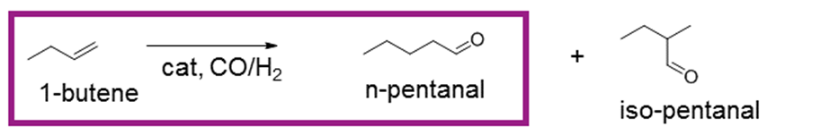
Fig. 1. Hydroformylation reaction formula

Experimental
This presentation gives an overview of the most relevant results of the currently running EU funded project ROMEO (Reactor Optimization by Membrane Enhanced Operation).

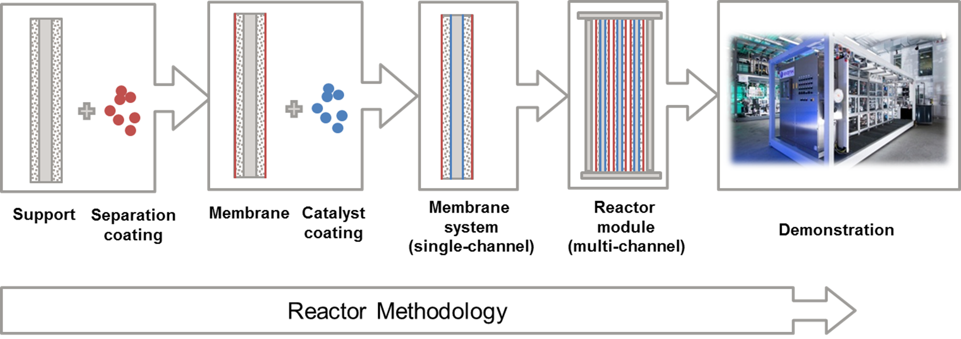
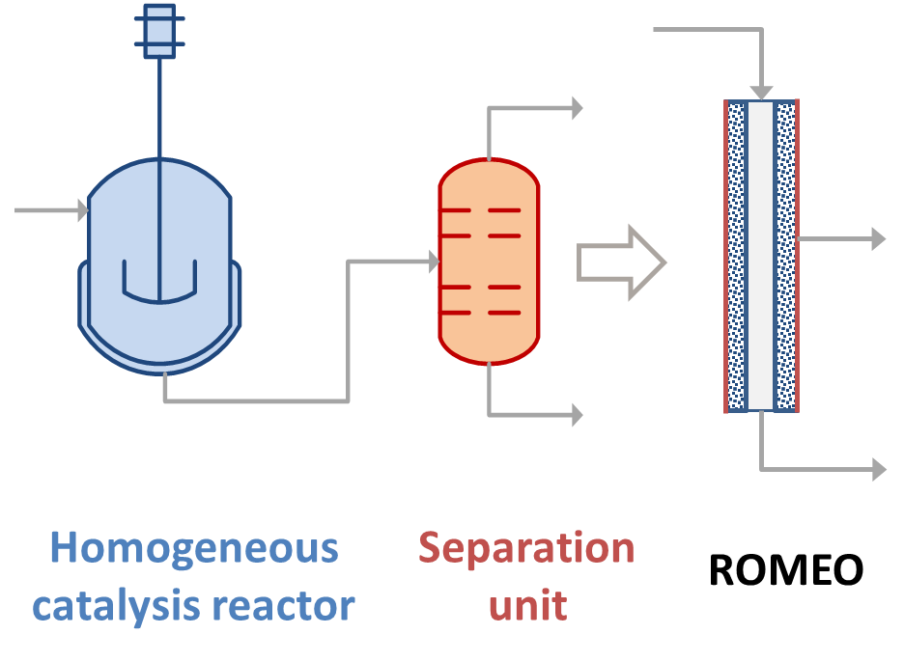
Fig. 2. 2-in-1 reactor principle (left) and reactor methodology (right)

The project aims at the combination of a catalytic reaction with the separation step on a single support structure. This combination in an innovative “2-in-1” reactor opens the possibility to omit or at least significantly downsize the separation units. In case of catalytic processes that are performed close to the chemical equilibrium the constant removal of one reaction partner from the reaction enhances the efficiency.

Results and discussion
The catalytic system contains of a ceramic support combined with a membrane coating and an impregnated hydroformylation catalyst. In order to evaluate the relevant long-term stability of such a catalytic system, a modular demonstration plant with a switchable reactor system was manufactured. With this modular design it is possible to compare the performance of a single monolith reactor with a multi-monolith reactor module. To operate the reactor with a technical industrial feed, a start-up procedure, an insitu catalyst impregnation and a catalyst recovery technology were developed.

The presentation will show relevant long-term experimental results as well as some sensibility studies of the membrane reactor modelling.

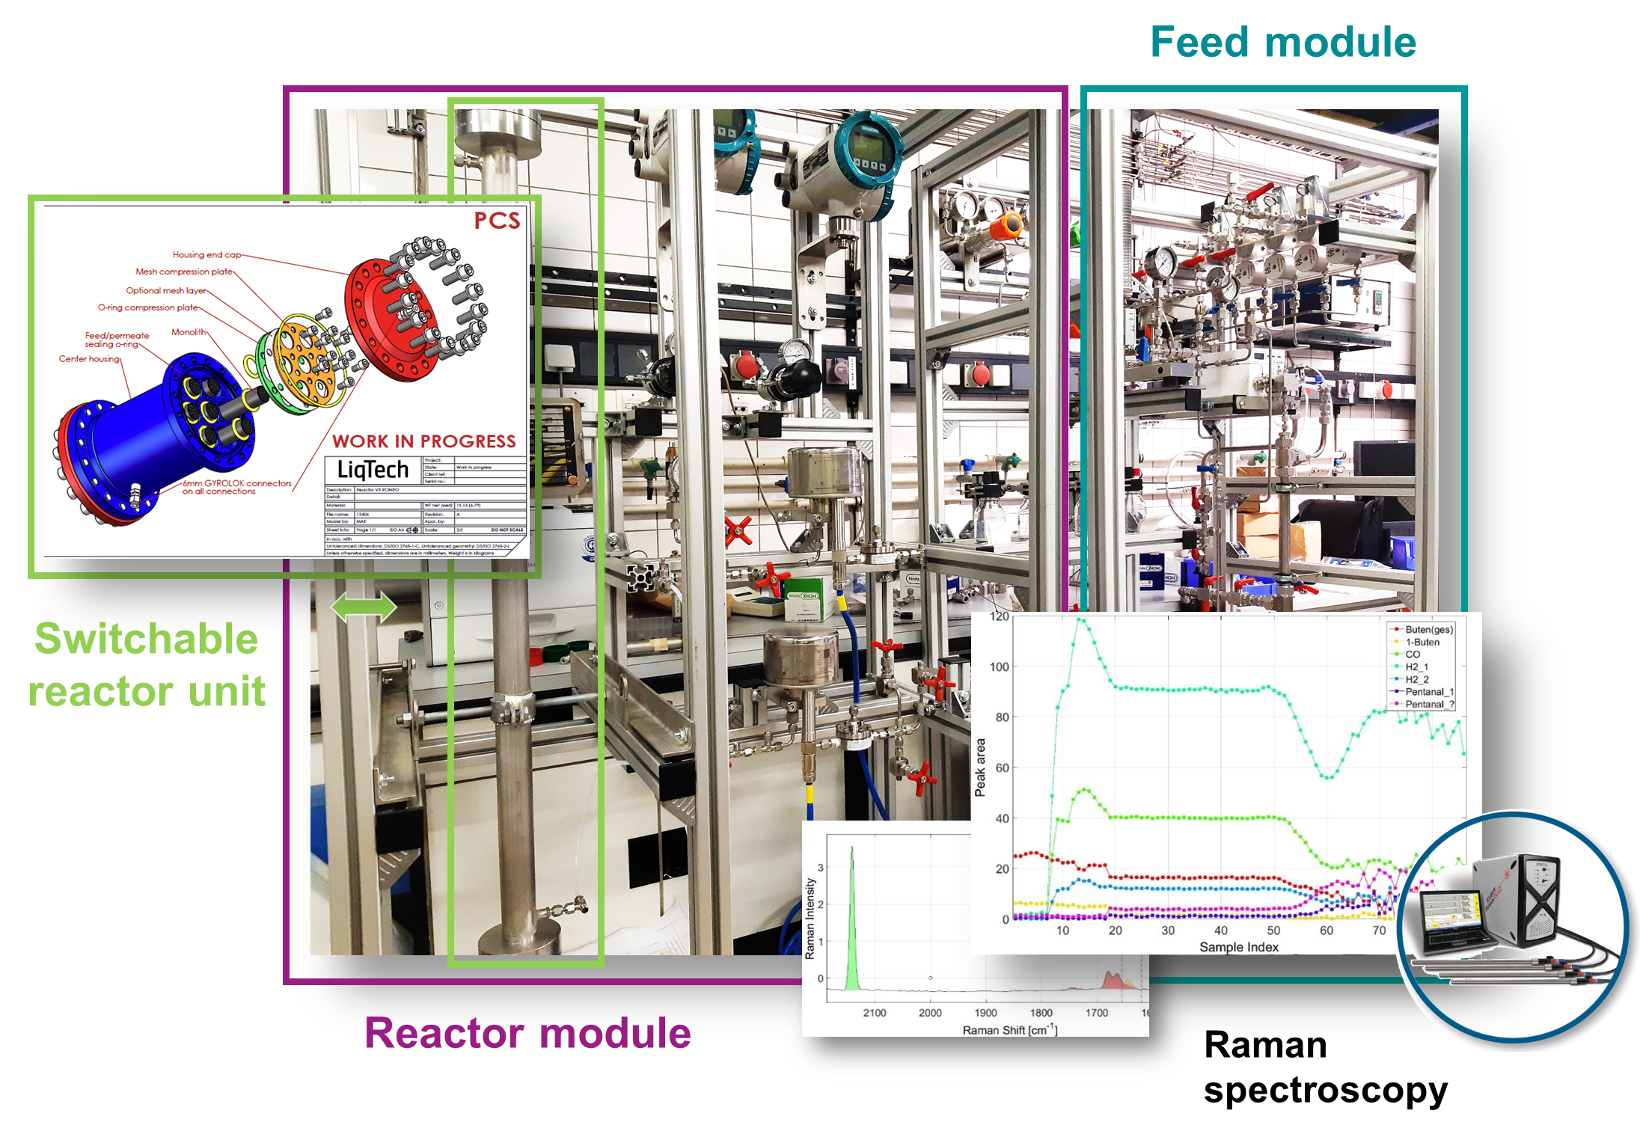

Fig. 3. Modular demonstration plant for long-term hydroformylation operation

Conclusions
Membrane optimization in terms of mechanical stability and material selectivity is still a challenge of the project but long-term demonstration already shows a significant economic benefit compared to the benchmark process concerning catalyst costs. The implementation of a pilot reactor to the benchmark process will be the next step to evaluate the technology in a bypass stream.

Acknowledgment
ROMEO has received funding from the European Union’s Horizon 2020 research and innovation program (grant agreement No

