Improving CO₂ Bioconversion Processes: Effect of Carbonic Anhydrase and a Fixed Bed Trickle Down System on gas solubilization
Laura Pérez¹, Adrián Marí¹, Annabel Serpico¹, Alba Suárez¹, Edxon Licon¹, Julia García¹
¹ LEITAT Technological Center, C/ de la Innovació 2, 08225, Terrassa (Spain)
*Corresponding author: lperez@leitat.org
Highlights
- Use of carbonic anhydrase (CA) to enhance CO₂ solubilization.
- Different concentrations of CA tested.
- Use of a fixed bed trickle down system to enhance CO₂ solubilization.
- Comparing the two different strategies and their combination.

1. Introduction
In recent times, CO2 has started to be used as a building block to produce a wide range of chemicals and products via biological processes. This has drastically changed the point of view, from seeing it just as a pollutant, to consider it as an economic substrate. This idea totally fits in the idea of circular economy, reducing greenhouse gases (GHG) emissions and converting CO2 into a high value product.
However, one of the major bottlenecks in the conversion of CO₂ into desired molecules via industrial biotechnology is the low yield of the target compounds. Among the different factors responsible for this low productivity, issues regarding gas availability should be addressed, like gas-liquid mass transfer and CO₂ solubility.
This study assesses two different strategies and their combination, a fixed bed trickle down system (TBR) [1] and a robust enzyme carbonic anhydrases (CA) [2], [3]. The improvement of gas-liquid mass transfer and CO₂ solubility enhance further 3-hydroxypropionic acid (3-HP) production using the Cupravidus necator.
2. Methods
Temperature and pH are two physical conditions that must be defined to promote the solubility of CO₂ and enhance the performance of the selected microorganism or enzyme. In this case, the experiments are performed at 30ºC (optimal temperature for Cupravidus necator) and at pH 8 (being the bicarbonate the main chemical species at liquid phase). The solution has a buffer of K⁺-PO₄³⁻ and each experiment takes place in 3 hours.
Figure 1 shows the two main strategies for CO₂ solubilisation. On one hand, CO₂ is introduced in a 1 L stirred vessel filled with the buffer solution with and without CA. On the other hand, a TBR filled with Raschig rings (6x6mm) is first optimized in terms of liquid flow and gas flow ratio (in countercurrent) and then the optimized concentration of CA is introduced in the system.
Samples are withdrawn regularly during each experiment to study the kinetics of CO₂ absorption.
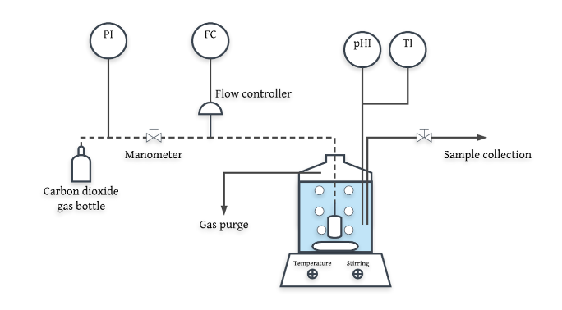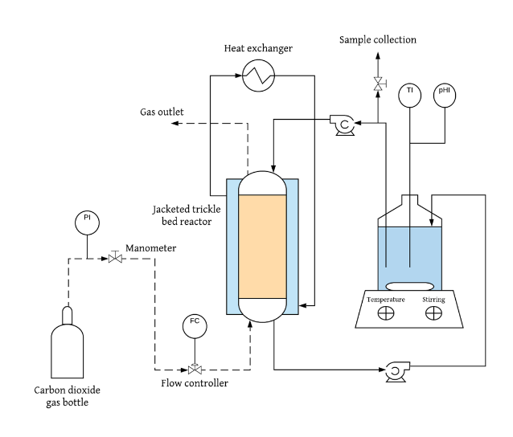
Figure 1. Experimental set-up for solubilization in vessel (left) and in TBR (right).
3. Results and discussion
Table 1 shows the preliminary results of CO₂ absorption in different conditions.
Table 1. Preliminary results on CO₂ absorption.
 | Water | Buffer | Buffer + CA | TBR
CO₂ absorbed (%) | 6,49 | 16,34 | 17,91 | 39,67
As it can be seen, the use of the buffer increases significantly the amount of CO₂ absorbed as the pH is maintained at 8. The use of CA has a slightly positive effect, but further experiments using higher concentration of CA are needed. Furthermore, the TBR presents the better result in terms of CO₂ adsorption and the use of CA in this system is expected to increase this value even more.
4. Conclusions
The use of CA and TBR has proven to be effective strategies to enhance CO₂ solubility. This will allow the conversion of CO₂ into desired molecules via industrial biotechnology to have a higher yield of the target compounds such as 3-HP (as is the case of the project in which this study is framed) and other chemicals and products via biological processes.
Acknowledgements
This project has received funding from the European Union’s Horizon 2020 research and innovation programme under Grant Agreement no. 761042 (BIOCON-CO2). This output reflects the views only of the author(s), and the European Union cannot be held responsible for any use which may be made of the information contained therein.
References
- RANADE, Vivek V.; CHAUDHARI, Raghunath; GUNJAL, Prashant R. Trickle bed reactors: Reactor engineering and applications. Elsevier, 2011.
- SAVILE, Christopher K.; LALONDE, James J. Biotechnology for the acceleration of carbon dioxide capture and sequestration. Current opinion in biotechnology, 2011, vol. 22, no 6, p. 818-823.
- KANTH, Bashistha Kumar; LEE, Jinwon; PACK, Seung Pil. Carbonic anhydrase: Its biocatalytic mechanisms and functional properties for efficient CO2 capture process development. Engineering in Life Sciences, 2013, vol. 13, no 5, p. 422-431.

