Rheology and Draining Properties of Model Dry Powders in a Hopper: Effect of the Vibrations and Opening Geometry.
Arthur Pascot¹*, Sébastien Kiesgen De Richter¹, Salaheddine Skali-Lami¹
1 Laboratoire d’Energétique et de Mécanique Théorique et Appliquée, University of Lorraine, UMR 7563 *Corresponding author : arthur.pascot@univ-lorraine.fr
Highlights
- Vibrations change the structure and rheology of the flow in a silo
- Vibrations prevent arches but tend to decrease the flowrate of the silo
- A law can be drawn between flow rate, geometry and vibrations parameters

This study is conducted in the framework of the “PowderReg” project, funded by the European programme Interreg VA GR within the priority axis 4 "Strengthen the competitiveness and the attractiveness of the Grande Région / Großregion".

1. Introduction
Granular materials are encountered in many fields, be it in Nature (sand castles, lava flows, avalanches…) or in industry (cosmetic powders, cereals, concrete flows…). Understanding the behaviour and flow properties (localization, jamming, aging…) of those materials is a major issue in rheology and fluids mechanic, mainly due to the complexity and multiscale aspect of the flow. Their comprehension is however important in order to optimize systems involving granular flows, such as hopper discharge.
2. Methods
The present work focus on the flow of dry powders in a quasi-2D silo (the depth allow only one layer of particle) when external vibrations are applied. The powders used are mainly spherical glass beads with a diameter around 1 mm. Numerical simulations using DEM [1] (Fig. 1.1) and experiments (Fig. 1.2) were performed in order to study the impact on the flow of the silo opening geometry and vibrations parameters.
For the geometry, various opening sizes between 4.5 to 18 particle diameters were tested, with opening angles ranging from 0 to 60°. For the vibrations, different amplitudes (10-5000 μm) and frequencies (15-600 Hz) were tested.
Experimentally, a scale follow the mass drained (measure of the flowrate) while the flow is recorded with a camera in order to determine the velocity fields (by PIV [2]) and the particle trajectories (by tracking) around the opening.
3. Results and discussion
We focus in particular on the effect of the vibrations on the flowrate, jamming properties (formation and destruction of arches) and local rheology of the flow. We show that, while vibrations can prevent arches formation, they also tend to decrease the flowrate. Therefore, we also propose an adimensional law linking the flowrate and the different parameters including vibrations properties, based on the Beverloo law [3]. The goal being, in the framework of the “PowderReg” project, to size a 3D silo alimenting with different powders a full scale demonstrator of an industrial chain.
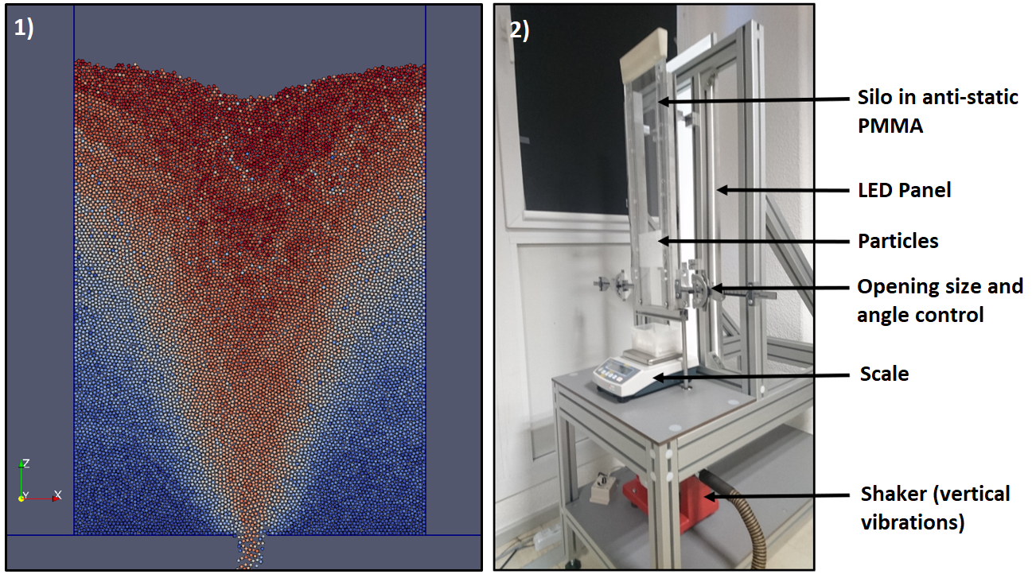
Figure 1. (1) Numerical simulation of the particle flow in the hopper and (2) Experimental setup.
References
- Peter A. Cundall, and Otto DL Strack. "A discrete numerical model for granular assemblies". Geotechnique 29.1 (1979): 47-65.
- D.A. Steingart and J.W. Evans. "Measurements of granular flows in two-dimensional hoppers by particle image velocimetry. Part I: experimental method and results". Chemical Engineering Science, 2005, vol. 60, no 4, p. 1043-1051.
- W. Beverloo, H. Leniger, and J. Van de Velde. "The flow of granular solids through orifices". Chemical engineering science, 1961, vol. 15, no 3-4, p. 260-269.

