Direct observation of particle accumulation on a model filter: analysis of the morphology of solid particles and yeast cakes.
Alberto Valencia¹, Philippe Schmitz^{1*}, Christine Lafforgue-Baldas¹, Jeffrey Morris²
1 Université de Toulouse, INSA, LISBP, Avenue de Rangueil, 135, F-31077
Toulouse, France;
2 Levich Institute, CUNY City College of New York, 140th Street and Convent Avenue, New York, NY 10031
*Corresponding author: schmitz@insa-toulouse.fr
Highlights
- A new microfluidic device for direct observation of particle accumulation.
- Use of image processing for particle tracking and concentration profile
- Growth of cakes of spherical solid particles and yeast cells.
- Compressibility effects of the yeast cake.

1. Introduction
Particle transport and capture are widely encountered in many applications, from living to environmental and manufactured systems. In the particular case of filtration of living cells such as microorganisms, the fouling phenomenon, partly related to cell accumulation at the filter surface, should still be better understood to improve the performance of a number of devices. Experiments in model systems have exhibited complex behaviors of the microorganisms due to their specific properties (shapes, mechanical properties, physiological state) that drastically depend on the local environment. A new microfluidic device was thus developed to study the morphology of filtration cakes through the direct observation of particle accumulation. Particle trajectories, velocity and concentration fields were all studied during cake growth.
2. Methods
The setup consists of a transparent photoetched microfluidic device with a rectangular channel (1mm x 20 to 30 µm) having a filtering structure of multiple slots and a microscope connected to a computer (Figure 1A). Different filter geometries were obtained by varying the width of the slots and the pitch (Figure 1B). Two model suspensions were used: monodispersed spherical solid particles (8.2µm) purchased from Thermoscientific, and cultivated yeast cells (mean diameter 6µm). Filtration experiments were performed at low flow rates (1 to 20 µl/min). The images of particle transport and capture and pressure drop were recorded during filtration. Dedicated image processing modules were developed for particle tracking, velocity and concentration fields and fluid/cake interface tracking.
3. Results and discussion
The effect of the filter geometry on the final position of the first arriving particles and the subsequent blockage of the slots was carefully analyzed. First, particles can eventually protect neighbor slots from blockage as function of the ratio between particle size and pitch (Figure 2A). The same results were previously obtained in the case of microsieves (provided by Aquamarjin) made of regular arrangement of circular pores [1]. Then the permeability of the resulting first layers of accumulated particles depends on the filter geometry.
The mean porosity of the cake was calculated from the cake observed thickness and the mass of particles accumulated, taking into account the time variation of the particle concentration field above the cake. As can be expected it is about 50% in the case of spherical solid particles. However, it is lower in the case of yeast suspensions and slightly decreases with time of filtration, exhibiting a compressibility effects of yeast cakes. This phenomenon was observed as an increase of the cake thickness when the flow rate is stopped (Figure 2B). Analog results were previously obtained and explained by the deformation of the yeast under pressure [2].
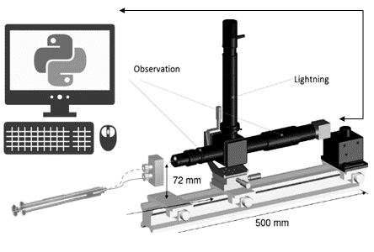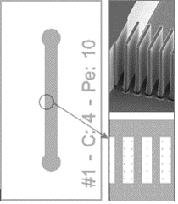
Figure 1. A) Experimental setup. B) Details of the filter geometry

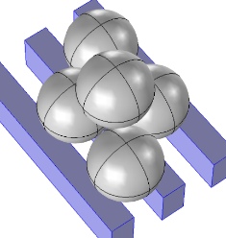
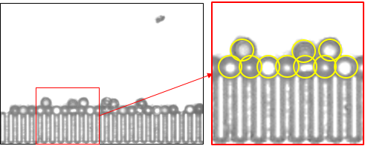
Figure 2. A) Visualization and sketch of first particle layer deposition. B) Compressibility effects of the yeast cake

4. Conclusions
A new microfluidic filtration device was developed to scrutinize the particle accumulation on a model filter. The results allow for better understanding of the first step of cake formation and the morphology of the cake, especially for yeast suspensions. Discussions should be strengthened by future experiments with non-spherical solid particles (snowman shape, for example) and yeast cells obtained from different states of cultivation.
References
- I. Ben Hassan, C. Lafforgue, A. Ayadi, P. Schmitz, J. Membr. Sci. 454 (2014) 283–297.
[2] M. Meireles, M. Clifton, Michael, P. Aimar, Desalination. 147 (2002) 19-23.

