Shape and Velocity Prediction of Slug Bubbles in Vertical Pipes.
Alexandre Boucher¹, Roel Belt², Alain Liné¹
- INSA Toulouse, Transfer-Interface-Mixing, LISBP - 135 avenue de Rangueil, 31077, Toulouse, France,
- TOTAL S.A., PERL, Pôle Economique 2 – B. PP 47, 64170 Lacq, France.
*Corresponding author: aboucher@insa-toulouse.fr
Highlights
- Vertical slug flow in stagnant and flowing liquids.
- Semi-analytical methods for slug bubble shape determination.
- Effect of inertia, surface tensions, and viscosity on bubble shape and velocity.

1. Introduction
Co-current vertical slug flow is present in numerous fields of applications, among which the transportation of hydrocarbons into pipelines, the promotion of mixing in reactors, the filtration through membranes, or emergency cooling of nuclear reactors are some practical examples. Simplified mechanistic models together with adequate closure laws seem to model satisfactorily vertical slug flow for most industrial purposes. Hence, a prolific number of closure relations have been developed on the terminal slug bubble velocity or the slug void fraction, but few focused on the characterization and the prediction of the slug bubble shape. However, terminal velocity and the shape of the nose are intimately linked, and most closure relations can benefit a better characterization of the slug bubble shape. Semi-analytical (the final analytical set of equations is solved numerically) methods have been reviewed and predictive slug bubble shapes have been computed with respect to flowing liquid velocities and surface tensions. Extended methods to include viscous forces into the predictions have also been studied.
2. Results and discussion
Dumitrescu [5] was one of the first to derive the slug bubble shape and velocity using a couple resolution of the Stokes stream function $ψ\left(ξ,η\right)$ given by potential flow theory and Bernoulli’s equation on the bubble surface. He concluded with an impressive accuracy that the square of the rising velocity $U_{B}$ of an elongated bubble in a stagnant liquid with negligible surface tension was proportional to the acceleration due to gravity $g$ and the pipe diameter $D$, leading to a Froude number $Fr=0.351$.
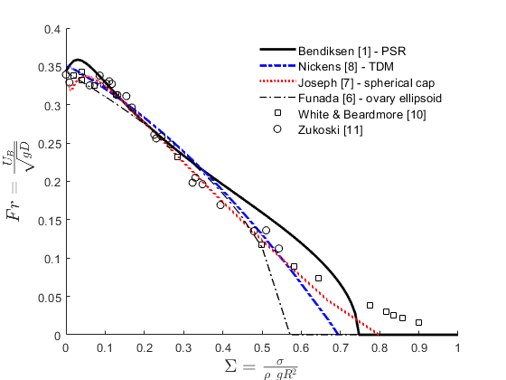
Ever since, his methodology was extensively used ([4], [9], [3], [1], and [8]) on problems with increasing complexity, taking for instance into account the effects of a flowing liquid ([9], [3], [1], and [8]) and turbulent velocity profiles ([3], and [1]) in terms of Reynolds number, and the effects of surface tension ([9], [1], and [8]) in terms of Eötvös number. These works can be grouped in two resolution methods: the Power Series resolution (PSR) used in [1], [4], [5] and [9], and the Total Derivative method (TDM) used by [3] and [8]. It is also worth mentioning that more recently the viscous potential flow theory was used in [7] and [6] in order to determine the shape and the velocity of a deformable spherical cap and an ovary ellipsoid respectively. The bubble shape for an air bubble in stagnant water was computed on Fig. 1 using the PSR solution. This result can be extended to different values of surface tensions as shown in Fig. 2 where the resulting velocity is compared to experimental data for different methods of resolution.
Figure 2. Dimensionless slug bubble velocity in function of surface tensions. Comparison to experimental data.
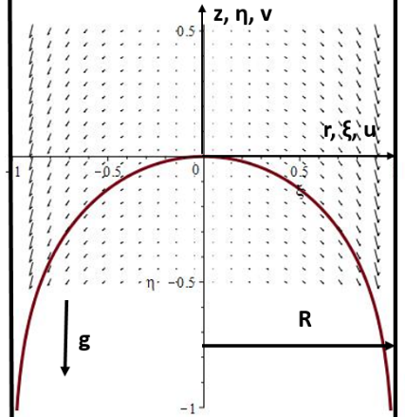
Figure 1. Computed bubble shape and velocity field around it in the moving frame coordinate system.
3. Conclusions and perspectives
The slug bubble shape can be computed using semi-analytical methods and the resulting rising velocity seems to be in agreement with experimental data for small values of surface tensions. For smaller tube diameters, the curvature of the bubble surface and the increasing importance of the liquid film (viscous zone) is in contradiction with potential flow hypothesis and require a specific theory of the kind of Bretherton’s [2] in order to accurately predict the film thickness of the developed zone. A new resolution method can thus be found considering both potential flow at the vicinity of the bubble nose and the effects of the draining film at a binding distance $l_{nF}(Eo,Re,Mo)$ of the bubble tip depending on the properties of the system.
References
- K. H. Bendiksen, ‘On the motion of long bubbles in vertical tubes’, IJFM vol. 11, no. 6, (1985) 797–812.
- F. P. Bretherton, ‘The motion of long bubbles in tubes’, JFM, vol. 10, no. 2, pp. 166–188, Mar. 1961.
- R. Collins, F. F. D. Moraes, J. F. Davidson, and D. Harrison, ‘The motion of a large gas bubble rising through liquid flowing in a tube’, JFM, vol. 89, no. 3, pp. 497–514, Dec. 1978.
- R. M. Davies and G. I. Taylor, ‘The mechanics of large bubbles rising through extended liquids and through liquids in tubes’, Proc. R. Soc. Lond. A, vol. 200, no. 1062, pp. 375–390, Feb. 1950.
- D. T. Dumitrescu, ‘Strömung an einer Luftblase im senkrechten Rohr’, ZAMM - JAMM / Zeitschrift für Angewandte Mathematik und Mechanik, vol. 23, no. 3, pp. 139–149, Jan. 1943.
- T. Funada, D. D. Joseph, T. Maehara, and S. Yamashita, ‘Ellipsoidal model of the rise of a Taylor bubble in a round tube’, IJFM, vol. 31, pp. 473–491, Apr. 2005.
- D. D. Joseph, ‘Rise velocity of a spherical cap bubble’, JFM, vol. 488, pp. 213–223, Jul. 2003.
- H. V. Nickens and D. W. Yannitell, ‘The effects of surface tension and viscosity on the rise velocity of a large gas bubble in a closed, vertical liquid-filled tube’, IJFM, vol. 13, no. 1, pp. 57–69, Jan. 1987.
- K. W. Tung and J.-Y. Parlange, ‘Note on the motion of long bubbles in closed tubes-influence of surface tension’, Acta Mechanica, vol. 24, no. 3, pp. 313–317, Sep. 1976.
- E. T. White and R. H. Beardmore, ‘The velocity of rise of single cylindrical air bubbles through liquids contained in vertical tubes’, Chemical Engineering Science, vol. 17, no. 5, pp. 351–361, Jan. 1962.
- E. E. Zukoski, ‘Influence of viscosity, surface tension, and inclination angle on motion of long bubbles in closed tubes’, JFM, vol. 25, no. 4, pp. 821–837, Aug. 1966.

