The Kinetics of Ethylene Oxide and Its Substituents in the Autocatalytic Reaction with Fatty Amines.
Pia Müller^{1*}, Wyatt Winkenwerder², John van der Schaaf¹

1 Department of Chemical Engineering and Chemistry, Eindhoven University of Technology, P.O. Box 513, 5600MB, the Netherlands; 2 Nouryon, Brewster, New York 10509, United States

*Corresponding author: p.muller@tue.nl
Highlights
- Ethylene-, propylene- and butylene oxide follow one reaction mechanism
- Lower or no substitution of the epoxide ring increases the reaction rate

1. Introduction
The reaction of fatty amines with two equivalents of epoxide is an industrial process producing surface-active compounds used in several applications, such as paints, corrosion inhibitors, and textiles. The reaction follows an S_{N}2 mechanism, which is auto-catalyzed by the formed intermediate (SEC) and the end product (TERT) shown in Figure 1.
R₁=C₈ alkyl chain
R₂= H (EO), CH₃ (PO), CH₂-CH₃ (BO)
Figure 1. Reaction scheme.
As described by Smith [1], the reaction is catalyzed by alcohol groups, such as the formed products. Sundaram and co-worker found that butylene- (BO), propylene- (PO), and ethylene oxide (EO) react with organic amines in an aqueous phase following the same mechanism [2]. Furthermore, the reaction rates decrease for increasingly substituted epoxides. In this work we aim to proof this correlation for the reaction with fatty amines without the influence of external catalysts or solvents.
2. Methods
Butylene- (BO) and propylene oxide (PO) reacted with octylamine (OA) as model substrate in a microchannel (10 ml). The reaction was carried out at 130 - 160 ºC and pressurized to 10 bar. The data was collected by the switch flow method. For EO the system was, due to safety reasons, built inside a glovebox with a set pressure of 60 bar. The products were analyzed by GC, NMR and FTIR.
3. Results and discussion
For the reaction of PO with OA experimental data were collected in flow (Figure 2). Based on preliminarily experimental data a kinetic model was fitted. The overall reaction for PO was 1.5 times as fast as for BO. It is expected for EO an increase in rate by at least a factor 2 compared to PO. The reaction proceeds slowly until significant amounts of SEC are formed. This could be avoided by using a CSTR or recycle system to further increase the process efficiency. Compared to the industrial process the continuous set-up is superior due to the higher saturation of the amine with epoxides.
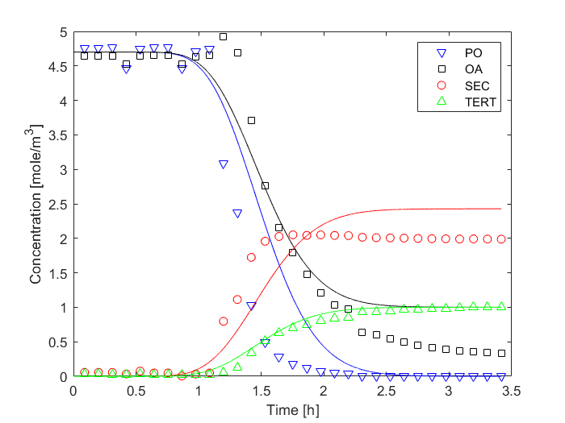
Figure 2. Exemplary reaction of PO with OA in a 1/1 ratio at 140 ºC and 10 bar.
4. Conclusions
A kinetic model fitting the experimental data for the reaction of BO, PO, and EO with amines was found and shows a rate dependency towards the substitution degree. The kinetic data collected are of high importance for the intensification of the industrial process. Using a continuous flow system, the intrinsic safety risks associated to the process could be overcome and different options for advanced process engineering can easily be tested and predicted.
References
[1] I. T. Smith, Polymer, vol. 2 (1961) 95–108.
[2] P. K. Sundaram and M. M. Sharma, Bull. Chem. Soc. Jpn. vol. 42 no. 11(1969) 3141–3147.

