Rheological characterization and flow simulation of a thixotropic toothpaste.
A. Makhmet¹, W. Bourguiba¹, C. Lemaitre^{1*}, P. Marchal¹, R. Mercade², R. Erkassov³
1 LRGP, Université de Lorraine-CNRS, UMR 7274, 1 rue Grandville, Nancy F-54001, France
2 School of Engineering, Nazarbayev University, 53 Kabanbay Batyr Ave, 010000 Astana, Kazakhstan
3 Department of Chemistry, Eurasian National University, 2 Satpaev st., 010008 Astana, Kazakhstan
*Corresponding author: cecile.lemaitre@univ-lorraine.fr
Highlights
- Rheological measurement on a toothpaste showed yield stress and thixotropy
- Kinetic and a rheological model selected and optimized to fit the experiments
- Rheological models implemented in ANSYS Fluent to simulate the toothpaste flow in an agitated tank.

1. Introduction
Due to their multi-ingredients composition, toothpastes are shear thinning (decreasing viscosity with increasing shear rate), they display a yield stress $τ_{y}$ (no flow for stresses lower than $τ_{y}$) and they are thixotropic (time evolving viscosity under constant solicitation, due to progressive evolution of the material structure) [1]. Toothpaste SIGNAL® Complete 8 was used in the present study.
2. Rheological characterization
A rotative strain-imposed rheometer ARES provided by TA Instrument is used to perform the measurements. The sample is placed between 2 parallel disks of 25 mm or 40 mm diameter, distant of about 1 mm. The operating temperature is set to 20°C.
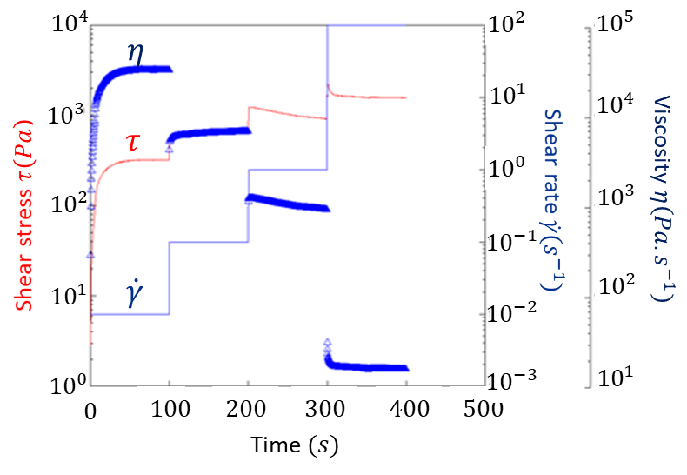 | 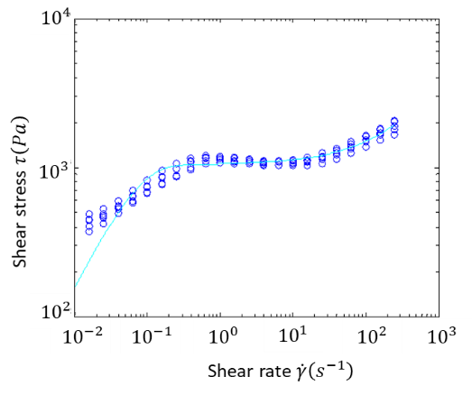
(a) | (b)
Figure 1. (a) Transient tests presented as a function of time. (blue line) imposed shear rate steps ; (red line) measured stress; (blue triangles) measured viscosity. (b) Steady tests: shear stress $τ (Pa)$ as a function of the shear rate $\dot{γ} (s^{-1}).$
Two types of tests were conducted: transient and steady. During the transient tests, shear rate $\dot{γ}$ steps were imposed to the sample and the shear stress τ and viscosity $η$were recorded in time. As for the steady tests, the τ and $η$ values at long times are measured for each imposed value of $\dot{γ}$.
The transient tests, Fig. 1(a), evidenced the thixotropic behavior of the toothpaste. The steady tests, presented in Fig. 1(b), show a shear thinning character, with a yield stress $τ_{y}≈{10}^{3}$.
Following [2], a kinetic and a rheological model were optimized to describe best the structural evolution in time of the toothpaste and the evolution of viscosity as a function of the shear rate.
3. Flow simulation
The purpose of the simulations was to reproduce the flow of a toothpaste sample in a tank equipped with a ribbon agitator, shown in Fig. 2(a), integrated to the ARES rheometer.
The geometry, designed with ANSYS Design Modeler, consists of two volumes: a cylindrical volume V1 containing the ribbon and an annular volume V2, surrounding V1, at the tank walls Fig. 2(b). Two meshes were generated with ANSYS Meshing, of 2,365,013 and 6,060,741 tetrahedral cells, refined near the walls. Both meshes were divided into two sub-meshes, one in V1 and the other in V2.
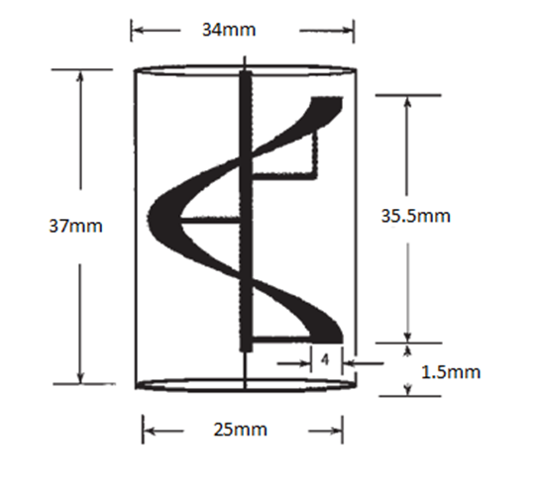 | 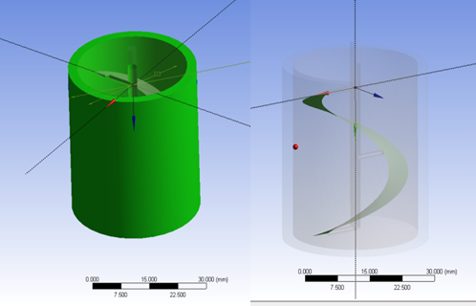
(a) | (b)
Figure 2. -(a) Dimensions of the geometry. (b) Geometry used for the sliding-mesh simulations.
The simulations were conducted with ANSYS Fluent. The rotational velocity of $N=0.573 rps$yielded a Reynolds number $Re=4.66×{10}^{-3}$, indicating laminar flow for a Newtonian fluid. The V1 sub-mesh was rotated at $N$, sliding against the static V2 sub-mesh. No-slip conditions were enforced at the tank and ribbon walls. On the free surface the shear stress was set to zero. The rheological model determined above was parametrized in Fluent. Navier-Stokes equations were solved using QUICK and central-difference schemes.
We will present the velocity vectors and profiles for different times. The calculated torque on the agitator will be compared to the one obtained experimentally.
References
- Laba D. Rheological properties of cosmetics and toiletries. New York : M. Dekker, 1993. 426 p.(Cosmetic science and technology, 13)
- Ardakani a, E. M. (2011). Thixotropic flow of toothpaste through extrusion dies. Journal of Non-Newtonian Fluid Mechanics.

