Charge-based agglomeration of submicron particles with potential for selective separation in grinding processes
Christoph Peppersack¹, Arno Kwade¹ and Sandra Breitung-Faes¹
1Institute for Particle Technology, Technical University of Braunschweig, Braunschweig, GER
*Corresponding author: c.peppersack@tu-bs.de
Highlights
- Top-down synthesis of submicron suspension with high quality standards
- Selective agglomeration in binary particle mixtures
- Separation of wear particles from wet grinding processes
1. Introduction
Within the top-down synthesis in stirred media mills, wear (abrasion) of the mill components, primarily the grinding media, is a major challenge in terms of lowering the product quality. A direct mechanical separation of the wear particles during/after the grinding process cannot be accomplished easily, as these usually have particle sizes similar to the product components.
The (hetero)agglomeration of submicron particle suspensions, induced by electrostatic particle-particle interactions, is a known process in literature. On the contrary, a selective agglomeration of certain components from a mixture of different materials has not been studied extensively yet. In this context, the principle of electrostatically induced agglomeration of submicron particles was investigated in a first step using zirconium dioxide suspensions as an exemplary wear component, since it is one of the most frequently used grinding media material. This study compares different agglomeration mechanisms with regard to their agglomerate size, strength as well as the yield of agglomerated particles. Subsequently, selective agglomeration of zirconium dioxide particles in a binary mixture with either an organic or inorganic material was evaluated. Here, this will be briefly described in its feasibility for anthraquinone as the organic material example.
2. Methods
For the data shown here, anthraquinone (product component, ρ = 1.31 g/cm³) and zirconium dioxide (wear component, ρ = 5,68 g/cm³) were chosen as materials. Using a stirred media mill (PML 2, Bühler AG), these substances were first ground in water to a defined particle size (x_{50, 3} = 0,3 μm for anthraquinone, x_{50, 3} = 0,3 μm for zirconium dioxide). To induce selective agglomeration of zirconium dioxide particles, the anthrachinone suspension was first mixed with a certain amount of agglomeration additive. Subsequently, the zirconium dioxide suspension was added in order to imitate the generation of wear. The final suspension had a mass concentration of anthraquinone equal to 4 %-w/w and of zirconium dioxide equal to 0.2 %-w/w. To analyse the success of selective agglomeration, samples of the suspensions were centrifuged for 5 minutes at different RCF values. Then, a defined volume was taken from the supernatants, which was first dried at 110 °C and then burnt out in a muffle furnace at 600 °C to decompose the organic material. After each heating step, samples were gravimetrically analysed in order to obtain both the loss of anthraquinone (product) and the loss of zirconium dioxide due to centrifugation.
3. Results and discussion
Figure 1. shows the percentage losses of anthraquinone (product) and zirconium dioxide in the supernatant obtained by centrifugation due to different RCF values with and without agglomeration additive. If the curves without additive are considered first, it can be seen that the zirconium dioxide particles can only be separated by higher centrifugal forces in larger quantities. However, this is associated with an undesired product loss, since anthraquinone particles are also centrifuged with the corresponding centrifugal forces. This effect would be enhanced if the centrifugal forces were increased or the centrifugation time extended.
In comparison, the curves with agglomeration additive show that a considerably higher proportion of zirconium dioxide could be separated from the suspension at significantly lower centrifugal forces (approx. 50 %-w/w at RCF = 380). This also ensures that almost the entire product material remains in the suspension because the centrifugal forces are too low to cause sedimentation of the anthraquinone particles. For this reason, it can be assumed from the results that the addition of the agglomeration ingredient resulted in selective agglomeration of the zirconium dioxide particles. This assumption can be supported by particle size analyses and SEM/EDX images (not shown).
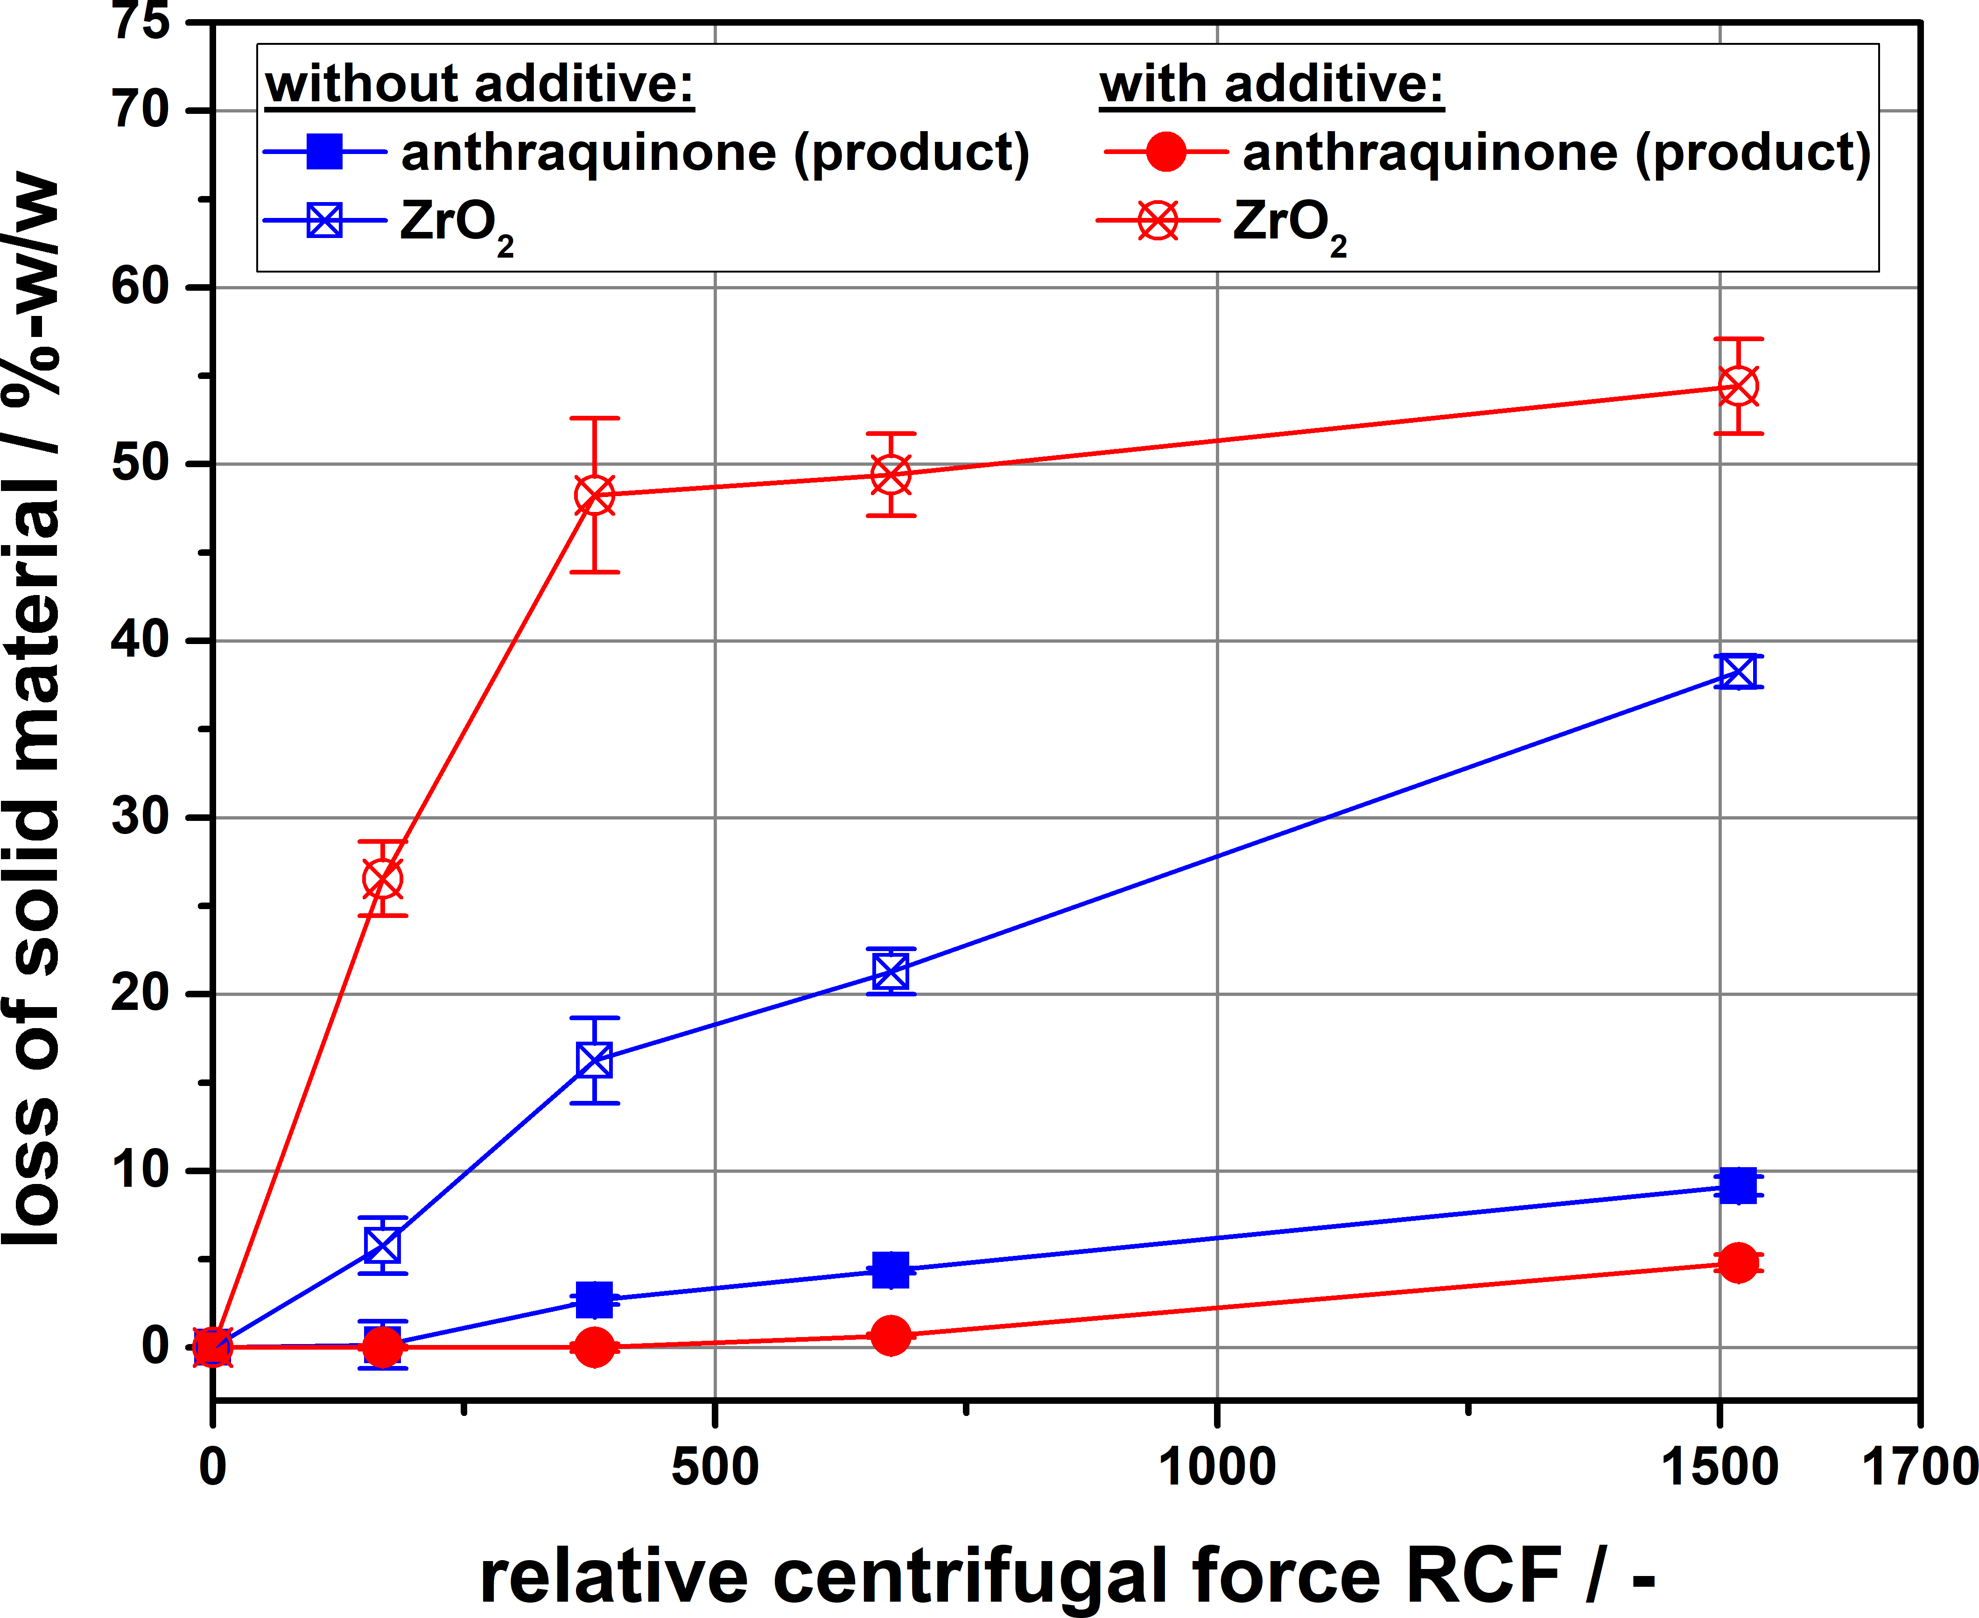
Figure 1. Gravimetrical analysis of selective agglomeration / separation
4. Conclusions
A promising method to selectively agglomerating the wear components is presented. It was shown that zirconium dioxide particles could be separated out of binary mixture with anthraquinone. Multiple variables in order to increase the yield of agglomeration are currently under investigation. The attained knowledge about an efficient, selective agglomeration can be used to remove the wear components from the product suspension in a suitable separation process. Hereby, this ensures that wear-free, submicron suspensions can be produced using a top-down process.
References
- S. Breitung-Faes and A. Kwade, A.Powder Technology, 212(3), 383-389, 2011.
- F. Flach et al., Advanced Powder Technology, 27(6), 2507-2519, 2016
- F. Flach, S. Breitung-Faes and A. Kwade, Colloids and Surfaces A: Physicochem. Eng. Aspects, 522, 140-151, 2017.
- W. Lin et al., (2006), Langmuir, 22, 1038-1047, 2006.

