CO₂ sorption modelling in humidified Polyvinyl amine (PVAm) with PC-SAFT
Riccardo Rea¹, Maria Grazia De Angelis^{1,*}, Marco Giacinti Baschetti¹
1 Department of Civil, Chemical, Environmental and Materials Engineering (DICAM), University of Bologna, Via U. Terracini, 28, 40127, Bologna
*Corresponding author: grazia.deangelis@unibo.it
Highlights
- H₂O sorption in PVAm modelled with PC-SAFT EoS
- CO₂ physical solubility predicted in the ternary systems PVAm / H₂O / CO₂

1. Introduction
Carbon dioxide emissions represent one of the main environmental issue of our time. The greenhouse gases atmospheric loading, due to anthropogenic activities, are causing a continue rise of global temperature. In the field of CO₂ capture from gas streams, membrane technologies are promising alternative to the more common operations. Among these, Facilitated Transport Membranes show high performances in terms of CO₂ permeabilities and selectivities even at low pressures by coupling a simple solution diffusion transport mechanism and a reversible chemical reaction with a carrier agent. Polyvinyl amine (PVAm) binds one primary amino group for each monomer along the chain, showing high hydrophilicity and affinity to CO₂. In this work we use the PC-SAFT [1] Equation of State to model the H₂O uptake and the solubility of CO₂ in the ternary system of PVAm / H₂O / CO₂.
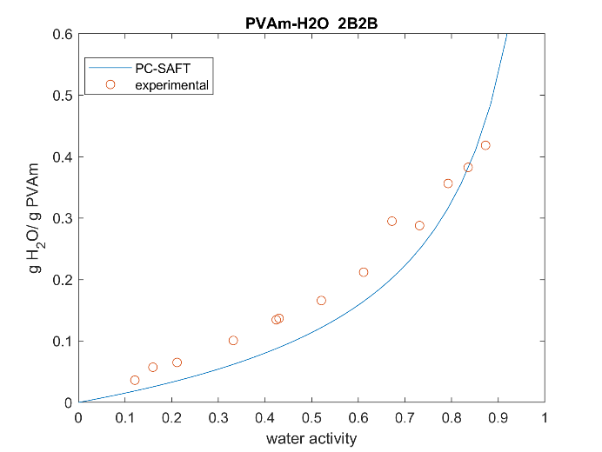 | 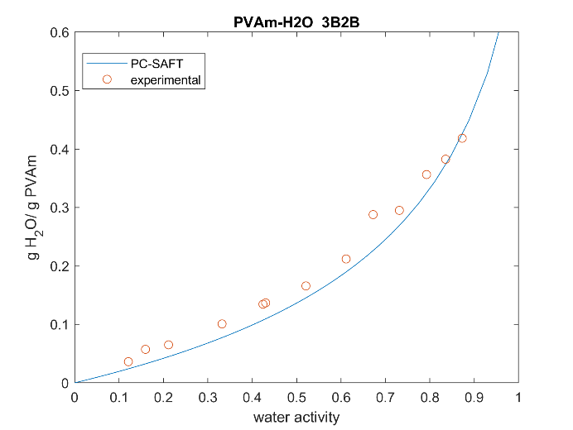
Figure 1. Water uptake in PVAm at 35°C. Circles are experimental data, lines are model calculations.

2. Methods
Within the PC-SAFT, each species is pictured as a series of chained spheres, interacting each other by dispersive, repulsive and associative forces. In the present work, the water has been treated as a self associative species, with 2 association sites (2B). The same scheme, together with the 3B [2], has been tested also for the PVAm. Besides the non associative case, two sites have been hypothesized for carbon dioxide to better consider the physical interactions among CO₂ and H₂O.
3. Results and discussion
In the figure 1 above, the uptake of water at 35°C in purified PVAm is reported, experimental points are the red circles while the blue lines are the model calculation. Both the association scheme used can describe the actual behaviour of the system in quantitative agreement with the experimental data. The scheme 3B (right) agree better over all the water activity range in respect to the 2B one. The physical sorption prediction (without considering explicitly the chemical reaction(s) ) of CO₂ in the ternary system is reported in figure 2 below.
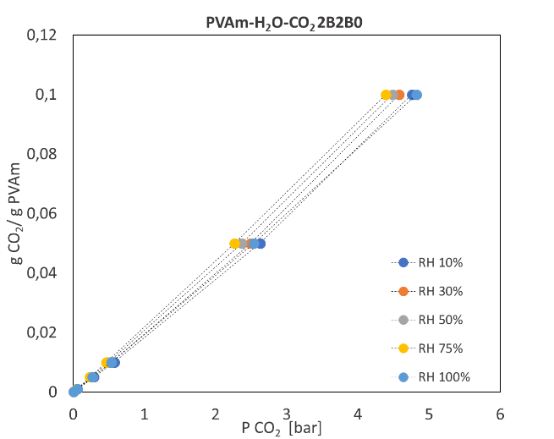 | 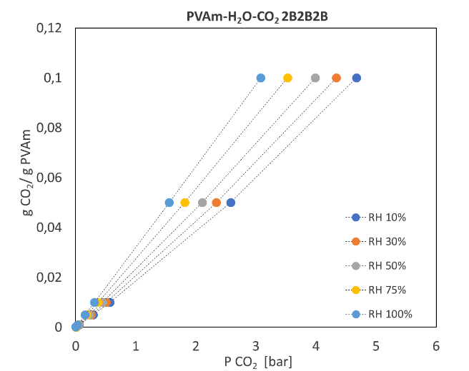
Figure 2. Prediction of CO₂ physical sorption in humidified PVAm.
In the non associative case (left figure) the relative humidity of water does not influence the uptake of CO₂ ; the presence of two sites, instead, elucidate the role of relative in humidity in the system . The higher the water activity, the higher the gas uptake, as we could expect for the system under study.
4. Conclusions
Both the two associative scheme used, 2B and 3B, are able to describe the behaviour of the membranes in terms of H₂O sorption. Moreover the physical solubility of the carbon dioxide in the ternary system of PVAm / H₂O / CO₂ is predicted and the role of relative humidity is elucidated by the presence of two possible associative sites on CO₂. A deeper investigation on the reacting ternary system is undergoing by the use of extended PC-SAFT [3] for polyelectrolyte.
Acknowledgements: This work has been performed in the framework of the European Project H2020 NANOMEMC² “NanoMaterials Enhanced Membranes for Carbon Capture”, funded by the Innovation and Networks Executive Agency (INEA) Grant Agreement Number: 727734
References
- J. Gross, G. Sadowski, Ind. Eng. Chem. Res. 40 (2001) 1244–1260.
- S.H. Huang, M. Radosz, Ind. Eng. Chem. Res. 29 (1940) 2284-2294.
- S. Naeem, G. Sadowski, Fluid Ph. Equilibria 299 (2010) 84-93.

