Mass Transfer Associated to the Metabolic Clearance of Uremic Toxins in a Surrogate System of the Artificial Kidney.
Mónica Faria¹, Tiago Eusébio¹, Pedro Brogueira¹, Maria Norberta de Pinho¹
1 Universidade de Lisboa Instituto Superior Tecnico, CeFEMA and Department of Chemical Engineering, Av. Rovisco Pais, 1049-001 Lisbon, Portugal; 2 Universidade de Lisboa Instituto Superior Tecnico, CeFEMA and Department of Physics, Av. Rovisco Pais, 1049-001 Lisbon, Portugal
*Corresponding author: monica.faria@tecnico.ulisboa.pt
Highlights
- Innovative membrane synthesis coupling phase inversion and sol-gel techniques
- Asymmetric monophasic hybrid (CA/SiO₂) membranes with enhanced hemocompatibility
- High water fluxes with total urea removal and total albumin rejection

1. Introduction
Artificial organs associated to clinically well-established membrane-based treatments assure in extracorporeal blood circulation devices the metabolic functions of a failing organ like the hemodialyzer for the kidney. The hemodialysis (HD) membrane is the key component of the artificial kidney as it is responsible for removing accumulated uremic toxins, excess ions and water while simultaneously retaining vital components from the blood of End Stage Renal Disease (ESRD) patients [1,2]. The technical and medical progress of the artificial kidney depends on two major factors: 1) hemocompatibility of the membrane/blood interfaces, and 2) enhancement of the flow management/mass transfer associated to the metabolic functions of the artificial kidney.
The present study reports the synthesis and characterization of hybrid CA/SiO₂ membranes containing 5 wt.% silica via the coupling of the phase inversion and the sol-gel techniques taking into account a two-fold goal: 1) development of integrally skinned asymmetric CA/SiO₂ ultrafiltration (UF) membranes with high water permeability, preferential permeation of uremic toxins and total retention of vital blood components; 2) tailoring of membranes with hemocompatible surface morphologies.
2. Methods
The surface morphology of the membranes was characterized by Scanning Electron Microscopy (SEM). Mass transfer studies associated to the metabolic functions of the kidney are conducted in a custom-made benchmark device with a membrane surface area of 60 cm² as a surrogate system of the artificial kidney. Permeation experiments are carried out to yield hydraulic permeability (Lp), Molecular Weight Cut Off (MWCO) and rejection coefficients (f) to a set of reference solutes including urea, creatinine, uric acid and Bovine Serum Albumin (BSA).

3. Results and discussion
Monophasic hybrid integrally skinned asymmetric membranes containing 5 wt.% of silica, CA/SiO₂-5, were synthesized by a novel method that combines phase inversion with acid-catalyzed sol-gel process [3]. Fig. 1 displays the SEM image of a monophasic asymmetric cross section of the CA/SiO₂-5 membrane characterized by a very thin dense layer and a much thicker porous substructure. Permeation studies reveal that the hydraulic permeability of the hybrid CA/SiO₂-5 membrane is 82 kg/h/m2/bar, which is approximately 2.5 times higher than the value of the pure CA membrane (32 kg/h/m²/bar), total permeation of urea and complete retention of bovine serum albumin (BSA).
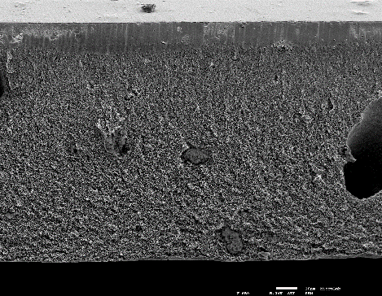
Figure 1. SEM image of the cross section (500x) of the hybrid integral asymmetric CA/SiO₂-5 [3].

4. Conclusions
In this work hybrid CA/SiO₂ membranes containing 5 wt.% silica were synthesized via the coupling of the phase inversion and the sol-gel techniques. Permeation studies show that the integration of silica into CA membranes by the innovative phase inversion/sol-gel method results in high flux ultrafiltration membranes with enhanced mass transfer properties pertaining to the metabolic functions of the kidney. In particular, the study shows that the CA/SiO₂-5 membrane is capable of complete removal of urea, the surrogate marker for small molecular weight uremic toxins while simultaneously retaining the vital protein found in blood, albumin. The versatility of the novel synthesis method allows further tailoring of structures and permeation properties of CASiO₂ membranes for the Artificial Kidney with high efficiency for specific removal of other critical uremic toxins.

References [Calibri 10]
- N.S. Hakim, ed., Artificial Organs, Springer-Verlag, London, 2009. //www.springer.com/gp/book/9781848822818.
- J. Vienken, Membranes in Hemodialysis, in: Membr. Life Sci., Wiley-Blackwell, 2010: pp. 1–48.
- G.Mendes, M. Faria, A. Carvalho, M.C. Gonçalves, M.N. de Pinho, Structure of water in hybrid cellulose acetate-silica ultrafiltration membranes and permeation properties, Carbohydr. Polym. 189 (2018) 342–351

