Synthesis of galacto-oligosaccharides from whey by enzymatic reaction in batch process versus continuous
Poliana C. Tiosso¹, Vanderson C. Fenelon², Graciette Matioli², Paulo W. Tardioli³, Flávio F. Moraes¹, Gisella M. Zanin^{1*}
1State University of Maringá, Chemical Engineering Department, Maringa – PR, Brazil
2State University of Maringá, Pharmacy Engineering Department
3Federal University of São Carlos, Chemical Engineering Department, São Carlos – SP, Brazil

*giselladeq@gmail.com
Highlights
- The continuous process allowed double the total GOS yield, compared to batch process.
- The continuous process favors a balance between the transgalactosylation reaction and the hydrolysis reaction.
- The maximum concentration of GOS in the continuous process was 256.72 g mL⁻¹ of solution, against 129.90 g mL⁻¹ of solution in the batch process.

1. Introduction
Galacto-oligosaccharides (GOS) are nondigestible carboydrates mostly produced from lactose transgalactosylation with β-galactosidases [1]. GOS are synthesized from lactose in a kinetically controlled reaction catalyzed by β-galactosidase (β-D-galactosidase galactohydrolase E.C.3.2.1.23), where the transgalactosylation and hydrolysis reactions occur simultaneously [2]. The high substrate concentration required is one of the main technological challenges in GOS synthesis; because of the relatively low solubility of lactose. Continuous stirred tank reactor has not been so much reported in the literature for the GOS synthesis, being the purpose of this work to evaluate the potentials of this strategy and to compare it with conventional batch synthesis. The present work has been conducted using β-galactosidase immobilized on macro porous silica, implementing a strategy for lactose feeding to the reactor and withdrawal of products; in order to avoid the effects of low lactose solubility, and thus achieve an increase in GOS yield at the end of reaction.
2. Methods
The chemical modification of the controlled porous silica was based on the study of Bernal et al [3]. Silanization was made using GPTMS (3-glycidyloxypropyltrimethoxysilane) solution. The immobilization of β-gal on glyoxyl-silica was done by the covalent method. After the immobilization, the enzyme was cross-linked with glutaraldehyde.
A duplicate experiment of GOS synthesis with K. lactis β-galactosidase was conducted in continuous process in order to evaluate its advantages over the batch operation mode. Operational sequence considered three stages at the following conditions: (i) An in initial batch synthesis stage lasting 45 min. (ii) A second stage in which a 40% w/w lactose solution was feed for 16 h at a feed of rate of 0.05 g of solution.h⁻¹and withdrawal of products with the same rate. (iii) A final batch stage during the next 48 h. The main product profiles were compared to the ones obtained by batch process. Lactose and products synthesis were done using HPLC system refractive index detector (SHIMADZU, UV-1601PC). The method was adapted from Santos [4].
3. Results and discussion
Figure 1 shows the yields for galacto-oligosaccharides production for batch and continuous process. Analysing this Figure, we can observe that the continuous process allowed double the total GOS yield. This can be explained by the fact that, the concentration of lactose is increased in this process, favouring a balance between the transgalactosylation reaction and the hydrolysis reaction. In the batch process, the GOS production is high only at the beginning, where the lactose concentration is still high, after which only the hydrolysis reaction is favoured.
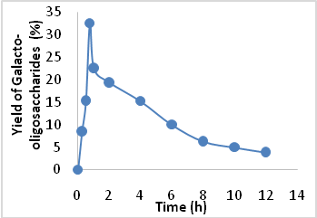  (a) | 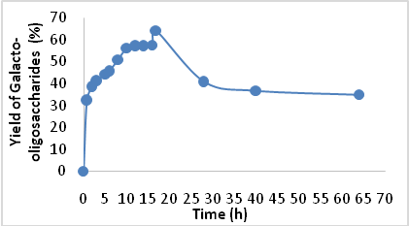  (b)
Figure 1.Yields of galacto-oligosaccharides. (a) Batch process, (b) Continuous Process.
4. Conclusions
This work shows that is possible to reach high total concentrations of dissolved sugars (>50% w/w) at moderate reaction temperatures without reduction in GOS yield by considering the synthesis of GOS in continuous process operation. This strategy allowed obtained an optimal final concentration of GOS higher than the one obtained in batch reactor operation.
5. Acknowledgements
The authors thanks CNPq and CAPES for financial support.
References
- G. Tzortzis, J. Vulevic, New York: Springer, 2009, 207-244.
- A. Gosling, G. W. Stevens, A. R. Barber, S E. Barber, S. E. Kentish, S.L. Gras, Recent Advances in refining galactooigosaccharide production from lactose. Food Chem. 2010; 121:307-318.
- C. Bernal, L. Sierra, M. Mesa,Design of β-galactosidase/silica biocatalysts: Impact of the enzyme properties and immobilization pathways on their catalytic performance, Engineering in Life Sciences, 2014, 14: 85-94.
- R. Santos, Production of galactooligosaccharide by fungal lactase. Dissertation (Master in Food Science) - State University of Campinas, Campinas - SP, 2006, 54p.

