**From a conventional wastewater sludge to a Photosynthetic Enhanced Biological phosphorus removal system**

Virgínia Carvalho1*, Elisabete Freitas1, Joana Fradinho1, Adrian Oehmen2, Maria Reis1

*1UCIBIO-REQUIMTE, Department of Chemistry Faculty of Sciences and Technology, Universidade NOVA de Lisboa, 2829-516 Caparica, Portugal*

*2Present address: School of Chemical Engineering, University of Queensland, Brisbane, QLD, 4072, Australia.*

*\*Corresponding author: virginiacfcarvalho@gmail.com*

**Highlights**

* Phosphorus removal with limited aeration
* Photosynthetic microorganisms as O2 suppliers
* Phototrophic system for wastewater treatment

**1. Introduction**

P is an element with vast applications in agriculture and industry but that can negatively impact the environment when released to water streams. One of the options for treatment of P-rich wastewater streams is the enhanced biological phosphorus removal (EBPR) system, that requires intensive aeration and thus increased operational costs [1]. With the aim of reducing the aeration dependence of EBPR processes, a new phototrophic-enhanced biological phosphorus removal (photo-EBPR) process was recently proposed [2]. The photo-EBPR system is composed of a consortium of polyphosphate (poly-P) accumulating organisms (PAOs) and photosynthetic microorganisms (algae, cyanobacteria) operated under dark/light cycles. During the dark anaerobic period, glycogen is hydrolyzed and poly-P is degraded, producing the necessary energy for volatile fatty acids consumption and accumulation as polyhydroxyalkanoates (PHA). During the light phase, photosynthetic microorganisms produce the necessary oxygen and, consequently, PHA is consumed, providing energy and carbon for the regeneration of poly-P and glycogen pools [2].

The first results obtained showed that it is possible to obtain a photo-EBPR system, capable of treating streams with high P concentration (60 mg/L) without need of external aeration, using as inoculum a sludge already enriched in *Candidatus* *Accumulibacter phosphatis* – well-known organisms for their capacity for high P uptake in conventional EBPR systems [2]. The aim of this study was to determine if it is possible to select a photo-EBPR system using conventional activated sludge from a conventional WWTP as seed sludge and to compare the results to the previous ones.

**2. Methods**

A sequencing batch reactor was seeded with activated sludge from a wastewater treatment plant in Lisbon and operated in 8 hour cycles (3 h dark, 4 h light and 1 h idle period), with a light intensity of 328 W/m2 provided by an internal halogen lamp. The sludge retention time was 20 days, hydraulic retention time was 16 hours, with temperature control at 20ºC and pH at 7.5. The reactor was fed with a solution (75%-25%) of acetate and propionate. COD in the feed was adjusted during the experiments, from 60 to 160mg/L, and the P concentration in the feed was 60 mg/L. Air was supplied in the last 2 h of the light phase to ensure that the culture was not limited by O2. Phylogenetic analysis of the bacterial community was done through Fluorescence in situ hybridization (FISH).

**3. Results and discussion**

Results show that in the first cycle with 60 mg/L of COD, the culture could not carry out EBPR despite VFAs being totally consumed during the dark phase (Figure 1-A). This suggests that the sludge from the WWTP was not enriched in PAOs and therefore not capable of immediately performing P release/uptake cycles. However, since VFAs were completely consumed in the dark period, COD in the feed was gradually increased along the SBR operation and P uptake in the light phase without aeration increased up to 13 ± 1 mg-P/L (Figure 1-B), a feature that may have resulted from the O2 availability from algae or direct P uptake by algae. Also, the higher carbon availability in the dark phase enabled more PHA accumulation and with more PHA available, more P can be taken up by PAOs. Although the culture selection process was slower in comparison with cultures already enriched in PAOs (table 1), activated sludge is widely available and a photo-EBPR system can be readily implemented without the need of a seed sludge previously enriched in PAOs. 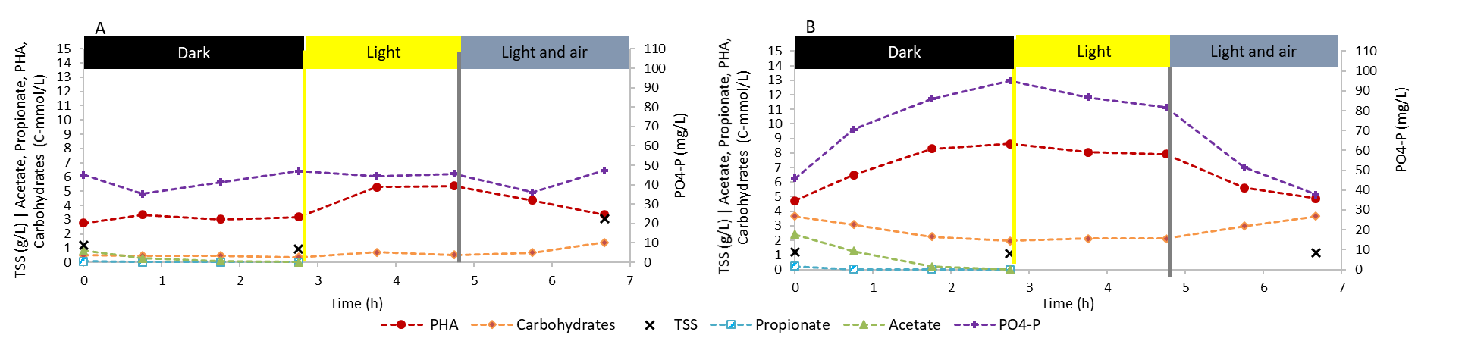

***Fig. 1 -*** Profile of P and carbon transformation during SBR operation: A – CODfeed= 60 mg/L; B – 160 mg/L

Table 1 - Comparison of the results obtained in the present work with the results obtained in Carvalho et al. (2018).



**4. Conclusions**

The present study indicates that conventional activated sludge can be enriched in PAOs and photosynthetic organisms capable of performing photosynthetic EBPR. Selecting a photo-EBPR culture directly from activated sludge could simplify the start-up and facilitate the implementation of photo-EBPR systems in wastewater treatment plants. In addition, the implementation of photo-EBPR systems will allow energy savings by eliminating the intensive aeration that increases operation costs in conventional EBPR.

**References**

1. Rosso, D., Larson, L.E., Stenstrom, M.K., 2008. Aeration of large-scale municipal wastewater treatment plants : state of the art 973–979. doi:10.2166/wst.2008.

[2] Carvalho, V.C.F., Freitas, E.B., Fradinho, J.C., Reis, M.A.M., Oehmen, A., 2019. The effect of seed sludge on the selection of a photo-EBPR system. N. Biotechnol. 49, 112–119. doi:10.1016/j.nbt.2018.10.003