The Challenge of Continuous Multiphase Flow For Heterogeneously Catalyzed Reactions with Liquid-Liquid Extraction.
Annika Grafschafter^{1*}, Matthäus Siebenhofer¹
1 Graz University of Technology, Institute of Chemical Engineering and Environmental Technology, Inffeldgasse 25C/II, 8010 Graz, Austria
*a.grafschafter@tugraz.at
Highlights
- Successfully implemented continuous multiphase flow.
- Heterogeneously catalyzed reactions with liquid-liquid extraction.
- Hydrodynamic investigation.

1. Introduction
The economic isolation of constituents from dilute aqueous effluents, as can arise in downstream processing of the biobased industry, may be achieved by the combination of reactive separations (e.g. esterification) with liquid-liquid extraction. By simultaneous extraction of the target product with a suitable solvent, equilibrium composition will shift and conversion can be enhanced. Slow chemical reactions, such as esterification reactions, require catalytic acceleration. For continuous operation, heterogeneous catalysts are very suitable since they are simple to separate via sedimentation. The implementation of continuous heterogeneously catalysed reactions combined with liquid-liquid extraction requires adequate apparatus design. Although different equipment is available on the market, equipment design and optimization is still a challenge, especially when targeting continuous multiphase flow. The Taylor-Couette Disc Contactor (TCDC) [1], a hybrid of the Rotating Disc Contactor (RDC) and the Taylor-Couette Reactor (TCR) satisfies the requirements for intensive continuous multiphase operation. The design of internals provides flexible operation under harsh operation conditions. The design is similar to the RDC, but with increased shaft diameter and without stator rings, whereby dead zones for accumulation of solid catalysts can be avoided. At convenient operation conditions, the shaft and rotor discs of the TCDC induce banded flow pattern, providing appropriate mixing of the liquid phases and the solid phase, and providing sufficient residence time for the solid catalysts.
2. Methods
Continuous liquid-liquid-solid flow has been implemented in a TCDC with 50 mm column diameter and 700 mm active mixing height. For the hydrodynamic investigation, ShellSol-T was used as solvent phase, deionized water as continuous phase and Amberlyst15® as solid phase. The hydrodynamic parameters dispersed phase holdup, solid phase holdup, mean droplet size as well as the on-set behavior of appropriate three phase operation have been investigated for varying rate of rotation (0 – 1100 rpm), hydraulic load (5-15 m³ m⁻²h⁻¹) and mass load of the catalyst. Since the continuous phase of this system is the driving force for appropriate mixing behavior, single phase CFD simulations of the continuous phase were conducted and evaluated.
3. Results and discussion
Beyond a critical rotational speed, the vorticity of the continuous phase overcomes sedimentation force of the dispersed phase and the solid phase and ensure intensive phase contact in the single compartment. The solid phase is dragged by the toroidal vortexes, and even in the presence of the dispersed phase the catalyst particles remain within the single compartment for reasonable residence time. The catalyst can easily be separated at the bottom of the column by sedimentation. Via the Q-criterion (CFD simulations) the vortexes inside the TCDC column can be pictured and the vorticity can be evaluated. Figure 1 depicts the vorticity of the counterrotating vortexes at increasing rate of rotation and varying hydraulic load. The vorticity increase with increasing rate of rotation. The increase of the hydraulic load does (nearly) not affect the vorticity.
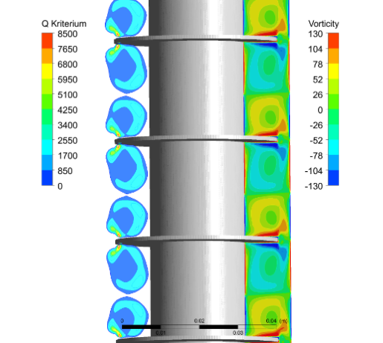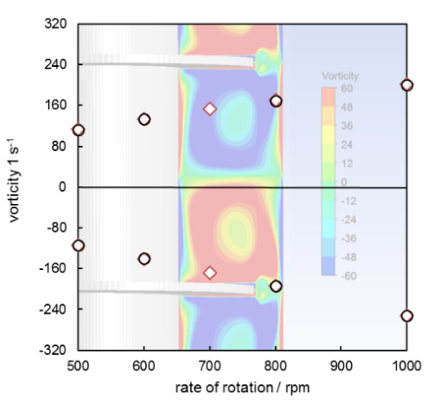
Figure 1. Q-Criterion and vorticity of the toroidal vortexes inside the compartment of a Taylor-Couette Disc Contactor.
4. Summary
The design principle of the TCDC offers intensive phase contact without hydrodynamic dead zones. Continuous multiphase flow was successfully implemented in the TCDC. Hydrodynamic investigations confirm applicability of this column design for intensifying heterogeneously catalyzed reactions combined with liquid-liquid extraction.
References
- E. Aksamija, C. Weinländer, R. Sarzio, and M. Siebenhofer, Sep. Sci. Technol. (2015) 2844-2852.

