Maximization of poly(3-hydroxybutyrate) production in fed-batch cultures of A. vinelandii based on the variation of the agitation rate

Beatrice Mongili¹, Claudio Alonso Padilla-Córdoba², Tonia Tommasi¹, Debora Fino¹, Alvaro Díaz-Barrera*²
1 Department of Applied Science and Technology (DISAT), Politecnico di Torino, Corso Duca degli Abruzzi, 24, 10129 Turin, TO, Italy;
2 Escuela de Ingeniería Bioquímica, Pontificia Universidad Católica de Valparaíso, Av. Brasil 2147 Casilla 4059, Valparaíso, Chile.
*Corresponding author: alvaro.diaz@pucv.cl
Highlights
- Specific growth rate is improved by high k_{L}a
- PHB productivity was affected by the volumetric oxygen transfer coefficient
- Variation of k_{L}a allowed to define maximal PHB productivity

- Introduction
The poly-hydroxybutyrate (PHB) is a polyethylene-like bioplastic naturally synthetized by several classes of microorganisms, as a source of energy and carbon unit [1]. This material, which is a promising candidate for the replacement of fossil-based plastic, is already present at an industrial scale. However, the maximization of its production process is the goal to achieve in order to reduce production costs. Azotobacter vinelandii is strictly aerobic gram-negative soil bacteria, able to produce PHB in a carbon substrate-rich environment and under oxygen-limitation conditions [2]. The production of this polymer is particularly interesting in this species, because it can accumulate up to 85% of its dried biomass as PHB [3]. It is known that agitation rate affects the PHB production by A. vinelandii [2]. In this work, the PHB productivity under fed-batch cultivation was evaluated to different volumetric oxygen transfer coefficient (k_{L}a). Thus, it was possible to determine an adequate k_{L}a range for scale-up the production of PHB.
2. Methods
Batch cultures of Azotobacter vinelandii OP were performed in a 3 L bioreactor (30 g L⁻¹ sucrose as carbon source) at 600 rpm during 30 h. After of this time, the cultures were fed by a single medium feeding pulse of the carbon source and the agitation speed was varied between 400 and 1000 rpm. The biomass evolution and the PHB production were evaluated. The k_{L}a was estimated at different agitation rate using dynamic method.

- Results and discussion
The maximal accumulation of biomass was 13.3 g L⁻¹, obtained at an agitation speed of 800 rpm (Table 1). A highest agitation speed increased the specific growth rate, reaching a value of 0.069 h⁻¹ to 1000 rpm. During fed-batch cultivation, a change in the agitation speed affected the PHB accumulation, obtaining the highest value (79.1 % w w⁻¹) to 600 rpm.

Agitation speed (rpm) | k_{L}a (h⁻¹) | µ (h⁻¹) | X_{max} (g L⁻¹) | PHB (% w w⁻¹)
400 | 30.3 | 0.011 ± 0.001 | 9.45 ± 0.14 | 66.0 ± 2.6
600 | 65.6 | 0.021 ± 0.001 | 11.50 ± 0.24 | 79.1 ± 1.5
800 | 103.6 | 0.062 ± 0.002 | 13.25 ± 0.49 | 54.7 ± 3.5
1000 | 188.0 | 0.069 ± 0.001 | 11.80 ± 0.05 | 46.3 ± 3.0
Table 1: Parameters obtained in the fed-batch cultures of A. vinelandii

Figure 1 shows the influence of k_{L}a on the PHB volumetric productivity. A maximal PHB productivity of 0.28 g L⁻¹ h⁻¹ was obtained at a k_{L}a of 104 h⁻¹. Overcoming the k_{L}a of 104 h⁻¹ the PHB productivity decreased until 0.18 g L⁻¹ h⁻¹. Under the conditions evaluated, the PHB productivity obtained to 100 h⁻¹ was similar to previous studies [2,3].
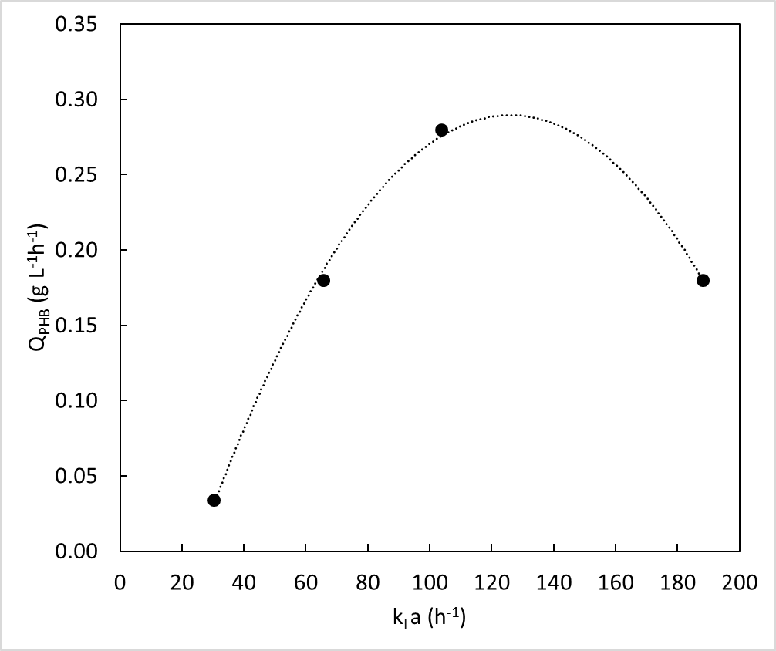
Figure 1. Relationship between the PHB volumetric productivity and k_{L}a values in Azotobacter vinelandii OP. The k_{L}a values evaluated correspond to the agitation speed of 400, 600, 800 and 1000 rpm.
4. Conclusions
In fed-batch cultures of Azotobacter vinelandii, the PHB productivity was affected by the volumetric oxygen transfer coefficient. The highest PHB productivity was obtained in the cultures performed to 104 h⁻¹ (800 rpm). In order to develop a bioprocess to produce PHB, it was possible to identify the optimal oxygen transfer conditions for further bioprocess scale-up.
References
- T. G.Y. Amy, C.L. Chen, L. Li, L. Ge, L. Wang, I.M.N. Razaad, Y. Li, L. Zhao, Y. Mo, J.Y. Wang. Polymers (Basel) 6(3) (2014) 706–54.
[2] A. Díaz-Barrera, R. Andler, I. Martinez, C. Peña. J. Chem. Technol. Biotechnol. 91 (2016) 1063-1071.
[3] T. Castillo, C. Flores, D. Segura, E. Guadalupe, J. Sanguino, E. Cabrera, J. Barreto, A. Díaz-Barrera, C. Peña. J. Chem. Technol. Biotechnol. 92(7) (2017) 1809–16.

