Effect of membrane profiles on the Limiting Current Density in Electrodialysis.
Mariagiorgia La Cerva¹, Luigi Gurreri¹, Michele Tedesco², Andrea Cipollina^{1*}, Alessandro Tamburini¹, Michele Ciofalo¹, Giorgio Micale¹
1 Dipartimento di Ingegneria, Università degli Studi di Palermo – viale delle Scienze Ed. 6, 90128 Palermo, Italia; 2 Wetsus, European Centre of Excellence for Sustainable Water Technology, Oostergoweg 9, 8911 MA Leeuwarden, The Netherlands
*Corresponding author: andrea.cipollina@unipa.it
Highlights
- LCD measurements in real ED stacks are presented.
- Different profiled membranes are tested.
- LCD performance of profiled and flat membranes are compared.

1. Introduction
Limiting Current Density (LCD) is a crucial parameter in electrodialysis (ED), and depends mainly on membrane surface properties [1] and on concentration polarization phenomena [2]. The latter are influenced by fluid dynamic aspects related, above all, to the characteristics of the spacers used in the channels. When profiled membranes [3] are used to create the channel thickness in stacks without spacers, the modification of the membrane surface and the presence of active membrane areas in directions not orthogonal to the current affect the LCD. Also the profile type is expected to have an effect on the LCD. In the present work, we experimentally investigated the effect of different membrane profiles on the LCD, testing also different operating conditions. The performance of profiled membranes and flat membranes (with spacers in the channels) were compared. The results were also used to validate our ED process model.
2. Methods
A crossflow ED stack, consisting of 10 cell pairs, with an active area of 10×10 cm² was used. Fujifilm membranes profiled with pillars or with overlapped cross filaments were tested. Inlet concentrations of NaCl ranging from 0.5 to 60 g/l and inlet velocities in the range 0.25 – 2 cm/s were examined. Current-voltage curves were built by chronopotentiometric measurements, thus identifying the LCD. Results obtained with profiled membranes were compared with data previously obtained with flat membranes and spacers [4]. Moreover, the experimental results were compared with the predictions of a one-dimensional process model [4], in which all the non-ideal transport phenomena through the membranes (osmosis, electro-osmosis, salt diffusion) are considered. The model predicts also concentration polarization by correlations for the Sherwood number obtained from computational fluid dynamics (CFD) simulations.

3. Results and discussion
We observed that the current-voltage curves show different trends depending on the membrane profile type present in the diluate compartment. In particular, when the profiles of the anion exchange membrane (AEM) are in the diluate compartment (blue symbols in Figure 1), the i-V curve changes slope at higher currents, thus leading to higher LCD values. However, this configuration exhibits lower LCD values compared to a stack equipped with flat membranes and net spacers (empty symbols in Figure 1), which can be attributed, at least in part, to a poorer mixing promotion.
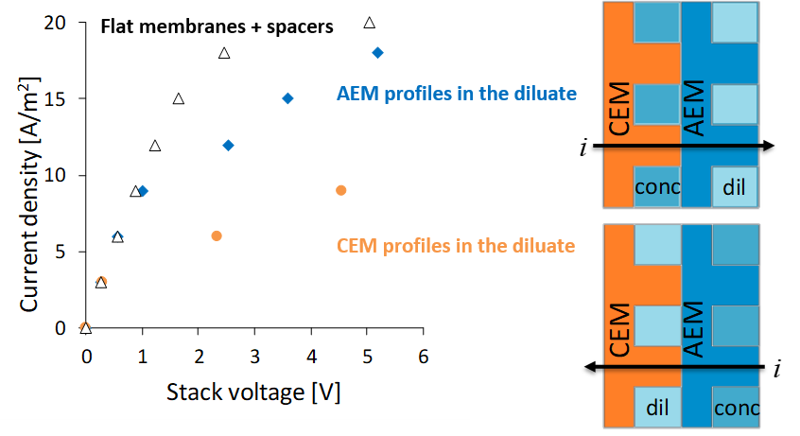
Figure 1. Current-voltage curves obtained with AEM profiles in diluate (blue symbols), with CEM profiles in the diluate (orange symbols) and with flat membranes and spacers (empty symbols). NaCl inlet concentration was equal to 0.5 g/l in both the concentrate and the diluate. Velocity was equal to 2 cm/s in both compartments.
4. Conclusions
In this work, we studied the influence of the membrane profiles on the LCD in ED units. We observed that the configuration with AEM profiles in the dilute channel is preferable, as provides higher LCD values. However, improved geometries have to be designed in order to enhance the performance with respect to conventional net spacers.
Acknowledgments
This work has been performed within the REvivED water project (Low energy solutions for drinking water production by a REvival of ElectroDialysis systems), Horizon 2020 programme, Grant Agreement no. 685579, www.revivedwater.eu.
References
- N. D. Pis’menskayaa, V. V. Nikonenko, N. A. Mel’nik, G. Pourcelli, G. Larchet, Russian Journal of Electrochemistry 48 (2012) 610–628.
- F. Li, W. Meindersma, A.B. de Haan, T. Reith, Journal of Membrane Science 208 (2002) 289–302.
- L. Gurreri, M. Ciofalo, A. Cipollina, A. Tamburini, W. Van Baak, G. Micale, Desalin. Water Treat. 55 (2015) 3404–3423.
- M. La Cerva, L. Gurreri, M. Tedesco, A. Cipollina, M. Ciofalo, A. Tamburini, G. Micale, Desalination 445 (2018) 138–148.

