Modelling and characterization of electrodialysis systems for multi-ionic solutions.
Antonino Campione¹, Andrea Cipollina¹, Luigi Gurreri¹, I. David L. Bogle², Michele Tedesco³, Alessandro Tamburini¹, Giorgio Micale¹
1 Dipartimento di Ingegneria, Università degli Studi di Palermo, viale delle scienze ed. 6, 90128 Palermo, Italia; 2 Centre for Process Systems Engineering, Department of Chemical Engineering, University College London, Torrington Place, London WC1E 7JE, UK; 3 Wetsus, European Centre of Excellence for Sustainable Water Technology, Oostergoweg 9, 8911 MA Leeuwarden, The Netherlands
*Corresponding author (A. Cipollina): andrea.cipollina@unipa.it
Highlights
- Modelling of electrodialysis for multi-ionic solutions.
- Estimation of multicomponent membrane properties.
- Assessment of membrane properties effect on multi-ionic systems

1. Introduction
Membrane desalination processes play a crucial role in the current scenario of drinking water production. In particular, electrodialysis (ED) is currently spreading as a viable alternative to other membrane desalination processes, so that plenty of modelling and simulation works have been published in the last few years [1–3]. However, most of modelling and experimental works assume that the feed solution contains dissolved NaCl only. In fact, real feeds always contain additional ions that can substantially affect process performances [4].
When multiple ions systems have to be modelled, the estimation of a much larger number of parameters related to membrane properties is required. Therefore, in this work a simplified approach for the modelling of an ED system operating with multi-ionic solutions is presented. The main parameters required to fully characterize the system and the criticalities arising in their experimental determination are highlighted. In particular, salt diffusion permeability, membrane resistance and transport numbers are discussed.
2. Methods
A hierarchical semiempirical model for ED process operating with multicomponent solutions is developed. The low-hierarchy of the model (i.e. the cell pair) has a one-dimensional structure and incorporates the main transport phenomena occurring through membranes. Each ion flux is described, accounting for the salt back diffusion as well as for water transport. In addition, cell pair voltage is estimated through both Ohmic (i.e. membrane and channels resistances) and non-Ohmic (i.e. membrane potential) contribution. Particular attention is given to the expression of the membrane potential that changes significantly compared to the single-salt scenario. The high-hierarchy model (i.e. the stack) links a series of cell pairs with the electrodes and it is devoted to computing the main performance parameters (i.e. energy consumption, current efficiency, water productivity…). In addition, a geochemical database (PHREEQC, USGS) is used for the estimation of the main thermodynamic parameters, such as activity coefficients, conductivities and saturation indexes of potential solid phases.
Empirical information on membrane properties are purposely collected via laboratory-test rigs: (i) salt diffusion permeability is estimated through batch diffusion dialysis experiments; (ii) membrane resistance is assessed via indirect measurement through an ED stack equipped with only one type of membrane (either anion or cation exchange membrane).
Finally, membrane transport numbers have been estimated through ED measurements according to Hittorf’s method [5].
3. Results and discussion
Figure 1 shows, as an explanatory example, simulation results for an ED unit fed with a NaCl, MgCl₂ and CaCl₂ ternary solution. A preliminary estimation of transport numbers and diffusion permeabilities is used as simulation input. The figure shows the concentration profile of the cations along the channel length. It is worth noting how the membrane properties can strongly affect the magnitude of each ion removal, resulting in this case in a much larger removal of sodium ions.
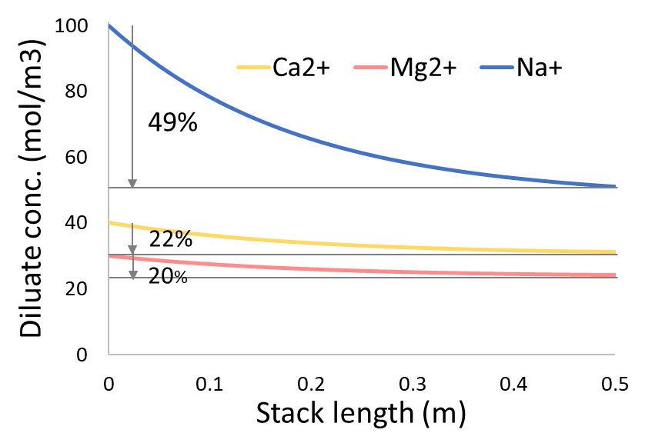
Figure 1. Concentration profiles inside a 0.1 x 0.5 m² electrodialysis stack desalinating a solution containing Na⁺, Mg²⁺, Ca²⁺ and Cl⁻. Channels 270 μm thick, 2A current, 1 cm/s flow velocity. Transport numbers in cation exchange membrane: 0.25 (Ca²⁺), 0.15 (Mg²⁺), 0.55 (Na⁺) and 0.05 (Cl⁻). Transport numbers in anion exchange membrane: 0.01 (Ca²⁺ ), 0.01 (Mg²⁺), 0.03 (Na⁺) and 0.95 (Cl⁻). Salt diffusion permeability are assumed equal to 4∙10⁻¹² m²/s for each salt.
4. Conclusions
The development of an efficient simulation tool for multi-ionic ED results into the possibility of estimating the effect of multiple components in the feed solutions. The effect of the characterization-parameters as the membrane properties is crucial for a reliable prediction of the system performance, thus justifying the need for properly estimating them.
References
[1] N. C. Wright, S. R. Shah, S. E. Amrose and A. G. Winter, Desalination, 2018, 443, 27–43.
[2] B. A. Qureshi and S. M. Zubair, Desalination, 2018, 430, 197–207.
[3] A. Campione, A. Cipollina, I. D. L. Bogle, L. Gurreri, A. Tamburini, M. Tedesco and G. Micale, Desalination, 2019 (under review).
[4] J. Moreno, V. Díez, M. Saakes and K. Nijmeijer, J. Membr. Sci., 2018, 550, 155–162.
[5] C. Larchet, L. Dammak, B. Auclair, S. Parchikov and V. Nikonenko, New J. Chem., 2004, 28, 1260.

