Particle comminution in stirred media mill and high-shear impeller – modelling and experimental approach
Norbert Wiatr¹, Radosław Krzosa¹, Radosław Adamek², Wojciech Orciuch^{1*}, Łukasz Makowski¹
1 Faculty of Chemical and Process Engineering, Warsaw University of Technology, Warsaw, Poland; 2 ICHEMAD-Profarb, Gliwice, Poland
*Corresponding author: Wojciech.Orciuch@pw.edu.pl
Highlights
- Particle comminution in stirred media mill and high-sheer impellers
- Influence of geometry and process parameters on the ultra-fine grinding process

1. Introduction
Size reduction process is crucial in many branches of the industry. It is commonly used in pharmaceutical, paint, cement, pyrotechnical industries and many others. Important problem is choosing the right parameters which will allow to optimize the cost of such an operation [1, 2].
In this work authors consider de-agglomeration and breakage process in two characteristic systems. The first device is a tank mixer equipped with a high-shear impeller. This type of agitators is usually high-speed and occur in the form of discs with protrusions to break up solid particles. The second device is stirred media mill that is one of the apparatus designed for ultra-fine grinding. The basic parameters describing the mixing process are: the amount of energy that is supplied into the fluid in a time unit by the mixer, mixing time, shear stresses, solids concentration and energy dissipation rate. The intensity of mixing, the speed of circulation and the presence of dead zones are also important in description of the mixing process. In stirred media mill the suspension mass flow, milling media size and material and mill geometry needs to also be considered. The set of these parameters allows to analyze the mixing process in terms of product quality and process economy [3, 4, 5]. Computational fluid dynamics is a convenient and fast tool for determining the influence of process parameters and system geometry on the considered process. It could reduce the cost of process optimization by reducing the number of experiments.
2. Methods
The systems geometries were created using SolidWorks software. Next for computational simulations the Ansys Fluent 19 software was used. To obtain detailed information of the hydrodynamics generated by the rotating element the multiple reference frame (MRF) approach was used. Turbulent flow k-ε and VOF models were used. It was checked that the results of the computations were not sensitive to a further increase of the number of computational cells. The SIMPLE method was used for the pressure-velocity coupling and the second-order discretization schemes were used for all variables to minimize numerical diffusion effects. The computations were regarded as satisfactorily converged when the total normalized residuals were smaller than 10⁻⁶.
In breakage experiments silica (SiO₂) or titanium oxide (TiO₂) particles suspended in water were used. The particle sizes distributions during process time were determined using Beckman&Coulter LS 13320 device.
3. Results and discussion
In this work we consider the influence of rotational speed, mass flow of suspension and mixing time on the dispersion and comminution processes. Additionally, in the case of a tank mixer, changes in the shape of the impeller were considered, while in the case of the mill the number and shape of the holes in the rotating discs were tested. In all cases global parameters of the system were determined as mixing power, mixing time, effective pumping number. Simulations for both studied systems were validated by comparison with experimental data obtaining a good agreement. Example of such simulation results is shown on fig. 1.
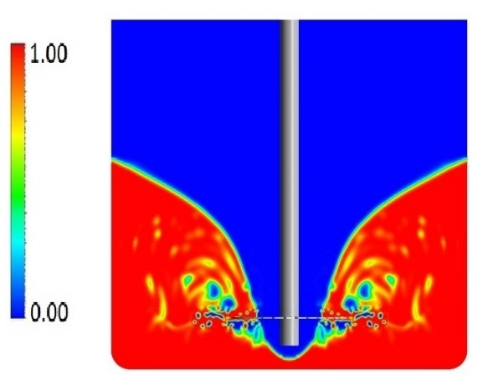
Figure 1. Volume fraction of suspension in tank mixer N=1000 $rpm$
4. Conclusions
Numerical simulations and experiments were carried out in order to gain influence of process parameters on comminution in two systems. Studying characteristic quantities as the power number or mixing time showed that the grinding process can be controlled by influence of the volume of the region of effective dissipation rate and particles residence time in this region. The obtained results help to predict better comminution conditions which may be useful especially when increasing the scale of process.
References
- J. Zhang, S. Xu, W. Li, High shear mixers: A review of typical applications and studies on power draw flow pattern, energy dissipation and transfer properties, Chem. Eng. Proc. 57– 58 (2012) 25– 41.
- Bałdyga J., Orciuch W., Makowski Ł., Malik K., Özcan-Taşkin G., Eagles W. and Padron G., “Dispersion of nanoparticle clusters in a rotor-stator mixer”, Industrial & Engineering Chemistry Research 47 (2005) 3652-3663.
- J. Ramírez-Muñoz, G. Martínez-de-Jesús, A. Soria, A. Alonso, L.G. Torres, Assessment of the effective viscous dissipation for deagglomeration processes induced by a high shear impeller in a stirred tank, Advanced Powder Technology 27 (2016) 1885–1897.
- D. Eskin, O. Zhupanska, R. Hamey, B. Moudgil, B. Scarlett, Microhydrodynamics of stirred media milling, Powder Technology 156 (2005) 95-102.
- S. Breitung-Faes, A. Kwade, Prediction of energy effective grinding conditions, Minerals Engineering 43–44 (2013) 36–43.

