The influence of water addition in Pre-Treatment of Sugarcane Straw Using Three Different Ionic Liquids
Felipe Ferrari^{1*}, Ariel Hijo¹, Jorge Pereira², Marcus Forte^{1*}
1 Faculty of Food Engineering, University of Campinas (UNICAMP), Campinas 13083-862, SP, Brazil; 2 School of Pharmaceutical Sciences, São Paulo State University (UNESP), Rodovia Araraquara-Jaú/Km 01, Campos Ville, 14800-903 Araraquara, SP, Brazil
*Corresponding author: ferrari.faf@gmail.com / forte@unicamp.br
Highlights
- Acetate based ILs had better performance on dry straw pre-treatment.
- [Emin][Ac] showed the best aptitude to pre-treat the dry straw.
- [Emin][Ac] was the most impacted by water addition.
- [Mea][Hex] was the only IL positively affected by water addition, regarding enzymatic digestibility.
1. Introduction
The replacement of fossil fuels by renewable alternatives has been studied in order to mitigate the environmental impact of energy production. However, the use of lignocellulosic (LC) residues, such as sugar cane straw (SW) to the synthesis of biofuels, demands pre-treatment, due to its complexity. The recent use of ionic liquids (ILs) in this process emerges as a strategy to overcome the problems faced, such as high-energy demand and inhibitory compounds production ¹. The ILs´ aptitude to efficient pre-treat SW in presence of water is crucial since LC materials are highly hydrophilic, and water addition is one strategy to overcome the hurdle of IL cost.
2. Methods
Brazilian Bioethanol Science and Technology Laboratory (CTBE) provided the grinded straw. Sieves (between 16 and 24 mesh) were used as feedstock for pre-treatments. Chemical composition was assessed before and after each experiment using NREL31 methodology adapted from CTBE. 1-ethyl-3-methylimidazolium acetate ([Emim][Ac], 98 % pure) was purchased from Iolitec (Germany) and used as received. 2-hydroxyethylammonium acetate ([Mea][Ac]) and 2-hydroxyethylammonium hexanoate ([Mea][Hex]) were synthetized in Schott flasks through acid-basic neutralization. All other chemicals and standards were purchased from Sigma Aldrich (Germany) and used as received. Enzymatic hydrolysis was performed in 1.5 mL plastic tubes using Cellic CTec2 (Novozymes), at 5% (w/w) of solid loading and 10 FPU of enzyme per gram of biomass. Hydrolysis was carried out in pH 4.8, citrate buffer, for 48h. The enzymatic digestibility of cellulose and hemicellulose was calculated according the relationship between initial solid mass and sugars concentration from supernatant (adapted from NREL’s LAP TP-510-4363031,32 ). Pre-treatment assays were done in triplicate. 0.6 g of dry SW was mixed with pure IL, and with IL 70 %(w/w) in H2O solution at 6% (w/w) solid loading, and then placed, in a convection oven at 90 °C for 12h. After the pre-treatment 10 g of water were added to each sample.
3. Results and discussion
The process using [Emin][Ac] had the best performance among the tested pure IL, entailing in 100 % of glucose realize after enzymatic digestion, followed by [Mea][Ac] and [Mea][Hex] 69 % and 46 %, respectively, without water addition. Both [Ac]⁻ based IL had similar performance on hemicellulose digestibility, 54 % for [Mea][Ac] and 55 % for [Emin][Ac]. Although acetate based ILs are described as good enhancers on biomass pre-treatment ², it is evident that changes of cations also play an important role on IL aptitude to pre-treat LC, mainly on cellulosic portion.
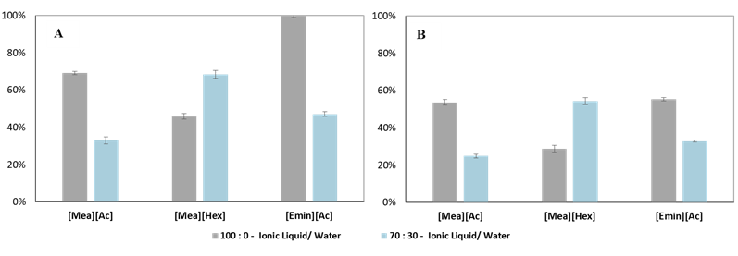
Figure 1. Enzymatic digestibility of cellulose (A) and hemicellulose (B) prevenient from residual solids after pre-treatment.
Nevertheless, in presence of water, [Mea][Hex] had the best performance among the tested IL, showing an opposite effect in this circumstance. Instead of the negative effect as observed in [Mea][Ac] and [Emin][Ac] process, water addition enhanced cellulose and hemicellulose digestibility in 49 % and 89 %, respectively. Acetate based ILs are good hydrogen bound acceptor, reason why IL species with this anion have good performance on LC pre-treatment ³, which also lead to higher interaction with water through hydrogen bound. Moreover, water tends to interact closely to the charged areas of IL (hydrophilic moiety) ⁴, the longer chain length of hexanoate anion my difficult the solvation of the molecule, thus allowing it to interact more efficiently with LC matrix than acetate in presence of water.
4. Conclusions
Considering enzymatic digestibility as criteria, [Mea][Hex] showed the best performance regarding water addition (the same values of cellulose and hemicellulose digestibility comparing with the pure [Mea][Ac]). The acetate based ILs were negatively impacted by water presence. Moreover, [Emin][Ac] had the worst stability regarding water addition, in the tested conditions, despite its good performance without water addition.
Acknowledges
The authors would like to acknowledge FAPESP for financial support, projects 2015/50612-8 and 2017/24520-4.
References
- Agbor, V. B.; Cicek, N.; Sparling, R.; Berlin, A.; Levin, D. B. Biomass Pretreatment: Fundamentals toward Application. Biotechnol. Adv. 2011, 29 (6), 675–685.
- Doherty, T. V.; Mora-Pale, M.; Foley, S. E.; Linhardt, R. J.; Dordick, J. S. Ionic Liquid Solvent Properties as Predictors of Lignocellulose Pretreatment Efficacy. Green Chem. 2010, 12 (11), 1967–1975.
- Brandt, A.; Gräsvik, J.; Hallett, J. P.; Welton, T. Deconstruction of Lignocellulosic Biomass with Ionic Liquids. Green Chem. 2013, 15 (3), 550–583.
- Sánchez, P. B.; García, J.; Pádua, A. A. H. Structural Effects on Dynamic and Energetic Properties of Mixtures of Ionic Liquids and Water. J. Mol. Liq. 2017, 242, 204–212.

