Superior performances of Fe-FER compare to Fe-ZSM5 in NO_{x} and N₂O abatements for Nitric acid plant
Michele Corbetta¹, Alberto Garbujo^{1*}, Roberto Lanza², Emmanuel Rohart³, Arnaud Lahougue³, Grégoire Gaudry², Raffaele Ostuni¹, Pierdomenico Biasi¹.
1 Casale SA, Lugano, Switzerland; 2 Verdant, Stockholm, Sweden; 3 Alsys, Ploemeur, France.
*Corresponding author: a.garbujo@casale.ch
Highlights
- Fe-FER, CASALE and ALSYS catalyst, shows better catalytic activity then Fe-ZSM5.
- Fe-FER, CASALE and ALSYS catalyst, has lower deactivation than Fe-ZSM5 under aging treatment.
- The results obtained point out the Fe-FER as the best industrial solution for Nitric acid plant.

1. Introduction
Nitric acid is one of the most produced commodity worldwide. It is mainly used as a strategical chemical for the synthesis of fertilizers and in 2013 the production reached 78 million tons[1] [2]. In recent years, the higher awareness in the greenhouse effect and in the environmental pollution, have highlighted the importance of a new development in the nitric acid tail gas treatment, especially concerning the N₂O and NO_{x} species [1]. Many metal oxide and zeolite catalysts have been developed for N₂O and NO_{x} abetment, each one with benefits and drawbacks. The state of the art materials are based on Fe-zeolites which both show NO_{x} and N₂O abatement with the same catalyst. Many Fe zeolites have been explored, such as Ferrierite (FER), ZSM5 and BEA [3].
In this paper, the comparison of fresh and laboratory aged Fe-FER and Fe-ZSM5 industrial catalysts, both supplied by ALSYS, has been carried out. Fe-FER catalyst is a proprietary catalyst of CASALE and ALSYS and is used in nitric acid plants [4]. The results from field and laboratory showed that Fe-FER will allow customers to benefit from a higher catalytic activity and greater stability compare to the current commercial solution with Fe-ZSM5.
2. Methods
The extruded catalysts tested were prepared at industrial scale, from process production to quantity scale, by ALSYS. The catalytic tests were carried out in an Inconel reactor under industrial nitric acid plant conditions. The feed compositions are reported in figure 1 caption. The GHSV used was 25,000 h⁻¹. Very high space velocity was chosen with the purpose to highlight the differences in catalytic activity among the catalysts tested. The hydrothermal aging treatment was performed for 150h at ambient pressure at two temperatures (600 and 700°C) with a feed of 12% of O₂ and 6% of H₂O with a GHSV of 5000 h⁻¹. The detector used was FT-IR coupled with a lambda probe for oxygen measurement.

3. Results and discussion
Fe-FER and Fe-ZSM5 extruded catalysts have been subjected to a simulated aging procedure to investigate the catalytic behavior under stressed condition. The catalysts show a uniform cylindrical shape with a diameter close to 2 mm (with typical composition and shape of industrial catalyst). The catalytic tests were performed under relevant industrial deN₂O and deNO_{x} reaction conditions. The results (figure 1) display the higher catalytic activity of Fe-FER compared to Fe-ZSM5. The superior Fe-FER catalytic activity becomes particularly significant after the aging procedure where a different catalytic behavior is observed. Fe-FER, slightly decreased its activity, after the aging treatment, while the Fe-ZSM5 dramatically dropped its performances. In addition, N₂O formation is detected under deNO_{x} condition for Fe-ZSM5, while the Fe-FER does not exhibit any N₂O formation. The characterizations performed revealed that the reduced activity of Fe-ZSM5 compared to the Fe-FER is due to the Fe species present in the catalyst.
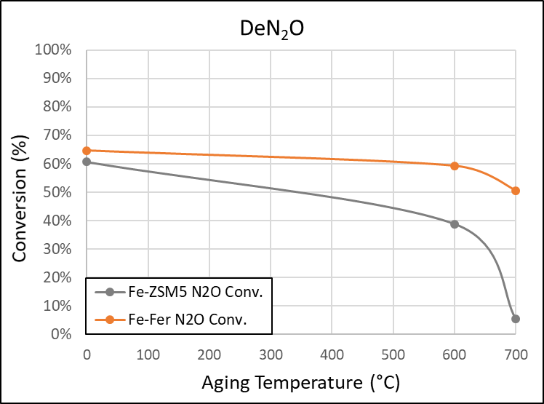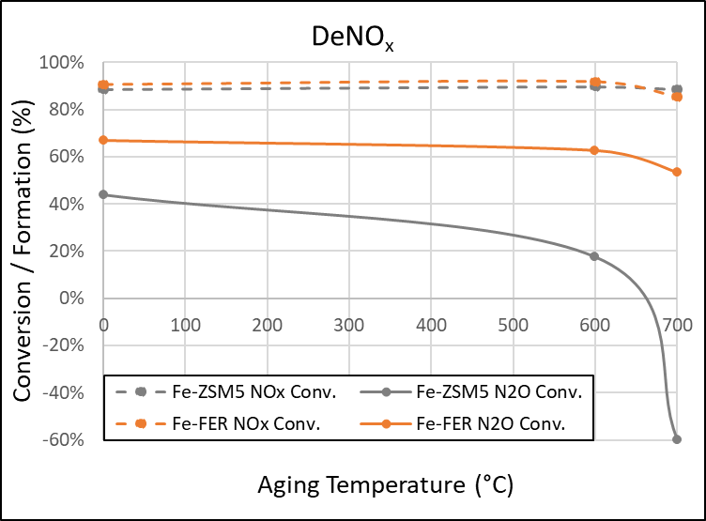
Figure 1. (Left) deN₂O condition: NO 70 ppm, NO₂ 30 ppm, N₂O 900 ppm, O₂ 3.0%, H₂O 0.3% and N₂ balance. (Right) deNO_{x} condition: NO 325 ppm, NO₂ 325 ppm N₂O 40 ppm NH₃ 650 ppm, O₂ 3.0%, H₂O 0.3% and N₂ balance.
4. Conclusions
In this work, representative industrial catalysts were investigated in industrial conditions before and after severe aging treatments. Results showed that Fe-FER is the most stable catalyst and high performance that can be used for tail gas treatment in nitric acid plants. Moreover Fe-FER is extremely selective in N₂ even after severe aging while the Fe-ZSM5 exhibited a larger undesired N₂O formation. The Fe-FER catalyst for DeN₂O and DeNO_{x} applications has superior performances compared to the Fe-ZSM5.
References
- M. Thiemann, E. Scheibler, and K. W. Wiegand, “Nitric Acid, Nitrous Acid, and Nitrogen Oxides,” Ullmann’s Encycl. Ind. Chem. Vol. 24, vol. 2003, Vol 24. 177-223.
- C. A. Grande et al., Ind. Eng. Chem. Res., vol. 57, no. 31, pp. 10180–10186, 2018.
- K. Skalska, J. S. Miller, and S. Ledakowicz, Sci. Total Environ., vol. 408, no. 19, pp. 3976–3989, 2010.
- C. Hamon, D. Le Guern, O. Le Lamer, and L. Navascues, EP1918016B1, 2006.

