Engineering Method for Calculating of an Axial Valve Separator with an External Location of the Locking Part.
Anna Kapranova¹, Sergey Neklyudov², Anton Lebedev¹, Alexander Meltser², Dmitriy Voronin²
1 Yaroslavl State Technical University, Moskovsky Prospect, 88, Yaroslavl, 150023, Russia; 2 JSC «Regulyator», Gagarin Street, 68a, Yaroslavl, 150023, Russia
*Corresponding author: kapranova_anna@mail.ru
Highlights
- Proposed a block diagram of the calculation of the axial valve separator.
- The required valve flow capacity is taken into account.
- The results of stochastic modeling of the hydrodynamic cavitation are the basis.
- An example of the calculation of the axial valve separator is made.

1. Introduction
Improving engineering methods for calculating valves is a pressing issue in the field of pipeline fittings design. The task of reducing the intensity of cavitation effects in the flow part of the valve can be successfully solved by throttling fluid flows. Axial valves provide a straight-line flow of fluid with minimal resistance when opened. The design of the axial valve proposed by the authors [1] assumes a coaxial arrangement of the separator and the movable external locking member, which have the form of hollow cylindrical shells (fig. 1). Thus, the throttle round holes of the fixed separator overlap when the cylindrical shell obeys along its outer surface. This shell can be set in motion as a rack and a crank mechanism.
2. Methods
The purpose of the work is to develop a scientifically based method for calculating the effective ranges of the design parameters of the throttle part of the axial valve. Earlier, the authors used the stochastic approach with the equilibrium representation of the states of the energetically closed macrosystem [2] within the framework of the Ornstein-Uhlenbeck random process [3] to form the model of the bubble formation process in the separator at the initial stage of hydrodynamic cavitation. The proposed stochastic models [4-8] allowed us to obtain differential distribution functions of the number of cavitation bubbles formed during the initial stage of the evolution of hydrodynamic cavitation, according to their size [4-6] and the degree of opening of the axial valve [7, 8]. The expression obtained using this model [4] for calculating the average over the ensemble of the diameter D_{sb} for the macrosystem of cavitation bubbles [5, 6] takes into account the physical and mechanical properties of the working medium, as well as the main design and operating parameters of the axial valve. Another model [7, 8] made it possible to establish a connection between the critical value of the Reynolds number Re_{cr} in the case of a complete opening of the valve and its design parameters. So, these expressions for D_{sb} [5, 6] and Re_{cr} based on [7, 8], as well as the obtained expressions for the energy parameter of the stochastic model [8] and the hydraulic resistance coefficient [9] are used in the proposed engineering method.
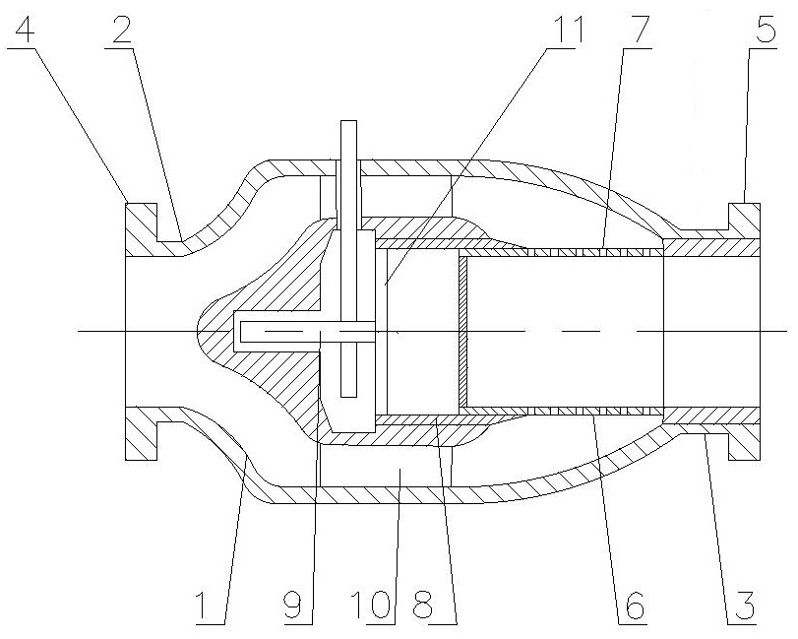
Figure 1. Schematic diagram of an axial valve with an external positioning of the locking member:
1 - outer case, 2 and 3 - inlet and outlet nozzles, 4 and 5 - flanges, 6 - separator, 7 - throttle holes, 8 - cylindrical conical, 9 - rack and pinion mechanism, 10 - cavity of the inner housing, 11 - radial partitions
3. Results and discussion
The proposed block diagram (fig. 2, 3) consists of 25 main blocks for calculating 13 effective values of the design parameters of an axial valve separator. For example, the required parameters include: diameter of round throttle holes d₀, arc distance between the holes in one row, distance between rows of these holes, separator thickness, number of holes for one row, number of these rows, diameter of the outlet of the separator, its perforated part length, bevel angle for the cylindrical part of the shell, etc. Specified operating parameters are the maximum attainable fluid flow through the regulating device at a given value of the medium temperature, the minimum pressure drop, the maximum pressure in the center of the bubble, which corresponds to the minimum value of its radius, the saturated vapor pressure of the medium, the velocity of the fluid in the pipeline. The input parameters for the calculation are the maximum attainable flow rate of the medium, the temperature of the medium, the limits of variation of the minimum pressure drop and the velocity of the fluid in the pipeline. The output parameter is the required valve capacity K’_{vy}. The flowchart proposes a phased calculation of various approximations of the desired design parameters depending on the selected intervals for changing the maximum value of the valve throughput. The specified intervals are refined three times (blocks 3, 10, 21), taking into account the required value of capacity K’_{vy} with the choice of safety factors. For the first time, this is done at specified intervals of change in the minimum pressure drop (block 3), in the second - after calculating Re_{cr} based on [7, 8, 10] to determine correction factors for medium viscosity (block 10), in the third - after estimating the hydraulic resistance coefficient ζ_{y}* [9] from the condition of minimal D_{sb} value (block 21) [5, 6].
4. Conclusions
According to the performed calculation example, with K’_{vy}=6,0 m³/h; Re_{cr}=5209,58; ζ_{y}*=0,119 obtained rational ranges of changes of the desired parameters, in particular, the average value of d₀ from the specified range is 5.05x10⁻³ m with a separator outlet diameter of 4.19x10⁻² m and the length of its perforated part 8.21x10⁻² m. The main practical value of this work is the possibility of reducing the intensity of cavitation in an axial valve when throttling fluid flows, as a result, extending the service life of regulating devices of this type.
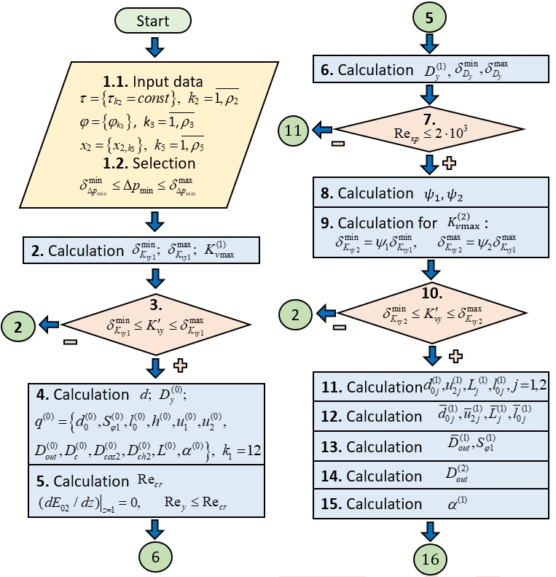
Figure 2. Conventional block diagram of the calculation of the design parameters of the axial valve separator with the external location of the locking member (Part 1)

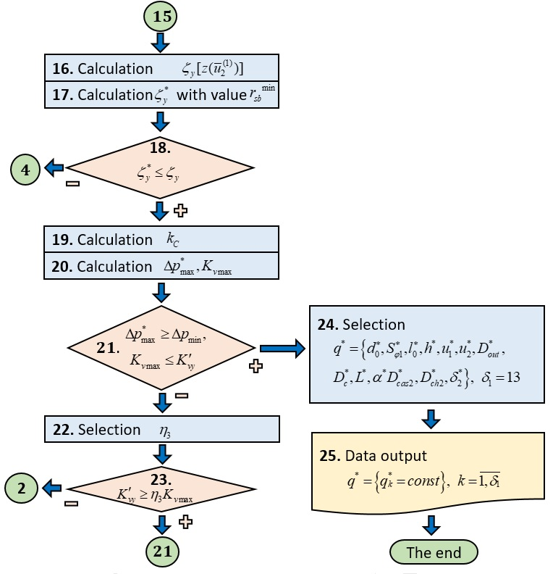
Figure 3. Conventional block diagram of the calculation of the design parameters of the axial valve separator with the external location of the locking member (Part 2)
References
- A.E. Lebedev, A.B. Kapranova, A.M. Meltser, S.A. Solopov, D.V. Voronin, S.V. Neklyudov. Patent on the model 175776 Russian Federation, IPC F16K 1/12, F16K 47/14, F16K 3/24. Direct-acting control valv. May 2018.
- Y.L. Klimontovich, Turbulent Motion and Chaos Structure: A New Approach to the Statistical Theory of Open Systems, LENAND, Moscow, 2014.
- A.B. Kapranova, A.E. Lebedev, A.M. Meltser, S.A. Solopov, Czas. Tech. Mech. 113 (2, 2016) 136-144.
- A.B. Kapranova, A.E. Lebedev, A.M. Meltser, S.V. Neklyudov, Vestn. IGEY Her IGEY. 4 (2016) 94-107. doi:10.17588/2072- 2672.2016.4.024-029.
- A. Kapranova, A. Lebedev, A. Meltser, S. Neklyudov, Int. J. Mech. Eng. Technol. 9 (3, 2018) 25-31.
- A.B. Kapranova, A.E. Lebedev, A.M. Meltser, J. Chem. Eng. Process Technol. 8(5 (Suppl), 2017). doi:10.4172/2157-7048-C1-009.
- A.B. Kapranova, J. Chem. Eng. Process Technol. 9 (2018). doi:10.4172/2157-7048-C3-016
- A. Kapranova, S. Neklyudov, A. Lebedev, A. Meltser, Int. J. Mech. Eng. Technol. 9 (8, 2018) 160-166.
- A. Kapranova, S. Neklyudov, A. Lebedev, A. Meltser, Int. J. Mech. Eng. Technol. 9 (8, 2018) 153-159.
- A. Kapranova, A. Miadonye, J Oil Gas Petrochem Sci. 2(2, 2019) 70-75. doi:10.30881/jogps.00026.

