Microwave assisted synthesis of levulinic acid using organic acids as green catalysts
Kinana Aliko, Naomi Adjaklo, Bilaal Ahmed, Paul D Topham, Eirini Theodosiou
Aston Institute of Materials Research, School of Engineering and Applied Science, Aston University, B4 7ET Birmingham, UK
*Corresponding author: Alikok@aston.ac.uk
Highlights
- Lignocellulosic biomass is a viable feedstock for the sustainable production of levulinic acid.
- Organic acids combined with microwave technology show great promise as a fast and environmentally friendly levulinic acid production route.
- Using maleic acid, in the presence of aluminium phosphate catalyst, can yield up to 45% levulinic acid from biomass waste.

1. Introduction
The chemical industry is moving away from petroleum-based products and focuses on the production and processing of ‘green’ chemical building blocks. Levulinic acid is amongst these ‘platform chemicals’ that can be developed in a sustainable way from bio-based sources. It acts as a precursor to a plethora of products, including pesticides, pharmaceuticals, solvents, cosmetics and food additives [1]. The global levulinic acid demand is predicted to reach 3,820 tonnes by 2020, which is a 30% increase since 2013, generating 19.65 million USD revenue.
Until now, the commonest commercial process to produce levulinic acid from agricultural residues depends mainly on a two-stage mineral acids catalysed reaction [1-3], which generates harmful environmental waste. The development, therefore, of a green catalyst for the above reaction remains key to the improved production of levulinic acid.
In this work, we detail the development of an environmentally friendly levulinic acid production route from very cheap and renewable feedstocks, such as barley straw, olive cake, beer waste, tomato peel, spent tea leaves and potato peel. Our process relies on the use of organic acids as catalyst substitutes for the mineral ones. These acids are less corrosive to the equipment, decrease the formation of humin (the major by-product of the reaction pathway) and can be degraded to nontoxic molecules [4, 5]. Our thermo-chemical method uses microwave heating, which compared to traditional heating methods, reduces reaction time and enhances the reaction rate.
2. Methods
Seven organic acids were employed in this study, namely: maleic; acetic; oxalic; malonic; tartaric; formic; and, citric. Dried samples of various biomass waste feedstocks were treated with each of these acids in the presence of different catalysts. The reactions were carried out in a laboratory microwave unit (CEM Discover S-Class, CEM Corporation, USA). The liquid phase was analysed by ¹H NMR to identify the composition of the reaction mixture, and HPLC to quantify the yield of levulinic acid. Design-Expert Ver.11 was used for Response Surface Methodology (RSM) analysis, based on the following variables: temperature; time; biomass to acid ratio; amount of catalyst; and, acid concentration.
3. Results and discussion
Initial experiments using AlCl₃ as a catalyst, indicated that of all the acids tested, maleic acid produces the highest yield of levulinic acid (35.7%; see Fig. 1). RSM optimization showed that temperature (T) and acid concentration (A) were the most significant factors, and levulinic acid yields increased to 42% (Fig. 2). Numerical optimization predicted the optimum yield of levulinic acid to reach 50% using the following reaction variables: 180 °C; 0.1 g catalyst; 38 min reaction time; 2 M acid concentration; and, 22 g/ml biomass to acid ratio. The effect of different catalysts (namely: aluminium phosphate, zeolite Y, aluminum chloride and aluminium sulfate) on the final yield was also investigated. Aluminium phosphate proved to be the best option, resulting in levulinic acid yields of up to 45%.
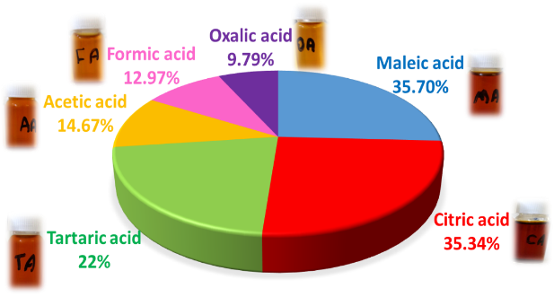  Figure 1. Levulinic acid production from barley straw using different organic acids and AlCl₃ as a catalyst. | 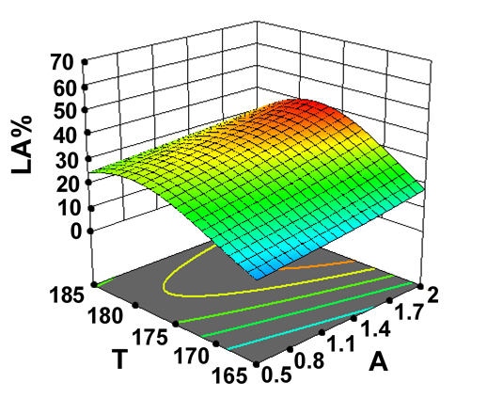  Figure 2. 3D surface plots of the effect of 2-way interaction variables on the yield of levulinic acid.  Key: T (temperature, °C); and, A (acid concentration, M).
4. Conclusions
A green route using organic acids, with help of a Lewis acid, can be a viable option in the sustainable production of levulinic acid from inexpensive lignocellulosic biomass feedstocks. The additional use of microwave heating not only speeds up the reaction time, but is also a more environmentally friendly alternative to processes involving mineral acids.
References
- O. Adeeyo, O.M. Oresegun, T.E. Oladimeji, AJER . 4 (2015) 14-19.
- H. Heeres, L. Janssen, B. Girisuta, Chem. Eng. Res. Des. 84 (2006) 339-349.
- D.W. Rackemann, W.O. Doherty, Int. Sugar. J. 115 (2013) 28-34.
- J. Ahlkvist, Formic and Levulinic Acid from Cellulose via Heterogeneous Catalysis, Umeå Universitet, 2014.
- J. Shen, C.E. Wyman, AIChE J. 58 (2012) 236-246.

